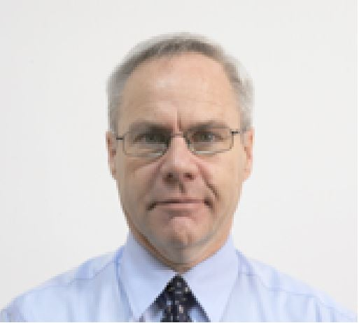
Jeff Allan
Jeff Allan has more than twenty-five years’ experience working first in broadcast journalism and then in international affairs. From 1987 to 2000 Mr. Allan worked in both English and French as a reporter and producer for the radio and television divisions of C.B.C. / Radio-Canada. He completed assignments in Edmonton, Calgary, Toronto, London and New York City.
In 2002, Mr. Allan embarked on a new career with the United Nations, working in the field of disarmament and non-proliferation. From 2002 to 2007, he served as an information analyst based in UNHQ-New York with the team of U.N. weapons inspectors charged with assessing Iraq’s suspected weapons of mass destruction capabilities.
From 2009 to 2014, Mr. Allan was stationed in Iraq where he worked as a United Nations political affairs officer. During that time, he completed assignments in Baghdad, Mosul and Erbil.
Mr. Allan holds a bachelor’s degree in political science from Laval University in Quebec City, a Master’s in social sciences from Syracuse University, as well as a master’s certificate in non- proliferation studies from the Monterey Institute of International Studies (MIIS) in California.

