Speaker Biographies

Dr. Allison Astorino-Courtois
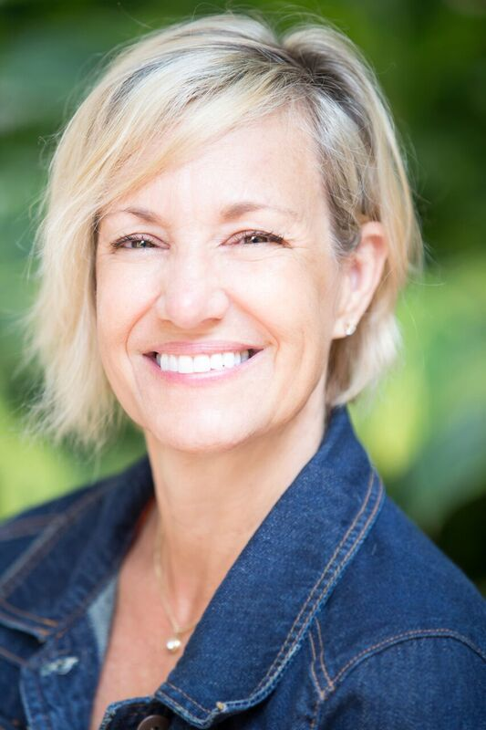
Dr. Allison Astorino-Courtois is Executive Vice President at NSI, Inc. She has also served as co-chair of a National Academy of Sciences study on Strategic Deterrence Military Capabilities in the 21st Century, and as a primary author on a study of the Defense and Protection of US Space Assets. Dr. Astorino-Courtois has served as technical lead on a variety of rapid turn-around, Joint Staff-directed Strategic Multi-layer Assessment (SMA) projects in support of US forces and Combatant Commands. These include assessments of key drivers of political, economic and social instability and areas of resilience in South Asia; development of an analytic approach used to identify PACOM requirements for humanitarian support in a Megacity (case study: Dhaka, Bangladesh); development of a methodology for conducting provincial assessments for the ISAF Joint Command; production of a "rich contextual understanding" (RCU) to supplement intelligence reporting for the ISAF J2 and Commander; projects for USSTRATCOM on deterrence assessment methods; and, work for USSOCOM on operationalizing its “gray zone” concept.
Previously, Dr. Astorino-Courtois was a Senior Analyst at SAIC (2004-2007) where she served as a STRATCOM liaison to U.S. and international academic and business communities. Prior to that Dr. Astorino-Courtois was a tenured Associate Professor of International Relations at Texas A&M University in College Station, TX (1994-2003) where her research focused on the cognitive aspects of political decision making and how to “market” peaceful conflict resolution to adversarial actors. She has received a number of academic grants and awards and has published articles in multiple peer-reviewed journals. She has also taught at Creighton University and as a visiting instructor at the U.S. Military Academy at West Point. Dr. Astorino-Courtois earned her Ph.D. in International Relations and MA in and Research Methods from New York University. Her BA is in political science from Boston College. Finally, Dr. Astorino-Courtois also has the distinction of having been awarded both a US Navy Meritorious Service Award and a US Army Commander's Award.

Dr. Lawrence Kuznar
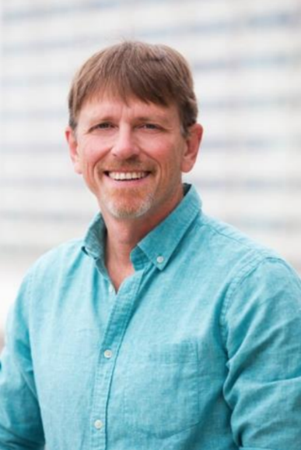
Dr. Lawrence A. Kuznar Chief Cultural Sciences Officer Lawrence A. Kuznar (Professor of Anthropology, Indiana University- Purdue University- Fort Wayne and NSI, Inc.) Dr. Kuznar conducts anthropological research relevant to counterterrorism and other areas of national security. His current research focuses on discourse analysis of Daesh leadership messaging to provide leading indicators of intent and behavior and has applied this methodology to Eastern European State and non-State Actors, Iran, and polities in the Middle East and Asia. He has developed computational models of genocide in Darfur and tribal factionalism in New Guinea, mathematical models of inequality and conflict, and integrated socio-cultural databases for predicting illicit nuclear trade and bioterrorism. He has conducted discourse analysis of the expression of conflict and enmity in Arabic, Farsi and Pashto, to identify leading indicators of conflict. Dr. Kuznar’s recent research has been funded by academic sources, the Office of the Secretary of Defense Strategic Multilayer Analysis, Air Force Research Lab (AFRL), the Human Social Cultural Behavior (HSCB) modeling program of the Department of Defense, and by the US Army Corps of Engineers. He has also served on the HSC Technical Progress Evaluation panel and a National Counterterrorism Center (NCTC) net assessment panel.

Dr. Peter Suedfeld
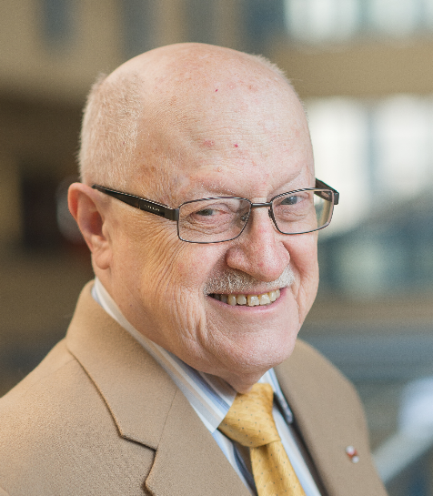
Peter Suedfeld was born in Hungary and emigrated to the United States in 1948. He was educated at Queens College of the City University of New York and, after three years in the Army, at Princeton University. He taught at the University of Illinois and Rutgers University before moving to The University of British Columbia, where he is now Dean Emeritus of Graduate Studies and Professor Emeritus of Psychology. His research is primarily concerned with cognitive, motivational, and personality factors related to coping, resilience, and growth during and after challenging experiences, including high-level political and military decision-making, genocide, work in polar regions, and spaceflight. Among other awards, he has received the NSF Antarctica Service Medal, the Canadian Polar Medal, Queen Elizabeth II’s Diamond Jubilee Medal, and the highest awards for scientific contributions from the Canadian Psychological Association and the International Society of Political Psychology. He is a Fellow of the Royal Society (the National Academies) of Canada, the Royal Canadian Geographical Society, and the International Academy of Astronautics, as well as APA, CPA, and other scientific bodies.

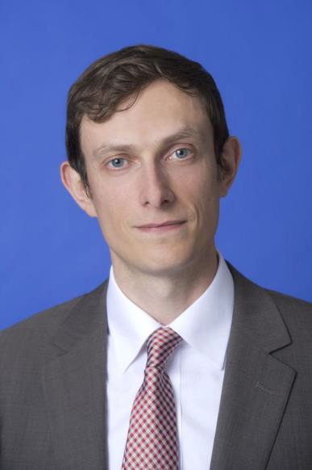
Dr. Nicholas Wright (Intelligent Biology)
Dr. Nicholas D. Wright is a consultant at Intelligent Biology and an affiliated scholar at the Pellegrino Center for Clinical Bioethics at the Georgetown University Medical Center.
He applies insights from neuroscience and psychology to decision-making in international confrontations in ways practically applicable to policy.
He has conducted work for the UK Government and Pentagon Joint Staff.
He was previously an Associate in the Nuclear Policy Program, Carnegie Endowment for International Peace, Washington DC, and a Senior Research Fellow at the Institute for Conflict, Cooperation and Security at the University of Birmingham (UK).
Prior to joining Birmingham and Carnegie, he examined decision-making using functional brain imaging at University College London (UCL) and in the Department of Government at the London School of Economics.
He worked clinically as a neurologist in Oxford and at the National Hospital for Neurology in London.
He has published academically (e.g. Proceedings of the Royal Society), in general publications such as the Atlantic or National Interest, and with the Joint Staff at the Pentagon (see www.nicholasdwright.com/publications).
He has briefed multiple times at the Pentagon, and also at the UK MoD, French MoD, German Foreign Office and elsewhere. He has appeared on the BBC and CNN.
Wright received a medical degree from UCL, a BSc in Health Policy from Imperial College London, has Membership of the Royal College of Physicians (UK), has an MSc in Neuroscience and a PhD in Neuroscience both from UCL.

