SMA Space Panel Discussion:
UK Perspectives

Booklet
Thursday, 17 May 2018
1030-1130 ET

Dial (866) 712-4038; Passcode 37250264#

Strategic Multi-Layer Assessment (SMA) provides planning support to Commands with complex operational imperatives requiring multi-agency, multi-disciplinary solutions that are NOT within core Service/Agency competency. Solutions and participants are sought across USG and beyond. SMA is accepted and synchronized by Joint Staff/J-39 DDGO and executed by ASD (EC&P).

Agenda
Panel Description: Allied perspectives will be key to U.S. success in many escalation scenarios involving space operations, but what do these allies think? A panel of leading UK scholars of space security will seek to address the following questions:

(1) What are the key features of UK thinking about:
(a) deterrence and other coercion in space
(b) escalation management in space
(c) integration of space and other domains in deterrence and escalation management (i.e. cross-domain deterrence and
escalation management)
(d) warfighting in space
(e) "Gray Zone" activities involving space, as well as the evolution of confrontations and norms involving space.

(2) Do key elements of such UK thinking differ from US ideas, and if so how?

(3) How does such UK thinking on space compare to UK thinking on cyber and nuclear?

(4) How does the UK view Russian thinking about space coercion, escalation management and warfighting? Is Russian thinking held to differ from US and/or UK thinking, and if so how?

(5) How does the UK view potential US actions or strategies in space? For example, the UK may be considered under US "extended deterrence". Within this "extended deterrence" how does the UK think about US assurances of US willingness and ability to defend UK space interests during peacetime or during crises? Are there specific space-related actions that the UK is particularly concerned about?
(6) How does the UK view the impact of military activities on commercial dimensions of space?

Panel Moderator: Dr. Nicholas Wright (Intelligent Biology)
Speakers:
- Dr. Bleddyn Bowen (University of Leicester)
- Dr. Mark Hilborne (King’s College, London)

Speaker Biographies

Dr. Bleddyn Bowen (University of Leicester)
Lecturer in International Relations
Dept. of History, Politics, and International Relations at the University of Leicester

Dr. Bleddyn E. Bowen is a Lecturer in International Relations at the University of Leicester. Before lecturing at Leicester in January 2018, he was a Lecturer in Defence Studies at the Defence Studies Department, King’s College London, which is embedded at the Joint Services Command and Staff College, Shrivenham. Prior to that, he was a Teaching Fellow at the Department of International Politics, Aberystwyth University, where he also worked for his various degrees. During his PhD at Aberystwyth University he was a Visiting Scholar at the Space Policy Institute in Washington, D.C. in Spring 2014. Bleddyn’s primary research interests concern warfare, politics, and security in outer space. Bleddyn has published in several academic journals and has written numerous op-eds for various outlets, provided evidence for the UK’s House of Commons Exiting the EU Select Committee on Brexit and UK space policy, and has appeared in the media several times in outlets such as BBC Radio 4, 5, Wales, Cymru, the Financial Times, The Times (London), and Wired. Bleddyn is currently working on his research monograph, about spacepower theory.

Dr. Mark Hilborne (King’s College, London)
Lecturer
Defence Studies Department at King’s College, London
Dr. Mark Hilborne is a lecturer at the Defence Studies Department at King’s College London, based at the Defence Academy. Dr Hilborne also runs the War Studies Online Air Power in the Modern World MA. He has also taught at RAF Cranwell, again as part of King’s, where he was Assistant Head of Air Power Studies, and at the University of Birmingham within the Department of Political Science and International Studies (POLSIS). Dr Hilborne also was a visiting Researcher at the United Nations Institute of Disarmament where he focused principally on space security issues. He was the academic director of the RAF Intermediate Command and Staff Course for a number of years and serves on the Editorial Board of RAF Air Power Review. Dr Hilborne has set up the Space Security Research Group, and he is currently supervising three PhDs in this field. His research focuses on nuclear proliferation and deterrence, space security and more recently hypersonic strategic weapons systems and their impact on nuclear deterrence. Dr Hilborne holds a BA from the University of British Columbia (UBC), and an M.Phil and PhD from Cambridge University. His latest research includes Beyond the Earth, beyond the state: NewSpace and Space Security, which is planned as part of a forthcoming special edition, of which Dr Hilborne is co-editor; ‘Britain’ in Mitigating Disinformation Campaigns against Air Power, NATO Joint Air Power Competency Centre, 2016; and ‘China’ in a special edition of Space Policy focusing on developing space programs (Space Policy, Aug 2016, 37, 1). Further publications relevant to space include ‘China’s Rise in Space and US Policy Responses: A collision course?’, Space Policy, May 2013; ‘UK Space Policy’ RAF Air Power Review, Summer 2009; and ‘Space Weapons: A technological Folly?’ in Brian Rappert (ed), Technology and Security, Palgrave (Basingstoke and New York) 2007.

Dr. Nicholas D. Wright (Intelligent Biology)
Intelligent Biology (UK)
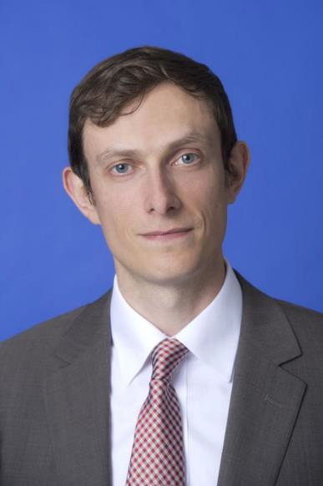
Dr. Nicholas Wright is a Senior Researcher at Intelligent Biology in the UK.
He applies insights from neuroscience and psychology to decision-making in international confrontations in ways practically applicable to policy.
He has conducted work for the UK Government and Pentagon Joint Staff.
He was previously an Associate in the Nuclear Policy Program, Carnegie Endowment for International Peace, Washington DC, and a Senior Research Fellow at the Institute for Conflict, Cooperation and Security at the University of Birmingham (UK).
Prior to joining Birmingham and Carnegie, he examined decision-making using functional brain imaging at University College London (UCL) and in the Department of Government at the London School of Economics.
He worked clinically as a neurologist in Oxford and at the National Hospital for Neurology in London.
He has published academically (e.g. Proceedings of the Royal Society), in general publications such as the Atlantic or National Interest, and with the Joint Staff at the Pentagon (see www.nicholasdwright.com/publications).
He has briefed multiple times at the Pentagon, and also at the UK MoD, French MoD, German Foreign Office and elsewhere. He has appeared on the BBC and CNN.
Wright received a medical degree from UCL, a BSc in Health Policy from Imperial College London, has Membership of the Royal College of Physicians (UK), has an MSc in Neuroscience and a PhD in Neuroscience both from UCL.

