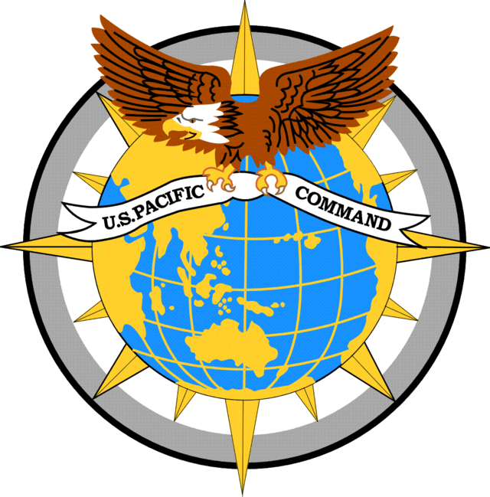
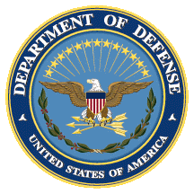
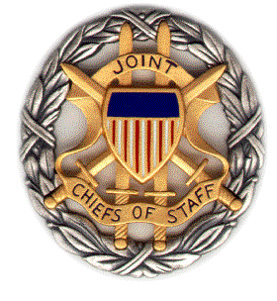

SMA PACOM Panel Discussion:
Korea Regional Impacts

Booklet
Tuesday, 5 June 2018
1600-1700 ET

Dial (866) 712-4038; Passcode 37250264#

Strategic Multi-Layer Assessment (SMA) provides planning support to Commands with complex operational imperatives requiring multi-agency, multi-disciplinary solutions that are NOT within core Service/Agency competency. Solutions and participants are sought across USG and beyond. SMA is accepted and synchronized by Joint Staff/J-39 DDGO and executed by ASD (EC&P).

Agenda
Panel Description:
Regardless of the prospects of denuclearizing North Korea, the United States and South Korea are likely to continue strengthening capabilities to deter North Korean coercive behavior. Yet, as they do this, it will become increasingly important to assess the regional implications of their actions. Their efforts have already had, and will continue to have, broad spillover effects, potentially creating new tensions with China and complicating alliance relations with Japan. All of the prospective deterrence options could fuel misperception and lead to further instability in the region. In their new report, Security Spillover: Regional Implications of Evolving Deterrence on the Korean Peninsula, Toby Dalton, Narushige Michishita, and Tong Zhao assess the challenges of narrowly tailoring deterrence against North Korean coercion from a regional perspective. The report will be released by the Carnegie Endowment for International Peace on June 12.
Panel Moderator: Dr. Nicholas Wright (Intelligent Biology; Georgetown University)
Speakers:
- Dr. Toby Dalton (Carnegie Endowment for International Peace)
- Prof. Narushige Michishita (Woodrow Wilson Center / National Graduate Institute for Policy Studies—Tokyo)

Speaker Biographies

Dr. Toby Dalton
Co-Director, Nuclear Policy Program, Carnegie Endowment for International Peace

Toby Dalton is a co-director of the Nuclear Policy Program at the Carnegie Endowment for International Peace. Before joining Carnegie, he served in various high-level nuclear policy positions at the U.S. Department of Energy. An expert on nonproliferation and nuclear energy, his work addresses regional security challenges in South Asia and East Asia and the evolution of the global nuclear order.

Prof. Narushige Michishita
Global Fellow, Woodrow Wilson Center
Professor, National Graduate Institute for Policy Studies (Tokoyo)

Narushige Michishita is a global fellow at the Woodrow Wilson Center and a professor at the National Graduate Institute for Policy Studies in Tokyo. Previously, he served as a senior research fellow at the National Institute for Defense Studies, Ministry of Defense and assistant counsellor at the Cabinet Secretariat for Security and Crisis Management of the Government of Japan. A specialist in Japanese security and foreign policy, as well as security issues on the Korean Peninsula, his works include North Korea’s Military-Diplomatic Campaigns, 1966-2008 (Routledge, 2009).

Dr. Nicholas D. Wright (Intelligent Biology)
Consultant, Intelligent Biology (UK)
Affiliated Scholar, Pellegrino Center for Clinical Bioethics, Georgetown University Medical Center

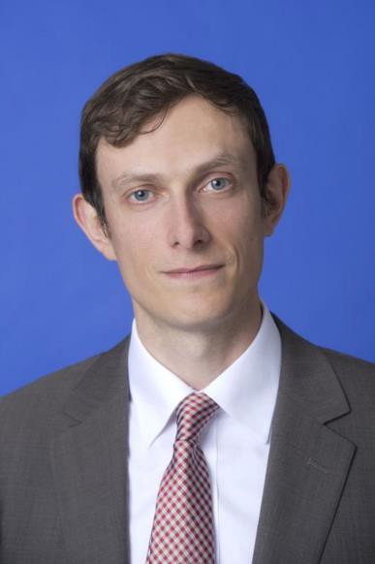
Dr. Nicholas Wright is a consultant at Intelligent Biology and an affiliated scholar at the Pellegrino Center for Clinical Bioethics at the Georgetown University Medical Center.
He applies insights from neuroscience and psychology to decision-making in international confrontations in ways practically applicable to policy.
He has conducted work for the UK Government and Pentagon Joint Staff.
He was previously an Associate in the Nuclear Policy Program, Carnegie Endowment for International Peace, Washington DC, and a Senior Research Fellow at the Institute for Conflict, Cooperation and Security at the University of Birmingham (UK).
Prior to joining Birmingham and Carnegie, he examined decision-making using functional brain imaging at University College London (UCL) and in the Department of Government at the London School of Economics.
He worked clinically as a neurologist in Oxford and at the National Hospital for Neurology in London.
He has published academically (e.g. Proceedings of the Royal Society), in general publications such as the Atlantic or National Interest, and with the Joint Staff at the Pentagon (see www.nicholasdwright.com/publications).
He has briefed multiple times at the Pentagon, and also at the UK MoD, French MoD, German Foreign Office and elsewhere. He has appeared on the BBC and CNN.
Wright received a medical degree from UCL, a BSc in Health Policy from Imperial College London, has Membership of the Royal College of Physicians (UK), has an MSc in Neuroscience and a PhD in Neuroscience both from UCL.

