Randy Kluver (Ph.D., University of Southern California) is the Dean of the School of Global Studies and Partnerships at Oklahoma State University. Dr. Kluver conducts theoretically driven research on political communication (including rhetorical and new media approaches), and global and new media. His work explores the role of political culture on political communication, and the ways in which cultural expectations, values, and habits condition political messaging practices and reception in a variety of contexts.

Skye Cooley (Ph.D., University of Alabama) is an assistant professor in the School of Media and Strategic Communications at Oklahoma State University. His research interests are in Russian political communication, global media and digital democracy, as well as civic deliberation online. Dr. Cooley holds certifications of accreditation in public relations (APR) and civilian service peace keeping operations (POTI). He has traveled actively through Europe, Latin America, Asia and Africa; publishing and presenting research on international political communication.

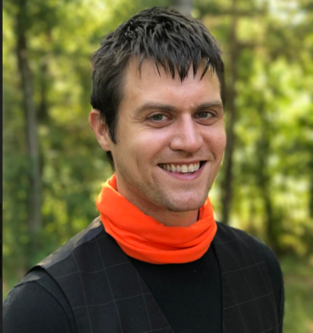

Ethan Stokes (Ph.D., University of Alabama) is an assistant professor of in advertising and public relations in the College of Communication and Information Sciences at the University of Alabama. Dr. Stokes’ research interests are in political communication, digital media, and open source intelligence systems. His work examines how narratives move and alter across global media.
