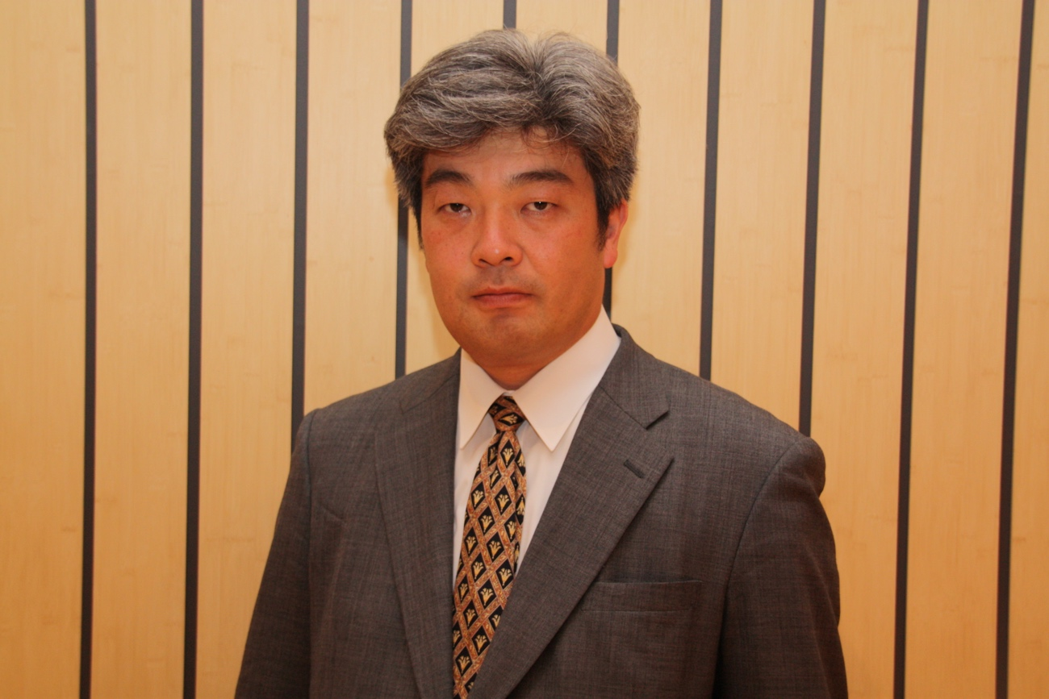

Kazuto Suzuki is Vice Dean and Professor of International Politics at Public Policy School of Hokkaido University, Japan. He graduated Department of International Relations, Ritsumeikan University, and received Ph.D. from Sussex European Institute, University of Sussex, England. He has worked in the Fondation pour la Recherche Strategique in Paris, France as assistant researcher and the Associate Professor at the University of Tsukuba from 2000 to 2008, and moved to Hokkaido University. He also spent one year at Woodrow Wilson School of Public and International Affairs at Princeton University from 2012 to 2013 as visiting researcher. He served as an expert in the Panel of Experts for Iranian Sanction Committee under the United Nations Security Council from 2013 to July 2015. He has conducted researches from International Political Economy perspective in Space Policy, together with nuclear energy policy, export control, counter-terrorism, non-proliferation, and policies on market regulation. He has contributed to the drafting the Basic Space Law of Japan, and serves as a member of Sub-committees of industrial policy and space security policy of National Space Policy Commission. His recent work includes Space and International Politics (2011, in Japanese, awarded Suntory Prize for Social Sciences and Humanities), Regulatory Power of EU (editor 2012, in Japanese), Policy Logics and Institutions of European Space Collaboration (2003) and many others.

