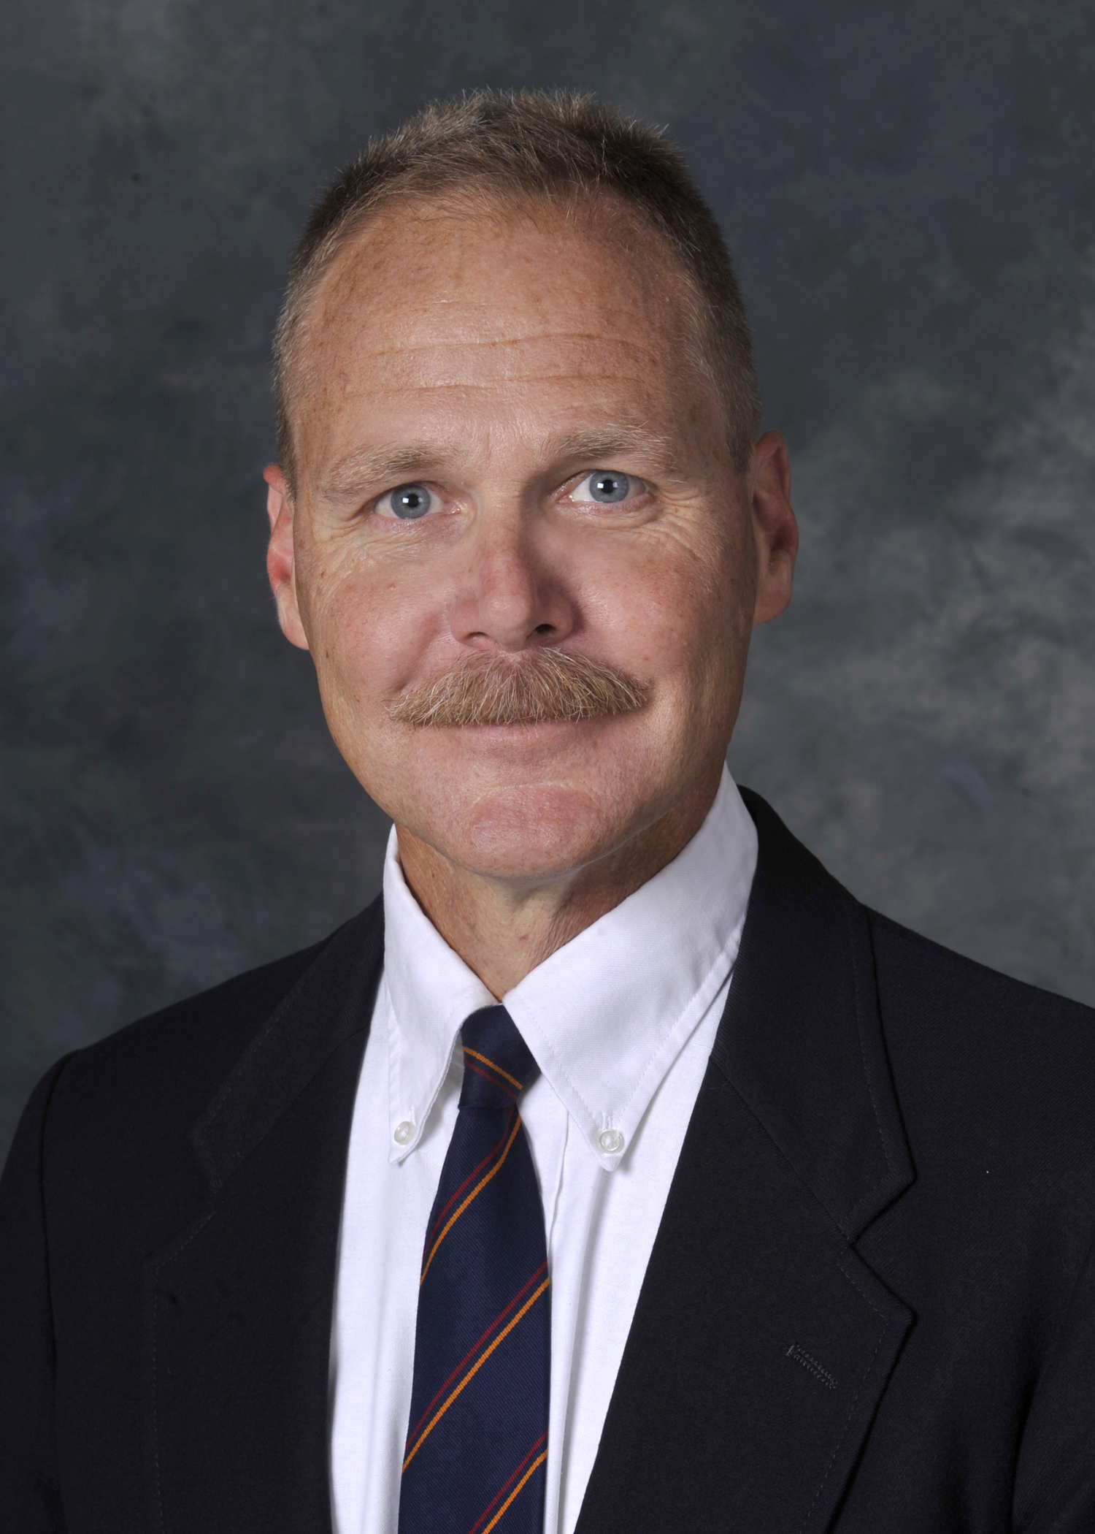

David R. Dorondo

Department of History
Western Carolina University
(828) 227-3908
dorondo@email.wcu.edu

David R. Dorondo earned the degree of B.A. cum laude in history from Armstrong State College in 1980 and the M.A. in German and European diplomatic history from the University of South Carolina in 1984. From 1984 to 1987, he was a member of St. Antony’s College, Oxford and was admitted to the degree of D.Phil. from the University of Oxford in 1988. While there, he earned a Fulbright Graduate Research Fellowship to attend the Otto-Friedrich-Universität Bamberg in the Federal Republic of Germany for the academic year 1985-1986, having already spent the year 1981-1982 at the same institution as a graduate exchange student.

Dorondo is the author of Bavaria and German Federalism: Reich to Republic – 1918-1933, 1945-1949 and Riders of the Apocalypse: German Cavalry and Modern Warfare, 1870-1945. He is also the translator of Schlachtfeld Fulda Gap: Strategien und Operationspläne der Bündnisse im Kalten Krieg (Fulda Gap: Battlefield of the Cold War Alliances. Edited by Dieter Krüger and Volker Bausch. Lexington Press, 2017.)

He has published numerous articles, reviews, encyclopedia entries, and op-eds on German and modern European military history. These include, but are not limited to, articles in:
- Great Lives from History: Twentieth Century
- Modern Germany: An Encyclopedia of History, People, and Culture, 1871-1990
- Air Warfare: An International Encyclopedia
- Naval Warfare: An International Encyclopedia
- Encyclopedia of the Korean War
- Journal of the Association of Historians in North Carolina
- Infantry Bugler: The Official Publication of the National Infantry Association

His most recent work includes, but is not limited to, the following:
- “The U.S. Army, Europe, and Nuclear Deterrence: A Historical Context” (in progress)
- War for Horses: The German Army Remount and Veterinary Services, 1918 – 1945 (in progress).
- A translation from German of the volume on the Battle of Tobruk from the post-1945 series Wehrmacht im Kampf (Casemate Press). Contract pending as of June 2018.

Dorondo is a member of US Strategic Command’s Deterrence and Assurance Academic Alliance and the Society for Military History. He sits on the Brewster Award Committee of the North Carolina Association of Historians. He joined the Department of History of Western Carolina University in 1987 and is the former holder of the Sossomon Chair in History. In 1996 he was awarded the Medal of Scholarship from Pi Gamma Mu International Honor Society in Social Sciences. Since 2000 he has served as Faculty Advisor to the Pi Psi Chapter of Phi Alpha Theta History Honor Society and received WCU’s College of Arts and Sciences Teaching Award for the year 2000-2001, as well as the University’s Last Lecture Award for teaching in 2011-2012. He founded and moderates The Carolina Round Table on the World Wars and co-founded and co-moderates WCU’s Global Spotlight Series on International Affairs.

An avid horseman and hiker, he lives below Flat Gap in the Cowee Mountains of Jackson County, North Carolina.

