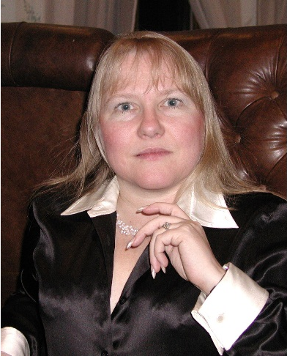
Dr. Kathleen M. Carley
Experience Dr. Carley is a Professor of Computer Science in the Institute for Software Research, IEEE Fellow, and Director of the Center for Computational Analysis of Social and Organizational Systems at Carnegie Mellon University. She joined Carnegie Mellon in 1984 as Assistant Professor Sociology and Information Systems. In 1990 she became Associate Professor of Sociology and Organizations, in 1998 Professor of Sociology, Organizations, and Information Technology, and in 2002, attained her current role as Professor of Computation, Organization, and Society. She is also the CEO of Carley Technologies Inc. aka Netanomics.
Dr. Carley’s research combines cognitive science, sociology, and computer science to address complex social and organizational issues. Her most notable research contribution was the establishment of Dynamic Network Analysis (DNA) – and the associated theory and methodology for examining large high-dimensional time variant networks. Her research on DNA has resulted in tools for analyzing large-scale dynamic networks and various multi-agent simulation systems. Her group has developed tools for extracting sentiment, social and semantic networks from social media and other textual data (AutoMap), simulating epidemiological models (BioWar), simulating covert networks (DyNet), and simulating changes in beliefs and practice given information campaigns (Construct). Her ORA system is one of the premier network analysis and visualization engines supporting geo-temporal analysis of social network and meta-network data. It is used worldwide and at several of the combatant commands. Illustrative projects include assessment of IRS outreach activities, assessment of impact of NextGen on airline re-rerouting, counter-terrorism modeling, counter-narcotics modeling, assessment of design of public-health departments, mapping the global cyber-attack network, and social media-based assessment of crises such as Benghazi, Darfur, and the Arab Spring.
Education Dr. Carley received SB degrees in Economics and in Political Science from M.I.T., and a PhD degree in Sociology from Harvard University.
Publications Among Dr. Carley’s many scientific publications, she co-authored papers “Exploring Characteristics of Suspended Users and Network Stability on Twitter” (2016), “Transition Networks in a Cohort of Patients with Congestive Heart Failure” (2015), “Remote assessment of countries’ nuclear, biological, and cyber capabilities: joint motivation and latent capability approach” (2015), “Destabilizing Terrorist Networks” (2003), “The Impact of US Cyber Policies on Cyber-Attacks Trend” (2016), “Rapid Modeling and Analyzing Networks Extracted from Pre-Structured News Articles” (2012), “An Incremental Algorithm for Updating Betweenness Centrality and k-Betweenness Centrality and Its Performance on Realistic Dynamic Social Network Data” (2015).
Honors Dr. Carley is an IEEE Fellow. She is the recipient of the Allen Newell award for research excellence. She has served as President of the North American Association for Computational and Organizational Simulation (2003-2004) and of the Mathematical Sociology Section of the American Sociological Association (1999-2000). She received the Lifetime Achievement Award from the Sociology and Computers Section of the ASA (2001). In 2011 she received the Simmel Award for advances in the area of social networks from INSNA and became a senior member of the IEEE. She has served as a Task Force Member of the Defense Science Board and of Geographic Information Science Panel of the Strategic Command. She has served on a committee and several panels of the National Research Council including ones on the military, big data, and geo-spatial analytics and was a member of the DHS-HSSTAC.

