NORTH KOREAN ECONOMY (9-02-2018)

Bradley O. Babson

Summary

- The North Korean economy has become a mixed economy with markets playing an increasingly important role in meeting consumption needs of the people and providing an impetus for domestically-led economic growth despite the adverse impacts of sanctions.

- As a result, the political economy of North Korea is changing with a large portion of the population participating in market activities for self-interest and a rising middle class of entrepreneurs accumulating economic wealth and power that weakens the top-down control and patronage system.

- The state tolerates but does not officially promote the marketization process, with limited policy and institutional reforms and rampant corruption.

- Kim Jong Un has given economic development a high priority and tethered the legitimacy of his rule to delivering on economic progress.

- The Cabinet has been given lead responsibility and more authority to guide the economic development process “in our own style.” Premier Pak Pong Ju was elevated to Vice Chairman of the State Administration Council that superseded the National Defense Commission in 2016.

- Economic growth has been modest but positive in recent years with stable food and foreign exchange prices despite the increased pressures of sanctions, although it appears growth in 2017 did decline.

- North Korea’s economic dependence on China is very high, so Chinese policies and willingness to increase sanctions and improve enforcement has been an important factor affecting the North Korea economy. A major dilemma is how the trade gap where North Korean imports exceed exports is being financed and how sustainable this can be.

- Sanctions are a double-edged sword that affects incentives for both state and non-state actors. North Korea has evolved networks and a variety of mechanisms to evade sanctions that are well documented. Post-Summits in 2018, there appears to be a growing climate of sanctions relaxation despite U.S. calls for continued pressure.

The North Korean economy in mid-2018 is a mixed economy with about one third of GDP based on market activities and about two thirds based on state-directed activities. In recent years, there has been continuing growth and diversification of market-based economic activity that has been tolerated and tacitly supported by the government, but not embraced by official policy. As a result, legal and financial institutions needed to support and control market activities are poorly developed. Payments to state enterprises and organs providing legal cover and widespread corruption provide the glue that enables private initiative for business investment and transactions. The rise of a class of successful entrepreneurs (donju) is changing the political economy of the elite and leading to a blurring of the boundaries of the state-led and market-driven economic systems and weakening middle class dependence on the public distribution system and patronage of the state. A significant majority of North Korean families participate in markets and derive income from the market economy that is altering the longstanding social contract. This also leads to a disconnect between people focused on earning money and state employees (especially military and security services) that are still tethered to the state-managed compensation system. This is a potential source of social friction and political threat. Demographic changes are also affecting the economy with an aging society and declining active workforce, and 60% of the population born during and after the famine of the 1990s having grown up with little experience of a functioning planned economic system.

A second recent trend is increased decentralization of economic responsibility and authority. Geographically, local governments and officials are expected to address needs and opportunities in their areas of control. This has been accompanied by growing income inequality between Pyongyang and different regions of the country. Functionally, state enterprise management reforms have given enterprise managers more flexibility in how they run and grow their businesses, and agriculture reforms are empowering smaller work units.

Estimates of the size of the North Korean economy and extent of its dependence on trade are problematic, as North Korea does not publish macroeconomic statistics except reports of performance and plans for the national budget at the annual meeting of the Supreme People’s Assembly. Annex 1 provides an estimate of the growth in GDP and trade from 2000 to 2015. One notable development is the rise in trade as a percent of GDP from 11.8% to 20.7% over this period. This reflects North Korea’s recognition that increasing outward orientation is important for its economic development despite the official policy emphasis on self-reliance.

Despite sanctions, the North Korean economy achieved modest positive growth in recent years, surprisingly reaching nearly 4% in 2016. This was largely due to increased efficiency in domestic production, expanding the role of markets in the economy and the 70-day and 200-day mass labor mobilizations that preceded and followed the 7th Party Congress in May 2016. A sharp turnabout seems to have occurred in 2017 due to the increased intensity of sanctions and commitment to their implementation by China and other countries. The South Korean Central Bank estimates that growth declined by 3.5%, the largest decline in more than 20 years, validating the effectiveness of the U.S.-led “maximum pressure” campaign. Agriculture, forestry and fisheries fell 1.3% while mining fell 11% and manufacturing fell 6.9%.

Despite these swings in economic growth under sanctions, market prices have remained stable especially for foreign exchange, and with normal seasonal variations for rice and corn (Annex 2). Diesel and refined petroleum prices did increase after sanctions were placed on imports of oil but even these prices have recently decreased and stabilized, possibly due to relaxation of hoarding and evasion of sanctions through increased ship-to-ship transfers of oil at sea and increased imports from Russia.

The gap between official prices and market prices is a major challenge for economic management in the mixed economy, contributing to distortions, inefficiencies and social tension between those compensated at market prices and those at state prices. Another monetary development is increased dollarization of the market economy with both dollars and yuan widely circulated and used for domestic as well as trade transactions. This complicates monetary management but also could be a factor explaining the stable market foreign exchange rate.

External Trade

North Korea does not report trade data to the UN, so estimates of North Korean trade require use of “mirror statistics” based on trade reported by other countries. Reporting errors and omissions and trade via third countries distort the accuracy of trade data estimates and changing international commodity prices also impact the valuation of trade. Nevertheless, it seems clear that sanctions and changes in demand for exports from North Korea have shifted the composition of trade and concentration of trading partners over time. Annex 3 provides a breakdown of the composition of trade in 2016, which indicates high dependence on a relatively small number of commodities for exports and a more diversified composition for imports. Coal, textiles and fisheries dominate the export picture. Textiles and machinery dominate imports. Oil imported from China by pipeline is not included in these statistics, as this is not reported by Chinese customs.

In recent years, about 90% of North Korean trade has been with China, although trade diversion to third country markets through China to evade sanctions (for example, in textile and fisheries exports) likely accounts for some portion of the China trade. In 2017, Chinese imports from North Korea as reported by the Chinese customs authorities plummeted as China implemented UNSC sanctions; but surprisingly Chinese exports to North Korea, while also declining, have continued at a higher level than the imports level leading to a widening gap (Annex 4). A recent South Korean report from KOTRA estimated total North Korean exports in 2017 amounted to $1.7 billion dropping 37.2% from 2016, while imports amounted to $3.7 billion increasing 1.8% over 2016 and producing a financing deficit of $2 billion.

Apart from questions about the quality of the data and accuracy of estimations of North Korean trade, a major question is how the continuing and growing trade gap is being financed. North Korea does not publish balance of payments statistics or national accounts, so estimates of national foreign exchange flows and reserves are questionable. Possible explanations for how the trade gap is being financed include: income from unrecorded remittances and tourism, reserves accumulated over many years, some which may be held in accounts outside North Korea; subsidized prices for some imports such as friendship prices for imported oil; in-kind transactions not recorded; suppliers credits; and loans. Smuggling has also played an important role across the North Korea-China border and there are reports that smuggling has increased with North Korean donju playing a growing role in organizing and scaling up this trade as one response to sanctions approved in 2017.

Economic Policy under Kim Jong Un

From his first New Year’s address in 2013 when he promised the North Korean people they would never have to tighten their belts again, Kim Jong Un has tethered the legitimacy of his rule to delivering on economic development. He has given increasingly high priority to addressing this challenge in the face of both external sanctions and inadequacies of economic policy and management while also laboring to consolidate his authority and reforming state governance. Light industry, agriculture and energy have been consistent sector priorities. The “byungjin” policy of giving equal priority to security through the nuclear and missile programs and economic development was first adopted in 2013 and then enshrined as state strategy at the 7th Party Congress in 2016.

The Cabinet under Kim Jong Un has been given lead responsibility and authority to plan and manage economic development, which is an important departure from the past where the Party played a central policy role. Cabinet technocrats have been elevated to senior positions and some given membership in the high-level Party organs. A new five-year economic development strategy was adopted at the 7th Party Congress that emphasized innovation and import substitution, but made no mention of the role of markets. Special Enterprise Zones have been embraced as a means to attract foreign investment and technology transfers, but with little success so far other than in Rason. Enterprise and agricultural reforms have also been pursued and compulsory education lengthened to reinforce the importance of the contribution of human resources to the national economic agenda. The elevation of the role of the Cabinet was also reflected in the appointment of Premier Pak Pong Ju as Vice Chair of the State Administration Council that superseded the National Defense Commission as the highest decision-making body in decisions of the Supreme People’s Assembly in June 2016. Recently Kim Jong Un has vocally criticized poor performance of Cabinet officials in addressing issues ranging from energy projects and infrastructure to public health.

It is noteworthy that while North Korea has studied foreign economic development experiences and been willing to allow limited economic and business training for officials and academics with foreigners, there has been no meaningful economic policy level dialogue. Senior economic officials have also not participated in track 1.5 meetings that are common for officials working on political and security issues. Early exploratory talks with the IMF and World Bank in the late 1990s came to a halt after the collapse of the Agreed Framework in 2002 and there has been no contact in the Kim Jong Un era. North Korea emphasizes that it is pursuing economic development and management “in our own style.”

The dramatic diplomatic developments in 2018 have created an impression that Kim Jong Un is keen to give priority to economic development in both political and pragmatic ways by negotiating a new national security framework that reduces tensions and eases economic pressures. His overtures to South Korea and China already appear to be producing initial results with Russia also supporting the path he has taken. Also, Kim’s increasingly frequent on-site visits for economic guidance and open acknowledgment of deficiencies in infrastructure and economic management indicates his intent to address seriously his economic challenges.

Growth of Markets and Blurring of the State and Market-led Economies

Economic reforms in 2002 and 2003 legalized markets and provided state enterprise managers with more flexibility in running their businesses. Since then, consumer goods markets have grown and diversified and are now firmly entrenched in urban centers and increasingly in rural areas. There are now over 450 licensed markets and 740 unlicensed markets. Many state enterprises participate in the market economy in a variety of ways, including:
- Providing legal cover for private businesses for compensation;
- Sourcing inputs to their own production from markets;
- Selling part of their product above the state plan to markets; and
- Renting space or subcontracting management to private entrepreneurs.

In addition to consumer goods, markets for housing, labor and finance have been evolving. While legally all land and housing assets are state-owned, informal property rights are widely recognized and treated as tradable, which has led to a rapid expansion of the housing market in urban areas. There are also reports of local officials leasing agricultural land for housing development by private entrepreneurs. Labor markets have become more flexible both in time commitments and wages. State enterprises increasingly are paying market not state-based wages to attract productive workers and using excess profits for performance bonuses. While the North Korean financial system is still underdeveloped as a tool for mobilizing domestic savings and providing intermediation for productive investments, successful donju are functioning as private financiers of both working capital and investment for start-up businesses. A recent North Korean economic research journal reports on plans to establish a mobile banking system for smartphone users and a first commercial bank is likely to be created soon with a regulatory system for domestic currency under a 2006 Commercial Banking Law.

Chinese policy of economic engagement with North Korea has been a major factor in the growth of markets through encouragement of formal and informal cross-border trade, emphasis on enterprise-to-enterprise business relations rather than government aid (other than subsidized oil), and relying on demand from neighboring provinces to drive imports from North Korea, especially iron, coal and minerals. This impact has been significantly enhanced by successful business relations between ethnic Koreans in China and their North Korean partners and the 300,000 ethnic Chinese living in North Korea with their Chinese partners. Following the curtailment of inter-Korean economic relations in 2010 from the sinking of the South Korean warship Cheonan, processing-on-commission trade especially in textiles migrated from South Korea to China and grew significantly and has been based on market principles and management.

Sector Perspectives

Distribution of economic activity across sectors has been relatively stable over the past decade. Annex 5 provides estimates by the Bank of Korea and CIA made in 2017. While these do not capture impacts of recently increased sanctions they provide a baseline for assessing different types of impacts on the economy. Services (30%) is the largest sector, with Agriculture including fisheries and forestry second (22%), and Manufacturing third (21%). Government including the military represents the largest share of the Services sector at 22% of GDP with financial and other services amounting to about 9% of GDP. Mining represents 13% and energy 5%.

Control over Economic Activities

North Korea has for many years divided control of enterprises involved in production and foreign exchange earning activities between the KPA (Military economy), cabinet (People’s economy), and Kim family and Party elite (Court economy). Production enterprises, trading companies and specialized banks have been clustered to meet the needs of these three economic silos pursuing their own financial interests. With sanctions focused on economic activities and enterprises that directly benefit the military and the growing influence of private initiative, North Korean leaders have an incentive to change this silo construct to place more responsibility in the hands of the Cabinet and transfer more financial resources to the military through the budget mechanisms as is the case with most market economies. Such a shift could result in improved overall economic efficiency and macroeconomic management ability while making it more difficult to track finance flowing to the military. Kim Jong Un’s efforts to enhance the coordinating role of the Cabinet and willingness to tolerate growth of private entrepreneurship are consistent with this direction of change.

The 2018 national budget allocates 15.9% for military expenditures, similar to previous years. This is not believed to be an accurate representation, and the combination of on and off budget transfers and income derived from military-owned enterprises is estimated to be in the range of 20-24% of GDP. Allocation of foreign exchange needed for priority military programs is likely to be managed centrally and supplement foreign exchange earned both from sales of military hardware and exports from military-controlled companies for commodities such as coal and seafood. Compensation of those in the armed forces is tied to the state system and far below wages earned in the market economy, although the state provides special benefits to scientists and others supporting high priority military programs. Bribery to evade ordinary military service is growing among those who can afford to pay. While undernourishment of ordinary troops has been a concern, recent reports suggest the diet of ordinary soldier is improving by crackdown on corruption in the higher military ranks on food distribution and allowing non-frontline bases to grow vegetables and meat to supplement the low nutrition value of food supplied by the distribution system

Manufacturing

Economic strategy under Kim Jong Un has been to promote growth of light industries both as a way to improve the livelihoods and consumption of most North Koreans, and as an import substitution strategy to reduce reliance on imports of consumer goods from China. Expansion of markets and services has reinforced this development as North Korean entrepreneurs seek to compete with Chinese imports on quality and price. The significant expansion in recent years of textile joint ventures and processing-on-commission with Chinese enterprises has also demonstrated success in increasing domestic valued added in manufactured exports and become a major source of export earnings.

Mining (Anthracite and Iron Ore)

Coal and iron ore have been the two important exports of North Korea but also are needed for domestic purposes. Before 2017 most of the increases in anthracite and iron ore production in North Korea were driven by demand from China and investment in mines by Chinese companies, curtailing availability for the domestic market. To balance its needs for the domestic economy and foreign exchange earnings, North Korea has segmented the management of these key resources. Anthracite for domestic use is priced at controlled prices set by the planning system while exports are priced at market prices and sold through market mechanisms. Mines are classified in three groups and managed under different rules and ownership arrangements. Large state mines are owned by the military, are dedicated for power generation and steel making and only 10% of production is allowed for export. Small and medium scale mines are largely devoted to producing for export and receive foreign investment. Many are operated by a local People’s Committee with a trading company and Chinese partner. Export of iron ore is dominated by the Cabinet as it is high risk, low profit and requires large-scale quarrying infrastructure and adequate availability of power.

Agriculture

North Korea has a low ratio of arable land to population and needs to import food for sustainable food security. Traditionally, agriculture production was energy intensive and dominated by large cooperatives. Improving agricultural production is a longstanding national priority both in order to increase caloric intake and to improve quality of the diet. The famine of the late 1990’s led to large-scale food aid provided by the UN World Food Program, NGOs and bilaterally by governments. This aid tapered off after 2002 following the collapse of the Agreed Framework accompanied by aid fatigue and increased focus on economic sanctions. South Korean rice and fertilizer aid continued until 2010 and ceased after the sinking of the warship Choenan. International food aid now is minimal and supports only highly vulnerable groups. UN appeals for humanitarian aid have met largely by deaf ears in recent years. Nevertheless, due to the expansion of markets, trade with China, reforms in policy regarding farm size and management, and lowering requirements for state procurement, overall agricultural performance has been improving with reduced dependence on fertilizers (Annex 6). Recent annual results vary with weather conditions and availability of fertilizer and agricultural machinery. It is expected that the 2018 harvest will be negatively affected by the extended heat wave and reduced availability of fertilizer due to oil import sanctions, which will add strain to the economy and increase market prices if imported food and fertilizer from China is curtailed.

Impacts of Sanctions and Responses

Sanctions have been a double-edged sword. They not only have direct negative financial impacts but also affect the behaviors of both state and non-state economic actors and change the incentives that motivate these behaviors. One response is to seek creative ways to evade sanctions that lead to non-transparent and costlier cross-border transactions. Another is to seek more efficient ways to utilize domestic resources and increase productivity that produces economic growth despite sanctions. Import substitution has been aggressively pursued by North Korea both as an ideological goal for strengthening national independence but also as a practical one to bolster the domestic economy. Examples are gasification of coal as a substitute for imported oil and domestic production of consumer goods to compete with low-quality imports from China. Sanctioned seafood is being diverted to domestic markets to the benefit of North Korean consumers as well as smuggled to China.

North Korea has publicly acknowledged that sanctions are creating problems for the government. In 2017, an inter-agency task force was established in the Cabinet to coordinate response to the increasingly negative impacts of sanctions. In addition to reduced foreign exchange earnings and economic growth, job losses at the Kaesong Industrial Complex, mining enterprises, and fisheries and textile workers, are major issues requiring a national response. Also, disruptions in imports by NGOs providing humanitarian aid have added to social distress. On August 6, the UN Sanctions Implementation Committee established by the Security Council issued new guidelines to facilitate exemptions to sanctions for delivery of humanitarian assistance to North Korean civilians. The UN is also appealing for $111 million for 2018 to address stunting due to malnutrition for an estimated 20% of children, inadequate supplies of medicines, and widespread unsafe water.

While recently expanded sanctions and tightened implementation are taking a toll, North Korea has evolved since 2006 and 11 UN Security Council Sanctions Resolutions extensive networks and varied mechanisms to evade sanctions to earn foreign exchange. These include:

- Smuggling with complicity of partners across the border with China or Russia;
- Hiding banned imports on transport vehicles (trucks and ships);
- Fraudulent documentation of shipments;
- Front companies in various countries with willing partners;
- Collusion with sympathetic countries (Syria, Myanmar, Iran, others);
- Lapses in border control and customs supervision with or without government knowledge and acquiescence;
- Exploitation of North Korean workers sent abroad to generate income for the state, especially in Russia and China but also many other countries;
- Transfers between ships in the open sea, especially oil;
- The use of cash rather than bank transfers or working with local banks not tied to the international system; and
- Abuse of diplomatic privileges.

Research by the UN Panel of Experts summarized in annual reports to the Security Council and by independent analysts such as C4ADS provide considerable detail and specific examples on the various means used to evade sanctions that have contributed to the tightening of implementation and sharpening of recently approved sanctions (Annex 7).

Post-Summit Relaxation of Sanctions

While the U.S. has called for retaining maximum sanctions pressure on the North Korean economy pending full denuclearization, there are signs that commitment to this objective this is weakening. Increases in tourism, oil transfers, the hiring of North Korea labor abroad (notably Russia), movements of sanctioned coal transport ships, economic consultations with Chinese leaders, and inter-Korean discussions for planning resumption of economic cooperation projects all point to an environment conducive to loosening of sanctions enforcement.

ANNEX 1: GROWTH IN GDP AND TRADE 2000-2015

 | Population (1,000) | GDP  (million $) |  | Per Capita GDP ($) |  | Growth Rate (%) | Trade (million $)
 |  | UN | BOK* | UN | BOK |  | Total | China
2000 | 22,963 | 10,607 | 16,733 | 462 | 737 | 0.4 | 1,972 | 488
2005 | 23,721 | 13,031 | 24,152 | 548 | 1,025 | 3.8 | 3,001 | 1,580
2010 | 24,134 | 13,945 | 25,847 | 570 | 1,068 | -0.5 | 4,174 | 3,465
2015 | 24,641 | 16,282 | 30,168 | 648 | 1,218 | -1.1 | 6,251 | 5,710
Note: Since Bank of Korea presents GDP data only in Korean Won, these figures are calculated by using won-dollar exchange rate.
Source: KOREA DEVELOPMENT INSTITUTE. 1) Population: Suk Lee (2014; 2016); 2) GDP: UNSA National Account Main Aggregates Database; 3) Growth Rate: Bank of Korea; 4) Trade: KOTRA

TRADE AS PERCENT OF GDP

SOURCE: KOREA DEVELOPMENT INSTITUTE. GDP based on Bank of Korea estimates.

ANNEX 2 – RICE AND CORN PRICES AND FOREIGN EXHANGE RATE

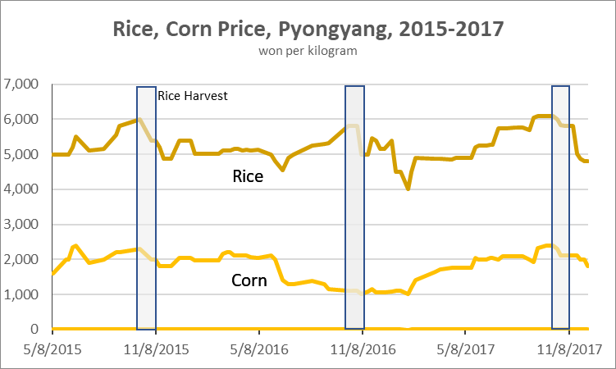
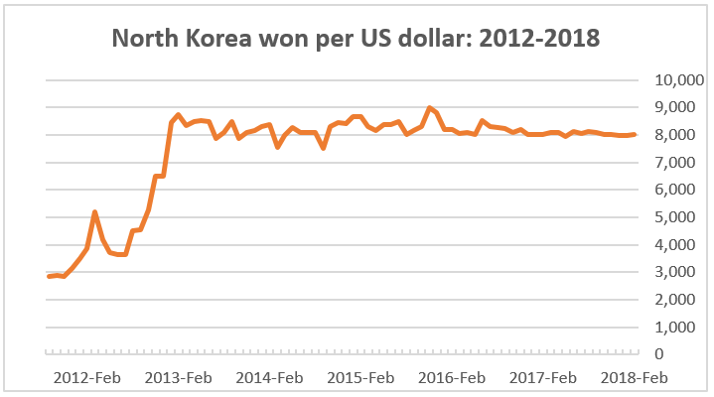
SOURCE: William Brown, North Korea’s Shackled Economy 2018, National Committee on North Korea Special Report, March 2018.

ANNEX 3: COMPOSITON OF EXTERNAL TRADE 2016

COMPOSITION OF IMPORTS 2016

Source: Observatory of Economic Complexity, Atlas media, MIT.

COMPOSITION OF EXPORTS 2016

Source: Observatory of Economic Complexity, Atlas media, MIT.

ANNEX 3: CONTINED

MINERALS AS A PERCENT OF ALL EXPORTS 2016

Source: Observatory of Economic Complexity, Atlas media, MIT.

ANNEX 4 – NORTH KOREA – CHINA TRADE AND FINANCE GAP

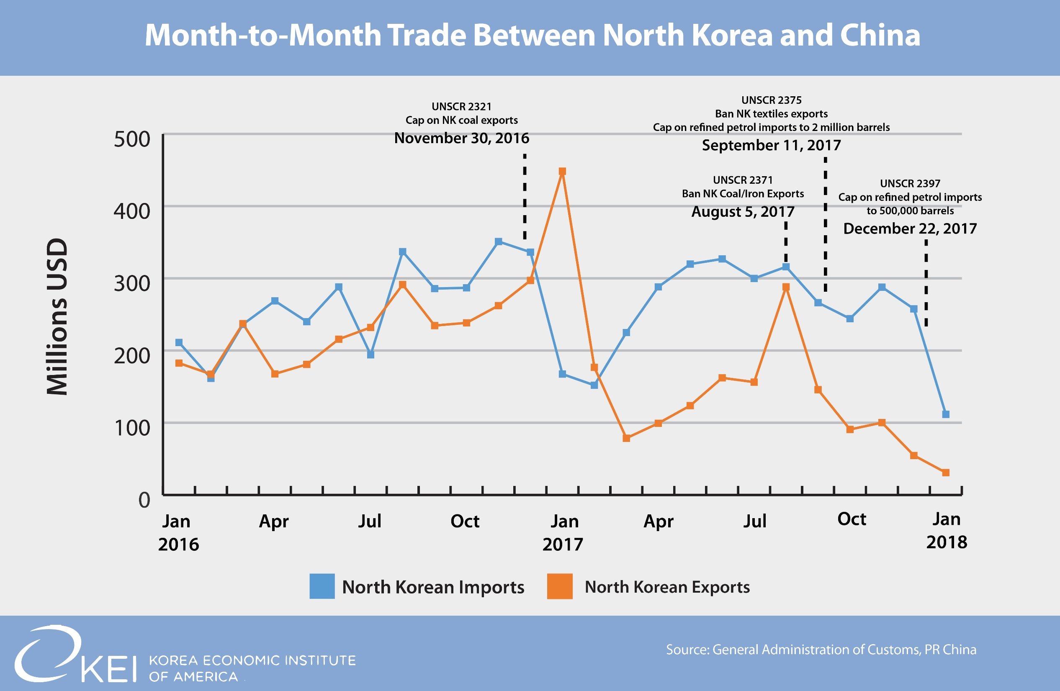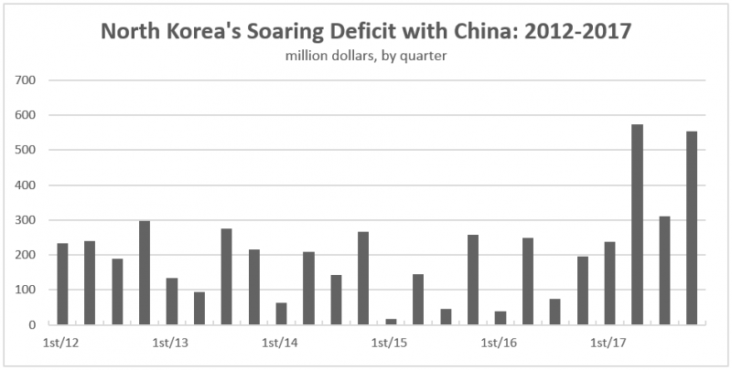

SOURCE: William Brown, North Korea’s Shackled Economy 2018, National Committee on North Korea Special Report, March 2018

Annex 5: SECTOR DISTRBUTION OF NORTH KOREA’S GDP IN 2016

SOURCE: BANK OF KOREA, 2017

SOURCE: CIA

ANNEX 6 – AGRICULRUAL PRODUCTION FOR FOOD SECURITY

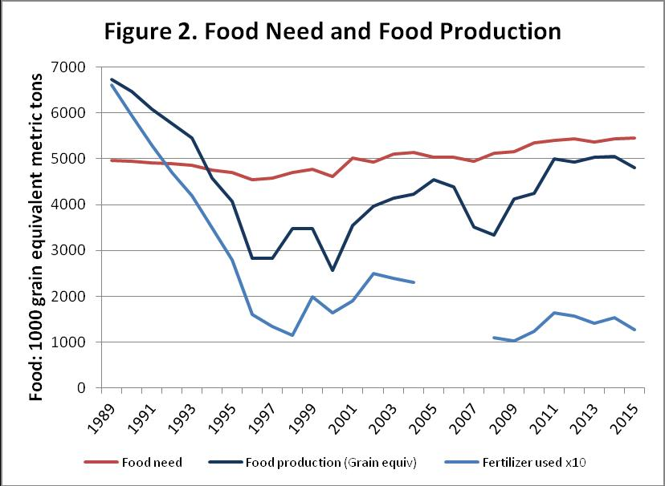

SOURCE: Randal Ireson, “Why Headlines About DPRK Agricultural Production Miss the Point,” 38 North, May 6, 2016.

ANNEX 7: MAJOR METHODS OF SANCTIONS EVASION

Networks and Front Companies

North Korean state trading companies have adapted to the changing eternal environment in pursuing both licit and illicit activities. Measures include:

- Hiring Chinese middlemen capable of handling financing, logistics, doing business with private Chinese firms and foreign firms operating in China;
- Taking up residence and embedding themselves in the Chinese mainland to increase effectiveness;
- Expanding the use of Hong Kong and Southeast Asia for regional commercial transfers; and
- Use of embassies as vehicles for procurement.

North Korean overseas networks are centralized around key commercial facilitators who act as control nodes across multiple networks. As their role in illicit activity is uncovered, they often create new webs of shell and front companies to continue operations.

China is the largest market exploited by North Korean overseas networks, yet this entire trading system has consisted of only 5,233 companies from 2013 to 2016. Top firms by revenue in this dataset not only play a disproportionately large role, they also have begun to consolidate among themselves.

Personal and institutional relationships are a critical aspect of the success of efforts to build and operate networks that facilitate North Korean commercial interests. The primary driver for the development of North Korean-run networks is the monetization of political relationships. The head of the private Chinese company, acting as the node of a network, has become adept at clearing a pathway of potential obstacles by buying the services of local law enforcement officers and politically connected officials. In a short period of time, these actors have become full-fledged partners in the network

An important evasion strategy is to convince foreign companies and governments that a North Korean partner is not North Korean. One method is to use front companies and foreign national facilitators to enable networks to appear Chinese, Russian, or Southeast Asia. Another is to use the word “Korean” in the country field in corporate registration paperwork that leads many corporate secretaries to record the registration as “South Korean.” A third method is to route goods through third countries to give governments the impression that they are not engaged in bilateral trade with North Korea.

Another evasion strategy is to establish elaborate corporate structures that mask North Korean involvement. This is done through the creation of multi-layer joint ventures that operate in multiple countries. Often joint venture partners are unaware of links to North Korea.

International Banking

Despite strengthened financial sanctions in 2016 and 2017, North Korea’s networks are adapting by using greater ingenuity in accessing formal banking channels, as well as bulk cash and gold transfers. North Korean banks maintain correspondent bank accounts and representative offices abroad and partner with foreign companies in joint ventures. Banks and designated entities make use of broad interwoven networks to undertake procurement and banking activity. Their ability to conceal financial activity by using foreign nationals and entities allows them to continue to transact through top global financial centers.

North Korean financial institutions maintain more than 30 overseas representatives who live and move freely across borders in the Middle East and Asia, where they control bank accounts, facilitate transactions and deal in bulk cash. Financial investigations highlight the activity of intelligence agents and other individuals acting on behalf of designated entities, operating bank accounts in Europe and the Asia-Pacific region and using diplomatic passports and diplomatic-plated cars to cross land and air borders with less scrutiny.

Collusion with Friendly States

Syria, Myanmar and Iran have continuing active economic relations with North Korea despite efforts to enforce sanctions on trade with these regimes also facing international sanctions. Other friendly countries notably Russia have been accused of deliberately facilitating sanctions evasion in ways that might be considered officially permitted collusion despite denials. Such collusion often is carried out by government agents or state-connected companies with historical ties to North Korea, such as the Myanmar Directorate of Defense Industries which is accused of procuring surface-to-air missiles, multiple rocket launchers and ballistic missile systems technology.

Abuse of Diplomatic Privileges

North Korean diplomats play a key role in the country’s prohibited programs, in particular, trade representatives and missions which provide logistical support for arms transfers, military technicians and intelligence operations, acting as fronts for designated entities and individuals and engaging in commercial activities that violate the UNSC sanctions and the Vienna Convention on Diplomatic Relations.

Oil

UNSC sanctions on crude and refined oil exports to North Korea in 2017 are largely dependent on compliance by China and Russia, and accurate reporting to the UNSC Sanctions Committee. Oil transfers from China have been divided between commercial transactions reported by Chinese customs and oil delivered directly by pipeline which is not included in customs declarations and where the exact volume and price are difficult to verify. Russia has been accused of recent increases in oil transfers beyond the limit set by UNSC sanctions by using shell companies linked to North Korean networks and falsification of documentation, but this also is hard to verify. Using small vessels that evade larger ship movement tracking technology is likely contributing to this uncertainty in illicit trade with both China and Russia.

Ship-to-ship oil transfers at sea is a method of evasion that is growing and claimed to involve trading networks based in Taiwan and probably other countries. These transfers sometimes occur at night to avoid detection and masking of physical ship identifiers to avoid a determination of culpability.

Coal and Iron

North Korea has successfully managed to evade coal and iron export sanctions in a number of ways. First, initial sanctions left an exception for exports that did not directly benefit the North Korean military. Since most iron is exported under Cabinet-controlled state enterprises and most coal is exported by enterprises managed at the local level with Chinese joint venture partners, it was not difficult to make the case for exclusion. Second, coal transfers through third counties, notably Russia, are increasing and facilitated by overseas North Korean networks (Taiwan) and employ practices such as trans-shipments, deceptive navigation, signals manipulation and falsification of documents. Even private importers from South Korea have managed to procure shipments of North Korean coal now only recently discovered. Third, Russia succeeded in obtaining an exception to UNSC sanctions for coal exports to the Rajin port in North Korea by rail, which Russia uses for transport by ship mainly to China. It appears that some North Korean coal is being exported on Chinese ships reported as Russian coal through this loophole.

Sanctioned ships for transporting North Korean coal have also recently been sighted at Chinese ports in defiance of sanctions, reflecting likely relaxation of sanctions enforcement by Chinese authorities.

Cross-Border Smuggling

Smuggling across the North Korea-China border is ongoing, despite tightened Chinese customs inspections and controls following the 2017 UNSC sanctions that significantly affected trade in textiles, seafood and refined petroleum products in addition to coal and iron. North Korean smugglers are focused on providing products that are in demand by their Chinese business partners, using ship transfers on the river and in the case of highly demanded fresh seafood, open transfer in daylight. Use of Chinese-owned ships has helped evade Chinese customs inspections with the rent for use of these boats influenced by the intensity of inspections by Chinese authorities. Recent reports are that customs inspections are being relaxed and these rents declining by about half.

Overseas Labor

North Korea sends citizens to work abroad under heavy surveillance and confiscates a major share of their wages. Many companies and individuals that employ North Korean workers are linked to activities that violate UNSC sanctions. For example, some companies that employ North Korean workers are registered as active joint ventures and cooperative entities, provide banking services to North Korean nationals, and have hired North Koreans to work on sensitive defense technologies including facial recognition software, insulated nanoceramics, and armor for military vehicles. North Koreans also work openly at local subsidiaries of companies sanctioned by both the United States and the United Nations for supporting North Korea’s missile program.

Firms that employ North Korean workers exhibit similar operational patterns across jurisdictions. Russian companies approved to hire North Korean workers exhibit decentralized corporate ownership structures but use common names and co-locate at a limited number of physical locations. There are 125 suspected North Korean restaurants around the world, more than two-thirds of which are in China. As in Russia, North Korean restaurants in China use common names and co-locate with other companies involved in an array of illicit commercial activities.

Despite trade restrictions, products of North Korean overseas labor—including advanced software and defense technology—continue to penetrate Western supply chains. North Korean forced laborers work overseas in sensitive industries that engage with research institutions, law enforcement bodies, and defense contractors in the United States and Europe. North Korea’s overseas workers have also used false identities and local intermediaries to sell sophisticated software products through online freelance marketplaces. North Korea continues to access critical technologies through its high-skilled overseas workers, who reportedly work in the same draconian conditions as their counterparts in low-skilled occupations.

Recent reports are that Russia is relaxing UNSC sanctions imposed in 2017 on overseas labor contracts by employing new North Korean laborers in a variety of occupations.

Material in this Annex is drawn from the following reports and recent press articles: - UN Panel of Experts Reports of February 27, 2017 and March 5, 2018. - C4ADS Reports: Risky Business, 2016; The Forex Effect, 2017; and Dispatched, 2018. - Angela Berger and Shea Cotton, Walls and Ladders: The Latest UN Panel of Experts Report on North Korea Sanctions, 2018. - John Park and Jim Walsh, Stopping North Korea Inc.: Sanctions Effectiveness and Unintended Consequences, 2016.

