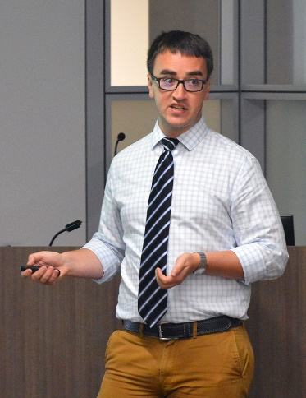
John K. Warden is a U.S. defense policy and strategy analyst at the Institute for Defense Analyses in Alexandria, Virginia. He focuses on deterrence and escalation, nuclear weapons and operations, U.S. alliances, and related issues. Mr. Warden previously worked at Science Applications International Corporation (SAIC), the Pacific Forum, and the Center for Strategic and International Studies (CSIS) and is the author or coauthor of many articles and reports on defense and foreign policy that have been published in The National Interest, Proceedings Magazine, Proliferation Papers, Survival, The Texas National Security Review, The Washington Quarterly, and War on the Rocks. Mr. Warden holds an M.A. in security studies from Georgetown University and a B.A. in political science and history from Northwestern University

