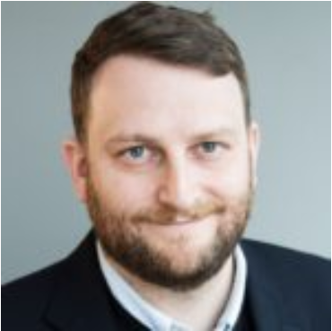
YUVAL WEBER, PH.D.

KENNAN INSTITUTE ASSOCIATE PROFESSOR OF RUSSIAN AND EURASIAN STUDIES

FULL TIME FACULTY

For Media Inquiries: newsroom@dmgs.org

Yuval Weber, Ph.D., is the Kennan Institute Associate Professor of Russian and Eurasian Studies and was the inaugural DMGS-Kennan Institute fellow.

Prior to joining the faculty at DMGS, Dr. Weber taught at Harvard University, where he was a Visiting Assistant Professor in the Department on Government and a Kathryn W. and Shelby Cullom Davis Research Fellow at the Davis Center for Russian and Eurasian Studies.

His first position was at the National Research University–Higher School of Economics, where he was an Assistant Professor in the Faculty of World Economy and International Affairs. He has additionally served as a researcher at the Carnegie Moscow Center and the New Economic School in Moscow and completed his post-graduate education at University of Chicago and University of Texas.

Dr. Weber is working on a project on the sources of liberal and anti-liberal dissatisfaction for powers in the international system and the strategies they employ to stake their claims for revising the international order. The first manuscript from that project is about the tension between demands of economic modernization and the security state in Russian political economy (Agenda/Columbia UP).

His work has appeared in Problems of Post-Communism, International Studies Review, Survival, Cold War Studies, Orbis, and the Washington Post.

