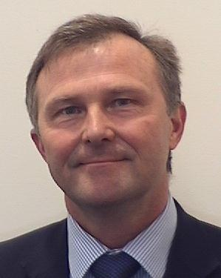

Colonel Joachim Isacsson
Colonel Joachim Isacsson is a Swedish Marine (artillery) with 35 years of military service. He has been posted to the UK MOD Development, Concepts and Doctrine Centre in Shrivenham since June 2013, where he is Deputy Assistant Head of DCDC Futures and the Global Strategic Trends Programme.
Joachim is a graduate from the Swedish National Defence University in Stockholm and has studied international relations and security policy at the Geneva Centre for Security Policy in Switzerland.
Joachim spent the first decade of his career as a soldier, Platoon, Company and Battalion commander in the Swedish Marines. He has also had a number of senior staff appointments in the Swedish Defence Staff and internationally, served as advisor to the Latvian Defence Staff, as well as Senior Lecturer in Strategic Studies at the Swedish Defence University.
He has experience from a number of military operations and Peace Support Operations training programs. Last year he spent some time as DCDC guest researcher to the Japanese MOD National Institute for Defence Studies.
Joachim is married and has four children. His favourite interests are military history and trekking.

