David B. Des Roches
david.desroches@ndu.edu
(202)256-1871
http://www.facebook.com/dbdesroches
Twitter: @dbdesroches

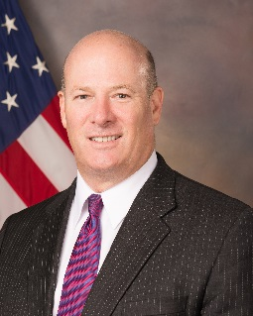

David B. Des Roches is Associate Professor at the Near East South Asia Center for Strategic Studies (NESA) at National Defense University, where he specializes in countries of the Arabian Peninsula, Gulf Cooperation Council Regional Security, Border Security, Weapons Transfers, Missile Defense, Counterinsurgency, Terrorism and emerging trends.

He joined NESA in 2011 after serving the Office of the Secretary of Defense for Policy in numerous positions, including as Director of the Gulf and Arabian Peninsula, the DoD liaison to the Department of Homeland Security, the Senior Country Director for Pakistan, the NATO Operations Director (where he drafted the NATO comprehensive approach directive), the Deputy Director for Peacekeeping, and the spokesman for the Defense Security Cooperation Agency. Prior to that, he served in the White House Office of National Drug Control Policy as an International Law Enforcement Analyst and Special Assistant for Strategy.

Professor Des Roches has lectured at the Qatari Staff College, the Saudi War College, and is the author of numerous articles and chapters on Gulf security. He is the editor of The Arms Trade, Military Services and the Security Market in the Gulf: Trends and Implications (Berlin: Gerlach, 2016), and a contributing author of the NATO curriculum on counterinsurgency (http://www.nato.int/nato_static_fl2014/assets/pdf/pdf_2017_09/20170904_1709-counterinsurgency-rc.pdf). He regularly presents at various Washington and international think tanks on Middle East issues.

Professor Des Roches holds advanced degrees from the University of London School of Oriental and African Studies and Kings College London, which he attended as a British Marshall Scholar. He also holds an advanced degree from the U.S. Army War College, and a bachelor of science degree from the United States Military Academy, West Point, where he was selected to Phi Kappa Phi. He is a non-resident academic fellow at the Arab Gulf States Institute in Washington, and senior international affairs fellow at the National Council on US Arab Relations.

Professor Des Roches is a regular commentator on regional affairs on various Arabic and English language television networks including Sky News Arabia, al-Hurra, al-Jazeera, al-Araby, and al-Mayadeen, and on radio networks such as the Voice of America.

