Michael Beckley Bio
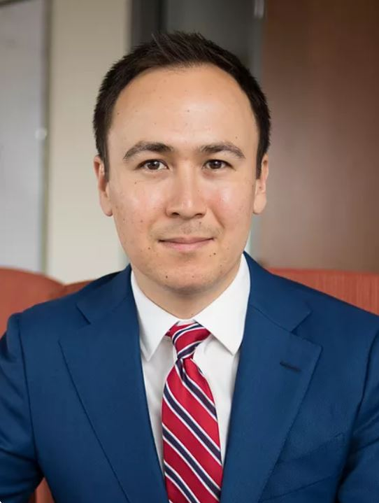
Michael Beckley is an assistant professor of political science at Tufts University and an associate at the Belfer Center for Science and International Affairs at Harvard's Kennedy School of Government.

His research focuses on the rise and fall of great powers and has been featured in numerous academic journals and popular media, including Axios, CNN, the Financial Times, Foreign Affairs, Foreign Policy, Fox News, the New York Times, NPR, the Washington Post, and Vox.

Previously, Michael worked for the U.S. Department of Defense, the RAND Corporation, and the Carnegie Endowment for International Peace. He holds a Ph.D. in political science from Columbia University.

https://www.michaelbeckley.org/about

