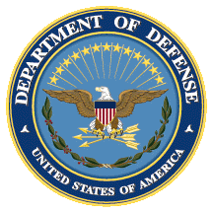
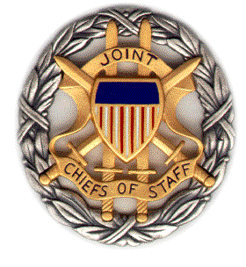

SMA White Paper
Panel Discussion

AI, China, Russia and the Global Order:
What is Happening in China and Russia, and What Impacts Does This Have Abroad?

Booklet
12 February 2019
1030-1200 ET

Dial (866) 712-4038;
Passcode 37250264#

Strategic Multi-Layer Assessment (SMA) provides planning support to Commands with complex operational imperatives requiring multi-agency, multi-disciplinary solutions that are NOT within core Service/Agency competency. Solutions and participants are sought across USG and beyond. SMA is accepted and synchronized by Joint Staff/J-39 DDGO and executed by ASD (EC&P).

Agenda

Panel Description: On 12 February 2019 from 1030-1200 ET, SMA will convene a panel discussion focused on important dimensions of its recently-released white paper, entitled “AI, China, Russia, and the Global Order: Technological, Political, Global, and Creative Perspectives.”

Specifically, in this panel we ask: What is happening in China and Russia, and what impacts does this have abroad?

A brief description of the white paper:

“Artificial Intelligence (AI) and big data promise to help reshape the global order. For decades, most political observers believed that liberal democracy offered the only plausible future pathways for big, industrially sophisticated countries to make their citizens rich. Now, by allowing governments to monitor, understand, and control their citizens far more effectively than ever before, AI offers a plausible way for big, economically advanced countries to make their citizens rich while maintaining control over them—the first since the end of the Cold War. Just as competition between liberal democratic, fascist, and communist social systems defined much of the twentieth century, how may the struggle between digital liberal democracy and digital authoritarianism define and shape the twenty-first?

This report focuses on the emerging Chinese and Russian models and how they will interact with the global order. It brings together deep expertise on China, Russia, strategy and technology—as well as artists to provide illuminating sidelights.”

Speakers: The speakers for this discussion will include:

- Ms. Shazeda Ahmed (University of California, Berkeley)
- Mr. Samuel Bendett (CNA)
- Dr. Rogier Creemers (Leiden University)
- Ms. Rachel Esplin Odell (Massachusetts Institute of Technology)
- Mr. Robert Morgus (New America)
- Mr. Valentin Weber (Oxford University)
- Dr. Nicholas Wright (Intelligent Biology)- moderator

Agenda: The following is an outline of the contents that each panelist will present during the discussion:

- Ms. Shazeda Ahmed (University of California, Berkeley)
  - Credit Cities and the Limits of the Social Credit System
- Mr. Samuel Bendett (CNA)
  - The Development of Artificial Intelligence in Russia
- Dr. Rogier Creemers (Leiden University)
  - The International and Foreign Policy Impact of China’s AI and Big Data Strategies
- Ms. Rachel Esplin Odell (Massachusetts Institute of Technology)
  - Chinese Regime Insecurity, Domestic Authoritarianism, and Foreign Policy
- Mr. Robert Morgus (New America)
  - The Spread of Russia’s Digital Authoritarianism
- Mr. Valentin Weber (Oxford University)
  - Understanding the Global Ramifications of China’s Information Controls Model

Speaker Biographies

Ms. Shazeda Ahmed (University of California, Berkeley)

Shazeda Ahmed is a PhD student at the University of California- Berkeley's School of Information. She has previously worked as a researcher for the U.S. Naval War College, Citizen Lab, the Mercator Institute for China Studies, and the Ranking Digital Rights corporate transparency review by New America. In the 2018-19 academic year she will be a Peking University-based Fulbright fellow researching public-private partnerships in the development of China's social credit system.

Mr. Samuel Bendett (CNA)

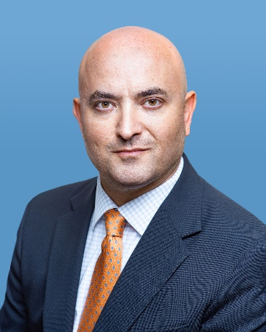
Samuel Bendett is a Research Analyst with the Center for Naval Analyses' Adversary Analysis Group, where he is a member of the Russia Studies Program. His work involves research on the Russian defense and technology developments, such as Russian naval and land capabilities, unmanned military systems and artificial intelligence, and Russian decision-making calculus during military crises. He is also a member of CNA’s Center for Autonomy and Artificial Intelligence.
Prior to joining CNA, Mr. Bendett worked at the National Defense University on emerging and disruptive technologies for government response in crisis situation, where he conducted research on behalf of the Office of the Secretary of Defense for Policy (OSD-P) and Acquisition, Technology and Logistics (OSD-AT&L). His previous experience includes working for US Congress, private sector and non-profit organizations on foreign policy, international conflict resolution, defense and security issues.
Samuel is also a Fellow in Russia Studies at the American Foreign Policy Council, where he conducts research on the Russian unmanned military systems and artificial intelligence.
Mr. Bendett’s analyses, views and commentary on Russian military robotics, unmanned systems and artificial intelligence capabilities appear regularly in the C4ISRnet, DefenseOne, Breaking Defense, The National Interest, War Is Boring, and The Strategy Bridge. He was also a foreign policy and international affairs contributor to the RealClearWorld.com blog, writing on Russian military technology. Samuel Bendett received his M.A. in Law and Diplomacy from the Fletcher School, Tufts University and B.A. in Politics and English from Brandeis University. He has native fluency in Russian.

Dr. Rogier Creemers (Leiden University)

Rogier Creemers is an Assistant Professor in the Law and Governance of China at Leiden University. He holds Master degrees in China Studies and International Relations, and a Doctorate in Law. His research investigates China’s domestic technology policies, as well as China’s participation in global cyber affairs. His work has been published, amongst others, in The China Journal and the Journal of Contemporary China. He is the leader of two major projects funded by the Dutch Organization for Scientific Research and the Ministry of Foreign Affairs. He is also a founding member of DigiChina, a project run in cooperation with New America, as well as a frequent contributor to international news media.

Ms. Rachel Esplin Odell (Massachusetts Institute of Technology)

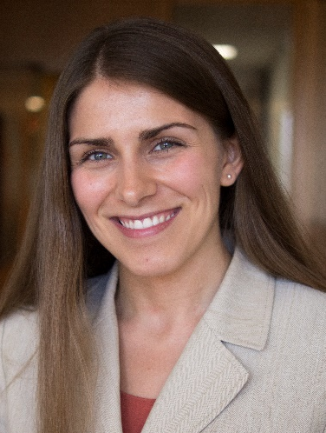
Rachel Esplin Odell is a PhD candidate in Political Science at the Massachusetts Institute of Technology and a member of the MIT Security Studies Program. Her research focuses on the nature and future of world order; U.S. strategy in the Asia-Pacific region; Chinese foreign policy, civil-military relations, and crisis management behavior; and Sino-U.S. and Sino-Japanese relations. Her dissertation studies the causes and consequences of disagreements among states over how to interpret international law, with a focus on the international law of the sea.
Odell is a recipient of the National Science Foundation Graduate Research Fellowship, the Smith Richardson Foundation World Politics and Statecraft Fellowship, and the Alexander George Award for Best Graduate Student Paper from the Foreign Policy Analysis Section of the International Studies Association. She was a Visiting Research Fellow in the Graduate School of Asia-Pacific Studies at Waseda University in November 2017. Odell is also a Nonresident Research Analyst at the Carnegie Endowment for International Peace, where she worked before coming to MIT. She holds an AB summa cum laude in East Asian Studies with a secondary field in Government from Harvard University.

Mr. Robert Morgus (New America)

Robert Morgus is a senior policy analyst and the Deputy Director with New America's Cybersecurity Initiative. His current work focuses on the intersection of global competition and technology, with particular focus on Russian internet doctrine and cybersecurity in the developing world. He holds a Bachelors of Arts from Occidental College in Diplomacy and World Affairs and is proficient in five languages.

Mr. Valentin Weber (Oxford University)

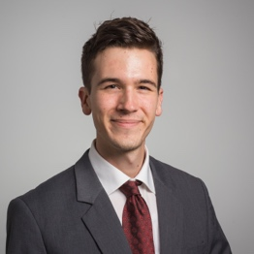
Valentin Weber is a DPhil Candidate in Cyber Security at the Centre for Doctoral Training in Cyber Security and a Research Affiliate with the Centre for Technology and Global Affairs, University of Oxford. He is also an OTF Senior Fellow in Information Controls at the Berkman Klein Center for Internet & Society, Harvard University. Valentin is interested in how the cyber domain is changing conflicts and state strategies. His current research focuses on the integration of cyber and grand strategy, as well as on the role of information controls in state strategies. He previously worked for the International Security Department at Chatham House.

Dr. Nicholas D. Wright (Intelligent Biology)

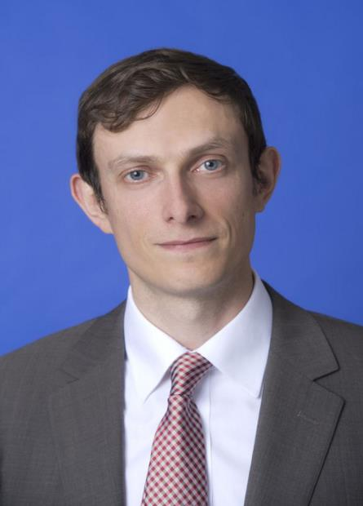
Dr Nicholas Wright is an affiliated scholar at Georgetown University, honorary research associate at University College London (UCL), Consultant at Intelligent Biology and Fellow at New America. His work combines neuroscientific, behavioural and technological insights to understand decision-making in politics and international confrontations, in ways practically applicable to policy. He leads international, interdisciplinary projects with collaborators in countries including China, the U.S., Iran and the UK. He was an Associate in the Nuclear Policy Program, Carnegie Endowment for International Peace, Washington DC and a Senior Research Fellow in International Relations at the University of Birmingham, UK. He has conducted work for the UK Government and U.S. Department of Defense. Before this he examined decision-making using functional brain imaging at UCL and in the Department of Government at the London School of Economics. He was a clinical neurologist in Oxford and at the National Hospital for Neurology. He has published academically (some twenty publications, e.g. Proceedings of the Royal Society), in general publications such as the Atlantic and Foreign Affairs, with the Pentagon Joint Staff (see www.nicholasdwright.com/publications) and has appeared on the BBC and CNN.
Wright received a medical degree from UCL, a BSc in Health Policy from Imperial College London, has Membership of the Royal College of Physicians (UK), has an MSc in Neuroscience and a PhD in Neuroscience both from UCL.

