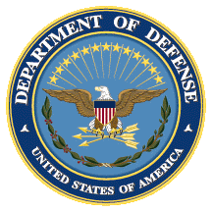
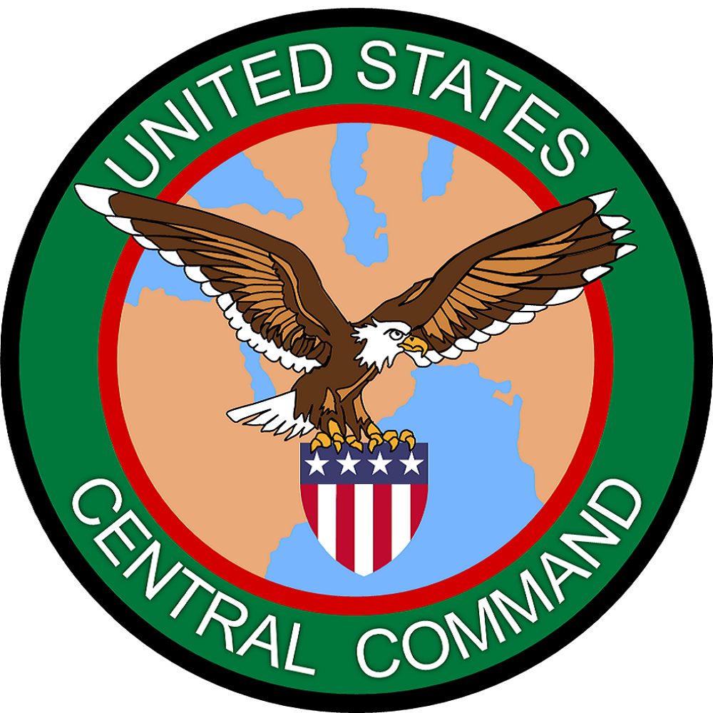
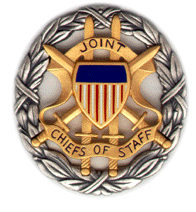

SMA CENTCOM (Afghanistan) Panel Discussion

Negotiated Settlement in Afghanistan: Elements of a Grand Bargain

In Support of US CENTCOM

Booklet
11 February 2019
1400-1530 ET

Dial (866) 712-4038;
Passcode 37250264#

Strategic Multi-Layer Assessment (SMA) provides planning support to Commands with complex operational imperatives requiring multi-agency, multi-disciplinary solutions that are NOT within core Service/Agency competency. Solutions and participants are sought across USG and beyond. SMA is accepted and synchronized by Joint Staff/J-39 DDGO and executed by ASD (EC&P).

Agenda

Panel Description: On 11 February 2019 from 1400-1530 ET, SMA will convene a panel discussion highlighting findings from its recently released periodic paper entitled, “Negotiated Settlement in Afghanistan: Elements of a Grand Bargain.” The paper suggests that it is not yet clear whether reconciliation in Afghanistan is possible. But what has become increasingly clear is that certain critical elements must be addressed and overcome before any semblance of long-term stability in Afghanistan can emerge. This report contextualizes the current pressure towards reconciliation in terms of what Afghans want, breaks down essential elements of a negotiated settlement into its component parts, and looks at spoilers that will make the process particularly challenging.

This report does not seek to establish the ground truth from an objective perspective—such an effort is not possible in the context of competing interests of stakeholders both inside and out of Afghanistan. Instead, it seeks insights from leading experts from a variety of viewpoints that hopefully lead to a more nuanced understanding of the critical paths and roadblocks to a grand bargain in Afghanistan.

Speakers: The speakers for this discussion will include:

Mr. James Krakar (TRADOC G27, Modeling & Simulation Branch, Athena Team)
Dr. Karl Kaltenthaler (University of Akron & Case Western Reserve University)
Mr. Vern Liebl (US Marine Corps University, Center for Advanced Operational and Culture Learning)
Mr. Michael Logan (University of Nebraska at Omaha)
Dr. Craig Whiteside (Naval Postgraduate School)

*Please note that due to scheduling difficulties, two of the authors (Mr. Sher Jan Ahmadzai (University of Nebraska at Omaha) & Dr. Thomas Barfield (Boston University)) will be presenting their findings at the panel discussion on 15 February 2019 from 1030-1200 ET.

Other paper authors who could not attend this session include LTG (ret.) Daniel Bolger (North Carolina State University), Dr. Raffaello Pantucci (RUSI), Dr. Barnett Rubin (New York University), and Dr. Homayun Sidky (Miami University). If you have questions for any of these authors, please contact Ms. Sarah Canna at scanna@nsiteam.com.

Speaker Biographies

Mr. James Krakar (TRADOC G27)
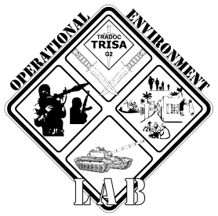
The Athena Study Team is a part of the US Army Training and Doctrine Command G-27. Athena is a decision support tool designed to increase a commander’s understanding of the effect of PMESII-PT variables (Political, Military, Economic, Social, Infrastructure, Information, Physical Environment, and Time) on a given area over time.

Athena models DIME-FIL (Diplomatic, Information, Military, Economic, Financial, Intelligence, and Law Enforcement, all elements of national power) interventions within a PMESII-PT context to enable a user to anticipate second- and third-order effects upon noncombatant groups, force groups, government and non-government actors. The primary outputs of Athena are trend lines that indicate changes in non-combatant populations' mood, the level of volatility and stability within a discrete area, control over an area, and the relationships between civilian groups, force groups, government and non-government actors.

Dr. Karl Kaltenthaler (University of Akron & Case Western Reserve University)

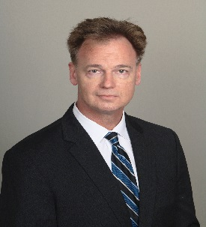
Karl Kaltenthaler is Professor of Political Science at the University of Akron and Case Western Reserve University. His research and teaching focuses on security policy, political violence, political psychology, public opinion and political behavior, violent Islamist extremism, terrorism, and counterterrorism. He has worked on multiple research studies in Afghanistan, Bangladesh, Iran, Iraq, Kazakhstan, Kyrgyzstan, Pakistan, Syria, Tajikistan, and the United States. He is currently researching the radicalization and recruitment process into Islamist violent extremism in different environments as well as ways to counter this process (Countering Violent Extremism). His work has resulted in academic publications and presentations as well as analytic reports and briefings for the US government. He has consulted for the FBI, the US State Department, the US Intelligence Community and the US military. His research has been published in three books, multiple book chapters, as well as articles in International Studies Quarterly, Political Science Quarterly, Studies in Conflict and Terrorism, as well as other several other journals.

Mr. Vern Liebl (Center for Advanced Operational Culture Learning)
Vernie Liebl is an analyst currently sitting as the Middle East Desk Officer in the Center for Advanced Operational Culture Learning (CAOCL). Mr. Liebl retired from the Marine Corps and has a background in intelligence, specifically focused on the Middle East and South Asia.
Prior to joining CAOCL, Mr. Liebl worked with the Joint Improvised Explosives Device Defeat Organization as a Cultural SME, and before that with Booz Allen Hamilton as a Strategic Islamic Narrative Analyst. He has also published extensively on topics ranging from the Caliphate to Vichy French campaigns in WW2.
Mr. Liebl has a Bachelors degree in political science from University of Oregon, a Masters degree in Islamic History from the University of Utah, and a second Masters degree in National Security and Strategic Studies from the Naval War College (where he graduated with “Highest Distinction” and focused on Islamic Economics).

Mr. Michael Logan (University of Nebraska at Omaha)

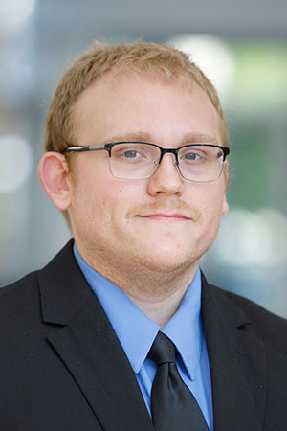
Michael Logan is a doctoral candidate in the School of Criminology and Criminal Justice at the University of Nebraska at Omaha and a research associate at the Center for Collaboration Science. He holds a master’s degree in criminal justice from Radford University and a bachelor’s degree in criminology from Lynchburg College. His research interests focus on violence, violent extremism, criminal decision-making and expertise, malevolent creative and innovation, and leadership in violent ideological organizations.

Dr. Craig Whiteside (Naval Postgraduate School)

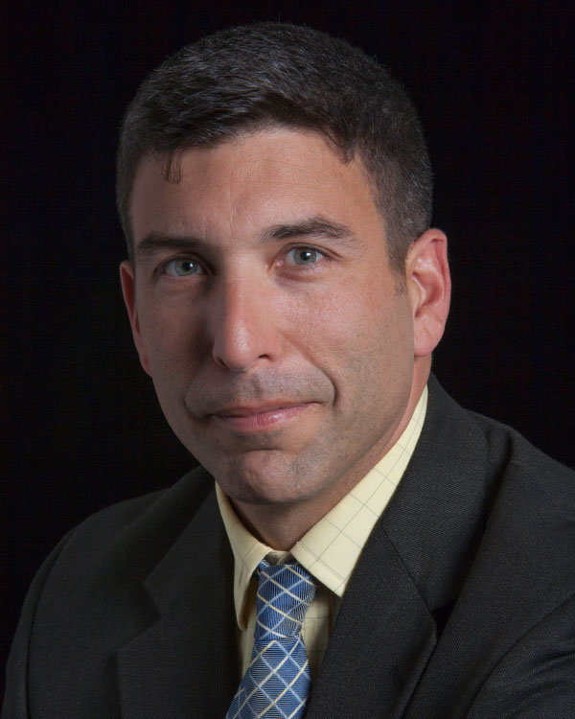
Craig Whiteside is an associate professor at the Naval War College at the Naval Postgraduate School, where he teaches national security affairs to military officers. He has a PhD in political science and has published extensively on the Islamic State in War on the Rocks, Small Wars and Insurgencies, Perspectives on Terrorism, and for the ICCT-The Hague where he is an associate fellow. His latest publication is “Nine Bullets for the Traitors, One for the Enemy: Slogans and Strategies of the Islamic State’s campaign to defeat the Sahwa (2006-2017),” ICCT (September 2018).

