Lt Col Dave Lyle, USAF
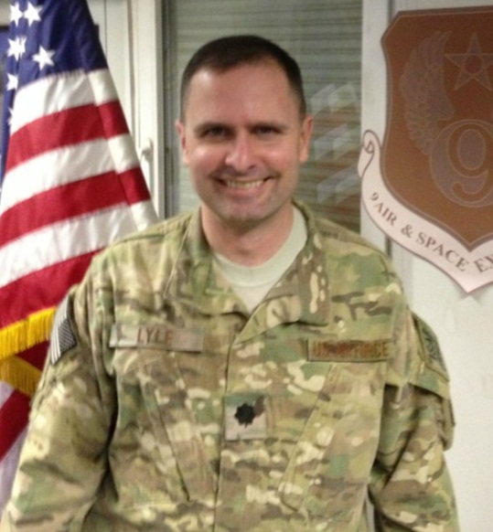
Lieutenant Colonel David J. Lyle (BS in Humanities, USAFA; MBA, Louisiana Tech; MMAS, US Army Command and General Staff College; MAAS, School of Advanced Air and Space Studies) is an Air Education and Training Command (AETC) and Air University liaison in the National Capital Region, currently stationed in the Pentagon. He has served in various strategy and operational planning assignments, including as the Director for the Combined Personnel Recovery Center for Afghanistan, Deputy Director of Strategy & Concepts/Warfighting Education at Air University, the A-5 (Strategic Plans) of the 9th Air and Space Expeditionary Task Force–Afghanistan in Kabul; director of staff for the 505th Command and Control Wing, Hurlburt Field, Florida, and has served on numerous joint air component coordination element (JACCE) assignments. Lt Col Lyle is an Air Operations Center initial qualification honor graduate and Command and Control Warrior Advanced Course graduate, holding US Army qualifications as a joint planner and distinguished master strategist. A master navigator with more than 2,400 flying hours in the B-52H, Lieutenant Colonel Lyle flew 43 combat missions over Kosovo and Afghanistan.

