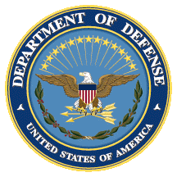
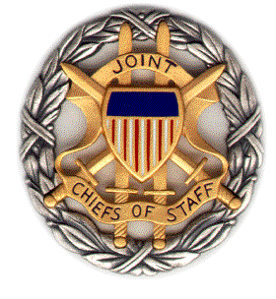

SMA White Paper
Panel Discussion

AI, China, Russia and the Global Order:
Chinese and Russian Domestic AI, Relative Power, and Military Dimensions

Booklet
7 March 2019
1200-1330 ET

Dial (866) 712-4038;
Passcode 37250264#

Strategic Multi-Layer Assessment (SMA) provides planning support to Commands with complex operational imperatives requiring multi-agency, multi-disciplinary solutions that are NOT within core Service/Agency competency. Solutions and participants are sought across USG and beyond. SMA is accepted and synchronized by Joint Staff/J-39 DDGO and executed by ASD (EC&P).

Agenda

Panel Description: On 7 March 2019 from 1200-1330 ET, SMA will convene a panel discussion focused on important dimensions of its recently-released white paper, entitled “AI, China, Russia, and the Global Order: Technological, Political, Global, and Creative Perspectives.”

Specifically, in this panel we ask: What is happening within China and Russia with AI; how might this affect relative power in the international system; and what are the military implications of AI in China and more broadly?

A brief description of the white paper:

“Artificial Intelligence (AI) and big data promise to help reshape the global order. For decades, most political observers believed that liberal democracy offered the only plausible future pathways for big, industrially sophisticated countries to make their citizens rich. Now, by allowing governments to monitor, understand, and control their citizens far more effectively than ever before, AI offers a plausible way for big, economically advanced countries to make their citizens rich while maintaining control over them—the first since the end of the Cold War. Just as competition between liberal democratic, fascist, and communist social systems defined much of the twentieth century, how may the struggle between digital liberal democracy and digital authoritarianism define and shape the twenty-first?

This report focuses on the emerging Chinese and Russian models and how they will interact with the global order. It brings together deep expertise on China, Russia, strategy and technology—as well as artists to provide illuminating sidelights.”

Speakers: The speakers for this discussion will include:

- Ms. Elsa Kania (Center for a New American Security (CNAS))
- Dr. Samantha Hoffman (Mercator Institute for China Studies (MERICS))
- Dr. Jaclyn Kerr (Lawrence Livermore National Laboratory (LLNL))
- Dr. James Lewis (Center for Strategic and International Studies (CSIS))
- Dr. Martin Libicki (US Naval Academy (USNA))
- Dr. Herbert Lin (Stanford University)
- Dr. Lora Saalman (EastWest Institute)
- Dr. Nicholas Wright (Intelligent Biology)- moderator

Agenda: The following is an outline of the contents that each panelist will present during the discussion:

- Ms. Elsa Kania (Center for a New American Security (CNAS))
  - Artificial Intelligence in Future Chinese Command Decision-Making
- Dr. Samantha Hoffman (Mercator Institute for China Studies (MERICS))
  - Managing the State: Social Credit, Surveillance and the CCP’s Plan for China
- Dr. Jaclyn Kerr (Lawrence Livermore National Laboratory (LLNL))
  - The Russian Model of Digital Control and Its Significance
- Dr. James Lewis (Center for Strategic and International Studies (CSIS))
  - AI and China's Unstoppable Global Rise: A Skeptical Look
- Dr. Martin Libicki (US Naval Academy (USNA))
  - A Hacker Way of Warfare
- Dr. Herbert Lin (Stanford University)
  - Escalation Risks in an AI-Infused World
- Dr. Lora Saalman (EastWest Institute)
  - China’s Integration of Neural Networks into Hypersonic Glide Vehicles

Speaker Biographies

Dr. Samantha Hoffman (Australian Strategic Policy Institute)

Samantha Hoffman is a Non-Resident Fellow at the Australian Strategic Policy Institute’s International Cyber Policy Centre and aVisiting Academic Fellow, Mercator Institute for China Studies (MERICS). Her research is focused on Chinese state security policy and social management. She holds a PhD in Politics and International Relations from the University of Nottingham (2017), and an MSc in Modern Chinese Studies from the University of Oxford (2011), and BA degrees in International Affairs and East Asian Languages and Cultures from the Florida State University (2010).

Ms. Elsa Kania (Center for a New American Security (CNAS))

Elsa B. Kania is an Adjunct Senior Fellow with the Technology and National Security Program at the Center for a New American Security (CNAS). Her research focuses on Chinese military innovation and technological development. At CNAS, she contributes to the Artificial Intelligence and Global Security Initiative, while also acting as a member of the research team for the Task Force on Artificial Intelligence and National Security. Elsa is a co-founder of the China Cyber and Intelligence Studies Institute, and she was a 2018 Fulbright Specialist and is a Non-Resident Fellow with the Australian Strategic Policy Institute’s International Cyber Policy Centre. She works in support of the U.S. Air Force’s China Aerospace Studies Institute through its Associates Program, serves as a Policy Advisor for the non-profit Technology for Global Security, and contributes to the Party Watch Initiative of the Center for Advanced China Research. Elsa has been invited to testify before the House Permanent Select Committee on Intelligence and the U.S.-China Economic and Security Review Commission. She has been named an official “Mad Scientist” by the U.S. Army’s Training and Doctrine Command.
Currently, Elsa is a PhD student in Harvard University's Department of Government, and she is also a graduate of Harvard College (summa cum laude, Phi Beta Kappa). Her thesis was awarded the James Gordon Bennett Prize, and her dissertation will examine Chinese military learning and innovation in historical perspective. Her prior professional experience includes time with FireEye, the Department of Defense, Long Term Strategy Group, and the Carnegie-Tsinghua Center for Global Policy. While at Harvard, she has also worked as a research assistant at the Belfer Center and the Weatherhead Center. Elsa was a Boren Scholar in Beijing, China, and she has professional proficiency in Mandarin Chinese

Dr. Jaclyn Kerr (Lawrence Livermore National Laboratory (LLNL)

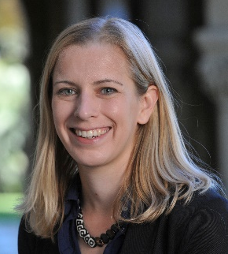
Jaclyn Kerr is a Postdoctoral Research Fellow at the Center for Global Security Research (CGSR) at Lawrence Livermore National Laboratory. She is also an Affiliate at the Center for International Security and Cooperation (CISAC) at Stanford University, and a New America Foundation Cybersecurity Policy Fellow. Her research focuses on the politics of cybersecurity, information warfare, and Internet governance, with a particular focus on the evolving approaches to Internet control within non-democratic and democratic countries and their repercussions, and on the changing international dynamics of cyber- and informational conflict. She completed her dissertation, Authoritarian Management of (Cyber-)Society: Internet Regulation and the New Political Protest Movements, at Georgetown University’s Department of Government in 2016 and is currently working on a related book project. While writing her dissertation, Jackie held predoctoral cybersecurity policy fellowships at Stanford’s CISAC, Harvard’s Belfer Center for Science and International Affairs, and was a visiting scholar at Harvard’s Davis Center for Russian and Eurasian Studies. She has held research fellowships in Russia, Kazakhstan, and Qatar, and has previous professional experience as a software engineer. Jackie holds a PhD and MA in Government from Georgetown University, and an MA in Russian, East European, and Eurasian Studies and a BAS in Mathematics and Slavic Languages and Literatures from Stanford University.

Dr. James Lewis (Center for Strategic and International Studies (CSIS))

James A. Lewis is a Senior Vice President and Program Director at CSIS where he writes on international affairs and technology. Before joining CSIS, he worked at the Departments of State and Commerce as a Foreign Service Officer and as a member of the Senior Executive Service. His government experience includes work on a range of politico-military and intelligence-related issues. Dr. Lewis led the US delegation to the Wassenaar Arrangement Experts Group on advanced civil and military technologies. He was assigned to US Southern Command and US Central Command. He has authored numerous publications since coming to CSIS, including the bestselling "Cybersecurity for the 44th Presidency," and is an internationally recognized expert on cybersecurity. Dr. Lewis was the Rapporteur for the UN's 2010, 2013 and 2015 Group of Government Experts on Information Security and has led a long running Track II Dialogue on cybersecurity with the China Institutes of Contemporary International Relations. He received his Ph.D. from the University of Chicago.

Dr. Martin Libicki (US Naval Academy (USNA))

Martin Libicki (Ph.D., U.C. Berkeley 1978) holds the Keyser Chair of Cybersecurity Studies at the U.S. Naval Academy. In addition to teaching, he carries out research in cyberwar and the general impact of information technology on domestic and national security. He is the author of a 2016 textbook on cyberwar, Cyberspace in Peace and War, as well as Conquest in Cyberspace: National Security and Information Warfare and various related RAND monographs. Prior employment includes twelve years at the National Defense University, three years on the Navy Staff (logistics) and three years for the US GAO.

Dr. Herbert Lin (Stanford University)

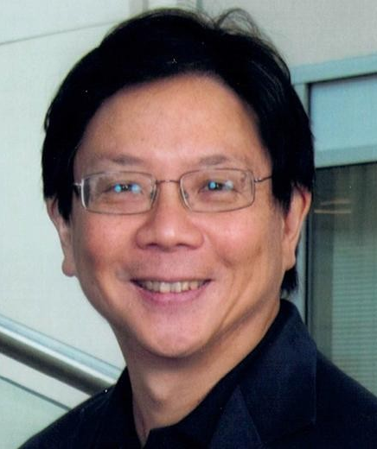
Herbert Lin is senior research scholar for cyber policy and security at the Center for International Security and Cooperation and Hank J. Holland Fellow in Cyber Policy and Security at the Hoover Institution, both at Stanford University. His research interests relate broadly to policy-related dimensions of cybersecurity and cyberspace, and he is particularly interested in the use of offensive operations in cyberspace as instruments of national policy and in the security dimensions of information warfare and influence operations on national security. In addition to his positions at Stanford University, he is Chief Scientist, Emeritus for the Computer Science and Telecommunications Board, National Research Council (NRC) of the National Academies, where he served from 1990 through 2014 as study director of major projects on public policy and information technology, and Adjunct Senior Research Scholar and Senior Fellow in Cybersecurity (not in residence) at the Saltzman Institute for War and Peace Studies in the School for International and Public Affairs at Columbia University; and a member of the Science and Security Board of the Bulletin of Atomic Scientists. In 2016, he served on President Obama’s Commission on Enhancing National Cybersecurity. Prior to his NRC service, he was a professional staff member and staff scientist for the House Armed Services Committee (1986-1990), where his portfolio included defense policy and arms control issues. He received his doctorate in physics from MIT.

Dr. Lora Saalman (EastWest Institute)

Dr. Lora Saalman is Vice President of the EastWest Institute's Asia-Pacific Program. She previously served as the director of the China and Global Security Program at the Stockholm International Peace Research Institute and continues to maintain an affiliation as an Associate Senior Fellow, contributing to work on China-Russia-U.S. relations and cyber deterrence, Chinese views on the Ukraine crisis, Chinese and Russian hypersonic glide developments, as well as the impact of machine learning and autonomy on nuclear risk in East Asia.

From 2013-2016, Dr. Saalman worked as an associate professor at the Daniel K. Inouye Asia-Pacific Center for Security Studies, where she covered cybersecurity issues and underwent training at the SANS Institute on hacker tools, exploits and incident handling, as well as ICS/SCADA security essentials. From 2010-2013, she was an associate in the Nuclear Policy Program of the Carnegie Endowment for International Peace and based at the Carnegie-Tsinghua Center for Global Policy in Beijing, China and served as an adjunct professor at Tsinghua University teaching courses in Chinese and English.

From 2003-2006, Dr. Saalman worked as a research associate at the Wisconsin Project on Nuclear Arms Control in Washington, D.C., as well as a visiting fellow at the Observer Research Foundation in New Delhi and the James Martin Center for Nonproliferation Studies (CNS) in Washington, D.C. While at CNS, she earned a one-year fellowship to work at the Division of Safeguards Information Technology at the International Atomic Energy Agency. She earned her B.A. with honors from the University of Chicago in 1995, her M.A. with a certificate in nonproliferation from the Monterey Institute of International Studies in 2004, and her Ph.D. from Tsinghua University in Beijing in 2010, where she was the first American to earn a doctorate from its Department of International Relations, completing all her coursework in Chinese.

Dr. Nicholas Wright (Intelligent Biology)

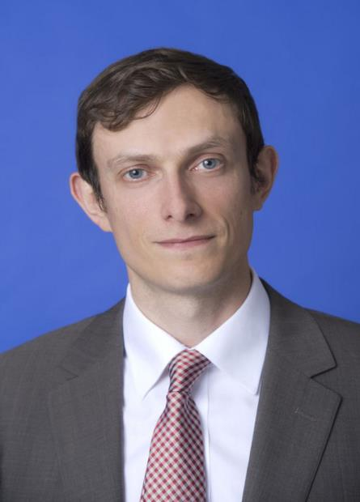
Dr. Nicholas D. Wright is an affiliated scholar at Georgetown University, honorary research associate at University College London (UCL), Consultant at Intelligent Biology and Fellow at New America. His work combines neuroscientific, behavioural and technological insights to understand decision-making in politics and international confrontations, in ways practically applicable to policy. He leads international, interdisciplinary projects with collaborators in countries including China, the U.S., Iran and the UK. He was an Associate in the Nuclear Policy Program, Carnegie Endowment for International Peace, Washington DC and a Senior Research Fellow in International Relations at the University of Birmingham, UK. He has conducted work for the UK Government and U.S. Department of Defense. Before this he examined decision-making using functional brain imaging at UCL and in the Department of Government at the London School of Economics. He was a clinical neurologist in Oxford and at the National Hospital for Neurology. He has published academically (some twenty publications, e.g. Proceedings of the Royal Society), in general publications such as the Atlantic and Foreign Affairs, with the Pentagon Joint Staff (see www.nicholasdwright.com/publications) and has appeared on the BBC and CNN.
Wright received a medical degree from UCL, a BSc in Health Policy from Imperial College London, has Membership of the Royal College of Physicians (UK), has an MSc in Neuroscience and a PhD in Neuroscience both from UCL.

