How Russian Society Challenges Putin’s Grand Narrative: Perceptions of
Domestic Problems and External Threats after Crimea

(Part of a draft chapter for a book-length manuscript)

Thomas Sherlock, Ph.D.
United States Military Academy, West Point

Introduction
Since his accession to power, Vladimir Putin has sought to restore Russia as a coherent state and then recover its status as a great power with claims to regional hegemony. Even before the crisis over Ukraine, Putin had come to perceive the West and particularly the United States as actively hostile to these goals. These perceptions of Western opposition have been reinforced by the Kremlin’s strategy to consolidate society by portraying the West and purported fifth columnists as a serious danger to Russia’s national interests including the integrity of the state itself.

For observers of Russian politics, Russian society has embraced this threat-based, great power narrative which is designed to legitimate the regime. According to Igor Kliamkin, the noted liberal intellectual, anti-Westernism is now the most important basis for unifying Russian society in both its horizontal and vertical dimensions. Other experts identify the annexation of Crimea in 2014 as a watershed event that enabled Vladimir Putin to forge a new “social contract” that employs a triumphant narrative of Russia as a resurgent great power confronting a malign United States. For Sergei Guriev, the prominent Russian economist: “Thanks largely to the government’s extensive control over information, Mr. Putin has rewritten the social contract in Russia. Long based on economic performance, it is now about geopolitical status. If economic pain is the price Russians have to pay so that Russia can stand up to the West, so be it.” Russians are portrayed as accepting socio-economic stagnation and autocratic rule in exchange for the recovery of Russia’s status as a great power able to defy the United States and extend its influence abroad.

Evidence from surveys and other sources point to flaws in these assessments. While mass publics are often inspired by the Kremlin’s story that Russia is a resurgent great power reclaiming its rightful place on the global stage, they view the external environment with caution and are wary of an aggressive foreign policy. Russia’s elites, unlike its mass publics, often advocate the projection of state power, including the creation of a sphere of influence in Eurasia which experts in the West often identify as a central goal of the Kremlin’s foreign policy. Nevertheless, many, perhaps most, of these elites (like mass society) want their government to emphasize domestic socio-economic development, not the production and demonstration of hard power. These views indicate that Russian society at the elite and mass levels enjoys sufficient perceptual autonomy to critically evaluate the core identity narrative of the Kremlin and develop alternate perspectives and preferences. As a result, the meta-narrative which provides the normative foundation of the Kremlin’s foreign policy is now undergoing substantial decay.

The Kremlin still possesses sufficient authority as well as coercive power to ignore contending foreign policy preferences. But not without eventual risk. Although popular support has allowed Putin to extend his control over the state and cripple opposition to his rule, his political survival still requires the maintenance of mass and elite approval. Reflecting this fact, Putin closely follows public opinion polls. Dmitri Trenin observes that Putin and his ruling circle understand that Russia’s future, and their own, “depends mostly on how ordinary citizens feel…. Russia is an autocracy, but it is an autocracy with the consent of the governed.” Trenin echoes Hans Morgenthau, who identified “national morale,” or the “degree of determination” with which society approves its government’s foreign policy, as a core element of state power. For Morgenthau, morale is expressed in the form of public opinion, “without whose support [i.e., consent] no government, democratic or autocratic, is able to pursue its policies with full effectiveness, if it is able to pursue them at all.” While most Russians currently back, if often cautiously, the Kremlin’s foreign policy, a costly and unpredictable escalation of conflict with the West in the context of Russian socio-economic stagnation or decline could undermine “consent” with uncertain political consequences.

This paper contains two sections and a conclusion. The first part examines the attitudes of the general public in Russia on issues with implications for Russian foreign policy, including neo-imperialist sentiment; perceptions of external threat, particularly from the United States; and preferred definitions of a great power. The second section addresses these topics from the perspectives of segments of the Russian elite. The conclusion provides a summary and identifies important limits to the influence of elite and mass opinion on Russian foreign policy.

Empirical support for the argument draws on opinion surveys published by the Institute of Sociology of the Russian Academy of Sciences and by leading Russian firms, including the Levada Center, the Public Opinion Foundation (FOM), the Russian Public Opinion Research Center (VTsIOM), and the Eurasia Monitor. The Levada Center kindly provided data for select questions from their surveys administered in July 2015 and March 2017. I also commissioned Bashkirova and Partners, the Russian firm, to conduct a nationally representative survey of 1,500 respondents in October 2016. Data on elite attitudes after the Crimea annexation are drawn from a number of sources, including Sharon Werning Rivera, et al., The Russian Elite 2016, (an analysis of the latest wave of the long-term study Survey of Russian Elites); the 2015 survey of elites by the Institute of Sociology of the Russian Academy of Sciences; and a report by the Council on Foreign and Defense Policy (SVOP). I also conducted extensive interviews as well as focus groups in Moscow during 2017-2018 in support of a chapter on Russian foreign policy for a book manuscript. This paper is part of that chapter.

Weak Public Support for Neo-Imperialism or Regional Hegemony
Contemporary attitudes about the Soviet Union help us understand how Russians perceive a possible return to forms of neo-imperialism or regional spheres of influence. Despite positive recollections and representations of the Soviet past, a survey by the Eurasia Monitor Agency in October 2016 found that no more than 7% of respondents in any age group believed that the Soviet Union in some form could “definitely” be resurrected. In another survey, also in late 2016, only 12% of the respondents felt that the Soviet Union should be restored. These pragmatic and normative stances suggest that the danger of “restorative” nostalgia, defined by Svetlana Boym as an individual’s strong desire to recreate the past, is relatively weak in Russia as to the revival of the Soviet empire in some form. Instead, the feelings of most Russians are in line with Boym’s more benign “reflective” nostalgia: a depoliticized and personalized longing for a lost period. Russians may have nostalgia for the Soviet Union, but only a minority expect or want it to be restored.

The effect of the incorporation of Crimea in 2014 on mass attitudes about Russia’s territorial identity provides other evidence of the weakening of expansionist sentiment in post-Soviet Russia. The greatest annual increase in the percentage of Russians who accept Russia’s existing borders rose to 57% from 32% of survey respondents and occurred during the year following the incorporation of Crimea in March 2014. In 1998, near the end of Boris Yeltsin’s term in office and the eve of Putin’s accession to power, only 19% of survey respondents were content with Russia’s post-Soviet boundaries.

Figure 1

How did the events of 2014 help produce this outcome? For many Russians, the incorporation of Crimea was a cathartic event, seeming to confirm that Russia had finally recovered from the Soviet collapse, casting off the “syndrome of self-abasement.” The widespread belief that Russia now possessed the strength and self-confidence of a great power helped foster a more stable sense of national identity, and as a result, a greater acceptance of Russia’s interstate boundaries. At the same time, the ensuing conflict with the West demonstrated to Russians the heavy costs of the annexation and the likely burdens and dangers of further attempts to redraw Russia’s borders.

In part because the Kremlin’s military operation in Crimea was virtually bloodless and the subsequent annexation widely perceived in Russia as free of coercion, Russians in 2014 strongly supported their government’s action. The fact that over 65% of the population of Crimea self-identify as ethnic Russians and that the peninsula has significant ethno-cultural, historical, and strategic value for Russia reinforced popular approval of the decision. The demonstration of Russian national power after more than two decades of strategic marginalization and international decline also prompted widespread approbation, akin to the subsequent pro-Kremlin “rally” response generated by the confrontation with the West over the annexation and Russia’s overt and clandestine support for separatist movements in eastern Ukraine.

Russians did embrace the idea of military confrontation and territorial expansion for a brief period after the seizure of Crimea. In a March 2014 Levada survey, 74% of respondents said they would support the Russian government in the event of armed conflict between Russian and Ukraine, now governed by a pro-Western regime. Less than a year later, this number fell to 44%, reflecting the growth of caution in Russian society despite the Kremlin’s claim that Ukraine had become a platform for future American aggression against Russia. 39% of respondents now said they would either “definitely” or “probably” withhold support from the Kremlin in a direct clash with Ukraine, up from 13% eleven months earlier. Most Russians increasingly fear that regional conflict will likely produce unacceptable social and economic costs for themselves, for Russia as a whole, and for the communities in the “near abroad” with which Russia has long-standing historical, political, ethno-cultural, economic, and personal ties. Millions of Russians have relatives, friends, colleagues, or acquaintances in Ukraine.
Expansionist fervor waned over whether Russia should annex the provinces of eastern Ukraine under the control of pro-Russian rebels. In early 2014, at the time of the incorporation of Crimea, almost half of Russian respondents (48%) approved the absorption of the eastern Ukraine into Russia. Less than a year later this preference had dropped to 15%. As for whether Russia and Ukraine as a whole should unite in a single state – long a core demand of extreme ethnic and state nationalists in Russia -- barely 7% of respondents supported that goal in September 2014, down from 28% in March of that year. By 2017, Russian society was split over whether Russia should even publicly approve the rebellion of the pro-Russian eastern provinces of Ukraine. According to one survey in April 2017, 41% of respondents believed that Russia should support the self-proclaimed DNR and LNR governments in eastern Ukraine; 5% thought that Russia should back the government in Kiev; and 37% believed that Moscow should remain neutral.

A question in the March 2017 Levada survey focused on an issue that the Kremlin had employed, among others, to justify the annexation of Crimea in 2014: should Moscow protect Russian speakers in the countries of the “near abroad” (other than Ukraine) if they experienced serious discrimination? Alarmed by Russian behavior in Ukraine and the Baltic region, the governments of Lithuania and particularly Latvia and Estonia fear that the Kremlin will engage in hybrid warfare against them. A particular concern of these states is that Russia will condemn their alleged mistreatment of Russian minorities in order to mobilize support, in both Russia and its diaspora in the “near abroad,” for asymmetric forms of aggression.

The survey question asked: “If the rights of ethnic Russians in neighboring countries (apart from Ukraine) are seriously violated, what should Russia do?” 35.8% selected the response that Russia should work toward a peaceful settlement of the problem while 29.8% believed that Russia should not become involved in such disputes. 28.1% of the respondents felt that “all means” (including military force) should be used to protect Russian-speakers who might be mistreated.

That each of the three possible responses garnered roughly equivalent levels of support underscores the divisions within Russian society on this central issue -- and the domestic political risk for the Kremlin in fomenting aggression of the sort feared by the Baltic states. It is noteworthy that the villages, towns, and small cities in Russia’s “heartland” that the Kremlin moved to activate as conservative counterweights after the political protests in 2011 and 2012 exhibited only modest levels of approval for the “right to protect” Russians in border countries. These population centers were slightly above or below the national average of 29.8% in advocating non-intervention. Respondents in Moscow were least willing to approve direct involvement by Russia in ethno-nationalist disputes. 41.2% of Muscovites felt that intervention would be an unjustified intrusion into the “internal affairs of other countries.” This number marked a 22% increase over the percentage of responses (19%) among Muscovites to the same question administered two years earlier, in the July 2015 Levada survey.

Russians express even greater reluctance to intervene in the “near abroad” if survey questions do not address the thorny issue of the Russian diaspora. In terms of broad regional ambitions, most Russians do not advocate the emergence of their country as a post-Soviet hegemon. Only 6% of respondents in a January 2017 Levada survey “definitely” agreed with the statement that Russia should keep the former Soviet republics “under its control” by any means necessary; 19% “mostly” agreed. 65% of respondents “definitely” or “mostly” disagreed (29% and 36%, respectively). In October 2016, a survey by the Institute of Sociology of the Russian Academy of Sciences also found respondents opposed to Russia becoming “the leader of post-Soviet space”: only 8% supported this role for their country. Beyond the “near abroad,” mass publics are also hesitant about Russia extending its military footprint to advance its geopolitical position.

The Limits of Anti-American and Great Power Narratives: Measuring Threat Perception
Threat perception is an important determinant of mass attitudes on whether Russia should expand its regional influence as well as its hard power. For The Economist, the Kremlin’s best hope for fulfilling its ambitious program for a military build-up is “persuading citizens to tighten their belts for the sake of a nation that supposedly faces a perpetual American peril.”

Has this political strategy been successful? Drawing on their surveys of public opinion in Russia, Theodore Gerber and Jane Zavisca convincingly argue that most Russians have adopted anti-Americanism. Yet despite the Kremlin’s identification of the United States as a serious threat and the existence of widespread anti-Americanism in Russian society, most Russians do not yet believe they face a “perpetual American peril.” The March 2017 Levada survey, my October 2016 Bashkirova survey, and other polling data help measure threat perception in Russia as well as levels of societal support for greater military spending and an aggressive foreign policy. While the data confirms that most Russians hold negative opinions of the United States, the intensity and political significance of these attitudes should not be overstated; Russian anti-Americanism evokes feelings of dislike and apprehension rather than those of fear and alarm, with correspondingly different (more moderate) effects on beliefs, attitudes, and behavior.

If Russians did perceive an imminent and serious threat from abroad, intergroup emotions theory (IET) and other models of group behavior, such as predatory imminence theory, would predict widespread expressions of collective anger at the menacing outgroup (the West, particularly the United States) as well as a strong desire to resist or inflict harm (for example, one would expect strong public backing or increased military spending; widespread pressure that Russia directly confront NATO; and perhaps advocacy for the annexation of eastern Ukraine and other controls over post-Soviet space as defensive buffers). The surveys under review point to the limited appeal of such responses among mass publics in Russia despite anti-American sentiments.

In a question from the March 2017 Levada survey, respondents were asked whether the United States currently poses a threat to Russia. 12.4% responded “definitely no” and 33.5% responded “more likely no than yes.” “Definitely yes” garnered 13.9% of responses, while 31.1% of respondents chose “more likely yes than no.” When the second group (which perceived a U.S. threat) was asked to identify all types of threat that applied, the “possibility of a [U.S.] military invasion or incursion” was selected by only 14.1% of respondents. Respondents regarded the peril if a military attack, presumably viewed as the worst of possible dangers, as the least of threats.

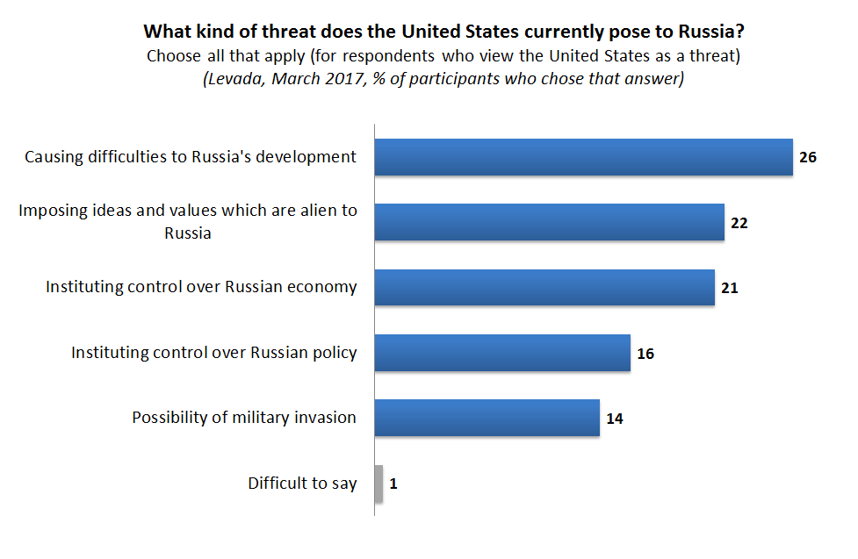
Figure 2

It is notable that the American threat most often selected by the respondents – “causing difficulties to Russia’s development” – reflects perceptions of the vulnerabilities of Russia’s economy, not its defensive capacity. So too does the third-ranked selection: the threat of America “instituting control over the Russian economy.” Other polling data suggest that Russians believe both of these non-military threats are best addressed through domestic socio-economic reform, including effective controls over political corruption, limits on military spending, and greater investments in human capital.

The October 2016 survey by Bashkirova and Partners underscores that most Russians are not preoccupied with threats from the United States. It employed a five-point scale to determine how respondents perceive potential dangers to Russia, identifying 1 as the “absence of threat” and 5 as the “greatest danger” (the interior scale numbers were not labelled). Respondents were asked to measure the severity of seven possible threats, evaluating each according to the five points of the scale. 9.9% of the respondents felt that the growth of American military power posed a “greatest danger” to Russia, while almost twice as many perceived no threat from that quarter. As for the possible threat to Russia of a “color revolution,” just under 8% of respondents saw Western-inspired political unrest in Russia as a “greatest danger” while almost 24% perceived no danger at all. At the same time, 19% of respondents found an “information war” of the West against Russia as a “greatest danger,” while only 8.5% did not consider it to be a threat.

Other polling data confirm that most Russians have a moderate level of threat perception regarding the West. A question in the March 2017 Levada survey probed how Russians would react to Ukraine’s possible acceptance of an invitation to join western political, economic, and security institutions. 37.7% of respondents overall thought that Russia should allow Ukraine to join either the European Union or NATO despite that country’s strong historical, cultural, socio-economic, and strategic importance to Russia. Close to 48% of Muscovites supported this position as did 37% of respondents from Russia’s villages and towns. Opposition to Ukraine’s entry into NATO, but not the EU, was expressed by 27.8% of survey participants. Less than 8% of respondents felt that Russia should “block any decision by Ukraine to join either the EU or NATO.”

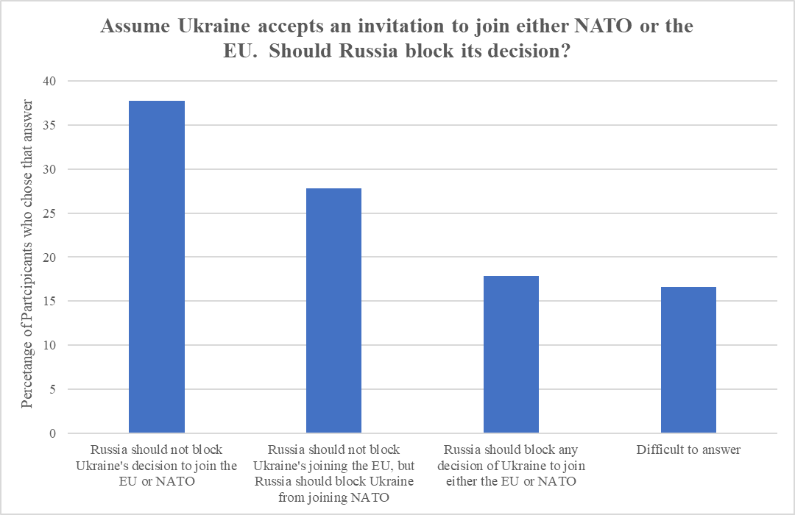
Figure 3

Surveys on attitudes toward Ukraine reveal an important distinction in how Russians evaluate possible external threats: a majority is less troubled by the risk of foreign attack and more concerned about Russia being drawn into a conflict in a bordering country like Ukraine.

This aversion to entanglement in Ukraine was undiminished by the “Crimean effect” or by the widespread belief, confirmed in surveys, that the Kremlin’s policy toward Ukraine was intended to defend Russia’s “military-strategic and geopolitical interests” and the prevention of NATO expansion. In another indication of wariness, only a minority of Russians in surveys thought the Kremlin should balance against Western influence in Eurasia by increasing Russia’s own power in post-Soviet space, particularly over the countries of the CIS, the Russian-sponsored security and economic organization. These cautious, inward-looking preferences have persisted over time.

“Practical Patriotism”: Tepid Support for Hard Power and an Aggressive Foreign Policy
Why do the Kremlin’s threat-based and great power narratives often fail to resonate in Russian society? The well-known hypothesis that external threat often strengthens political cohesion and weakens dissent requires qualification. As the data above suggest, threat should be viewed as a continuous variable in which individuals perceive different gradations or progressions of peril. Perceptions of external danger must reach a certain threshold before beliefs and behaviors that support political conformity begin to emerge. Whether this threshold is attained depends on a number of factors, including the character of the threat as well as the mobilizational capacity of the state and the coherence and intensity of its messaging. Other intervening variables, such as the material calculus of individuals, are situated at the societal level and shape an individual’s evaluation of the nature and degree of the external threat.

In the case of Russia after Crimea, two intertwined variables are particularly important: the perceived cost of preparing for and engaging in external conflict; and the increase in societal autonomy from the messaging of the state. In conditions of socio-economic decline and uncertainty, most Russians rationally calculate the costs of militarization and external confrontation. They fear that a significant rise in military spending and escalating clashes with the West will bring greater personal and collective distress. Economic concerns are substantial. After a noteworthy increase during 2000-2007, the level of personal wealth for most Russians has stagnated or declined, a problem predating Western sanctions and the steep drop in oil and gas prices. As a survey by Levada in August 2017 showed, Russians are more worried about economic and other domestic problems than external dangers.

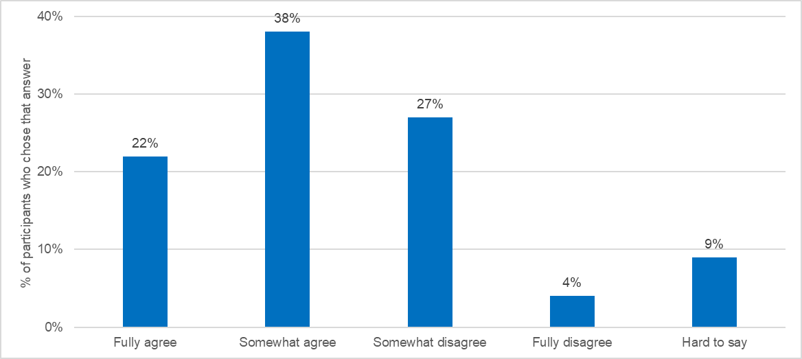

Figure 4: Do you agree or disagree with the following statement: "The internal problems of Russia are now more serious than external threats"? (Levada, August 2017)

Russians are often reluctant to risk greater economic difficulties for the sake of the state and its foreign policy, reflecting the limitations of what Russian sociologists refer to as “practical patriotism.” According to surveys administered by the Institute of Sociology, only 8% of respondents in late 2015 were “absolutely” willing to approve policies designed to restore Russian international power and defensive capacity “even if these measures were linked to a significant decline in their standard of living,” while 30% were “somewhat willing” to endure such costs (for a total of 38%). 23% of respondents were “absolutely” unwilling to do so, and 39% were “more unwilling than not” to engage in such self-sacrifice (for a “willing/unwilling” ratio of 38:62). For respondents who approved “the activities of V. Putin in the post of President of Russia,” the ratio, at 45:55, demonstrates that approval of Putin’s foreign policy is often provisional even among his devoted followers; the imbalance grew to 30:70 for those who supported Putin’s presidency only “in part.”

In a detailed evaluation of these and other surveys, scholars from the Institute of Sociology concluded that Russians are willing to engage in some self-sacrifice on behalf of the state, but only if it affects what were viewed as “minor aspects” of one’s life-style. For example, 75% of respondents in a 2015 poll would forego the purchase of food products imported from the West, but only 9% were willing to pay higher taxes. Moreover, this limited commitment to self-sacrifice “gradually weakens” as painful economic conditions persist.

The often fragile, uneven nature of the “Crimea effect” is also evident in the socio-cultural sphere. Surveys of the Institute of Sociology found among respondents increasingly negative evaluations of the moral, cultural, civic, and socio-economic condition of society. For example, 25% of participants in a survey administered a few months after the incorporation of Crimea (October 2014), believed that Russia as a moral-ethical community was growing stronger, marking an increase from 14% in 2011. By October 2016 only 9% expressed this opinion. 53% of respondents now thought the moral cohesion of Russian society was fraying. 38% had expressed this opinion two years earlier, in October 2014.

These responses suggest that the Kremlin’s threat-based and great power narratives face important limits in their ability to mobilize and unite Russian society. During the historical process of state formation, particularly in Europe, military conflict or the danger of war often enabled the government to centralize and increase its extractive capacity. Perceptions of high external threat, often manipulated by political authorities, led society to cohere more closely around symbols and myths associated with patriotic duty and provide more resources to the state through higher taxation and other methods. In Russia, this dynamic of self-sacrifice remains comparatively weak despite the “Crimea effect.” Although tensions with the West have helped produce a “rally” response that has bolstered Putin’s authority and strengthened dislike and mistrust of the United States, this condition has not increased broad societal support for the political system or for the production and exercise of the state’s hard power -- despite the prevalence of official narratives that emphasize external threat and state greatness.

Why isn’t threat perception stronger in Russian society given the regime’s control or influence over most forms of mass media? After the collapse of the Soviet Union, the reach of the newborn Russian state into society was reduced dramatically by processes of socio-economic privatization. The turbulent 1990s, when Russians could not reliably depend on the state for security, was a harsh and effective school for developing self-sufficient attitudes. So, too, has been the failure of political elites under Putin to fundamentally improve socio-economic conditions for almost a decade. Now more insulated from the state and its web of public communications, Russians increasingly privilege personal, family, and group interests – including economic concerns -- over those of the state. As these interests misalign with the priorities of the Kremlin, they act to filter, shape, or otherwise blunt the messaging of the state, including its threat-based narratives.

In a late 2015 survey administered by the Institute of Sociology, 59% of respondents felt that “[safeguarding] personal interests should be the main concern of people” while 41% agree that “people should be willing to sacrifice their personal interests” to the needs of the government. The demographic groups that placed the greatest emphasis on personal interests included residents of smaller cities, the better educated, and those with market-based employment opportunities. 66% of 18-30 year old group favored “personal interests” over those of the state, while 33% believed that the interests of the government should be paramount. Related surveys, also by the Institute of Sociology, identify an increase in the percentage of Russians who say they are self-sufficient and do not rely on public institutions for material help (44% in early 2015). Although other polling data indicate that belief in the centrality of the state and its paternalistic relationship with society remains strong in Russia, the growing emphasis on private life, even at the expense of the interests of the government, is politically significant.

The growth in the autonomy of post-Soviet society is both cause and effect of the declining trust that Russians have in state-run mass media. Reflecting their reliance on alternative sources of information and perspectives -- the family, the internet, business and social circles, as well as diverse forms of civic engagement – 47% of respondents in a March 2017 Levada survey did not trust or only partially trusted the information provided by state television, which is still the primary source of news about the country and the world for most Russians. According to another survey, this one by FOM, by mid-2017 the overall percentage of Russians who lacked confidence in state television crossed the “red line” of 50%. Another FOM survey more than a year later -- in late 2018 -- found that only 47% of respondents fully trusted state-controlled media, down from 70% at the height of the “Crimea effect” in 2015. Three-quarters of the survey participants also thought that state-controlled media should contain criticism of the political authorities.

Although Russian evaluations of external threat and domestic conditions are increasingly free of state manipulation, official messaging still predominates in a constrained marketplace of ideas where alternative, authoritative sources of mass information remain weak and dispersed. Public opinion on the existence of a seditious “fifth column” provides a useful example of the decay but also persistence of the regime’s threat-based narrative. Since the annexation of Crimea, the regime has strengthened its condemnation of allegedly treasonous or subversive activities on the part of pro-Western liberals, Russian NGOs with links to the West, and Western NGOs in Russia.
Despite the declining effectiveness of the Kremlin’s narrative, the information strategy of the government still spreads considerable confusion and doubt (and also caution) among Russians who might otherwise reevaluate their political beliefs. For example, 37.3% of the 18-24 year-old group rejected West-inspired conspiracies in the March 2017 Levada survey. Only 22.5% believed in the existence of an organized fifth column. However, 40.3% of this group now selected “It is difficult to say.” (36% chose this response in the July 2015 survey).

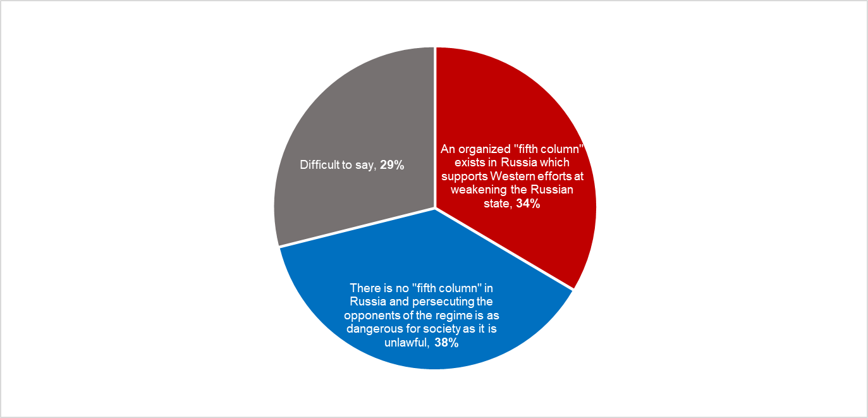

Figure 5: Which of the following positions is closest to your own view concerning a "fifth column"? (Levada, March 2017, % of participants who chose that answer)

What Kind of Great Power Do Russians Want to Be?
How Russians define a modern great power also offers insight into their evaluation of the external environment, including what kinds of foreign threats confront Russia. Similarly, their definition of a great power helps identify dominant preferences in society for Russia’s future socio-economic and political development.

The issue of guns versus butter underscores the inward-looking quality of Russian public opinion and its priorities for a modern power. When asked in the March 2017 Levada survey whether they prefer that Russia strengthen the military power of the state or improve the well-being of its citizens, the overwhelming majority of respondents (74.3%) chose the “well-being of its citizens.” This number rose to 80.2% in Moscow. As for Russia’s youth, analysts often maintain that a large segment of “Gen Putin” (the 18-24 year old group) has been socialized into anti-American authoritarianism, forming a bulwark against the West and its values. While there is some truth in this position, only 22.5% of “Gen Putin” in the survey favored a build-up of Russia’s military strength; this group also demonstrated the strongest approval of any age group for improved ties to the West (66.1%) in another question from the same survey. Confirming the limited reach of Kremlin messaging, these attitudes weaken efforts of the regime to heighten perceptions of threat in order to augment its authority while ignoring reform of Russia’s archaic developmental model.

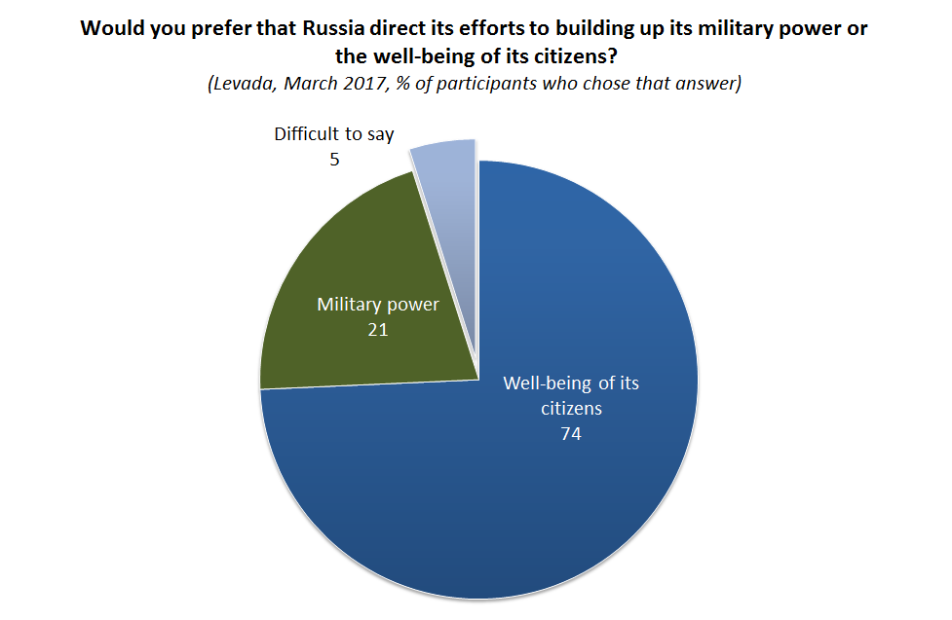
Figure 6

In the March 2017 Levada survey, respondents were also asked what constitutes a great power. The two leading answers were: “the well-being of its citizens” (62%); and “the economic and industrial potential of a country” (58%). “Military power” came in third at 48% (up to three answers were permitted). While 66% of 18-24 year olds selected “well-being,” no age, occupational, settlement, or educational category fell below 60% for this answer. The income groups of both “poor” and “wealthy” registered slightly above 64%. Other surveys have elicited similar responses.

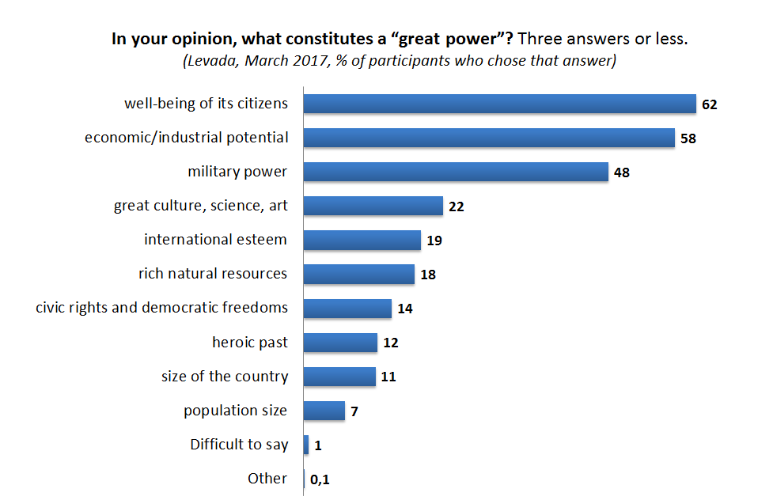
Figure 7

Another question from the March 2017 Levada survey probed how Russians might differently value the hard and soft dimensions of national power. The respondents were asked how they would prefer to see Russia in the future: as a great power which other countries “both respected and somewhat feared,” or as a country “with a high standard of living that might not be one of the most powerful countries in the world.” Overall, 56.1% of respondents would like to see Russia as a country with a high standard of living; 41.6% felt that hard instruments of international status and influence, such as military power, should take precedence over peaceful development.

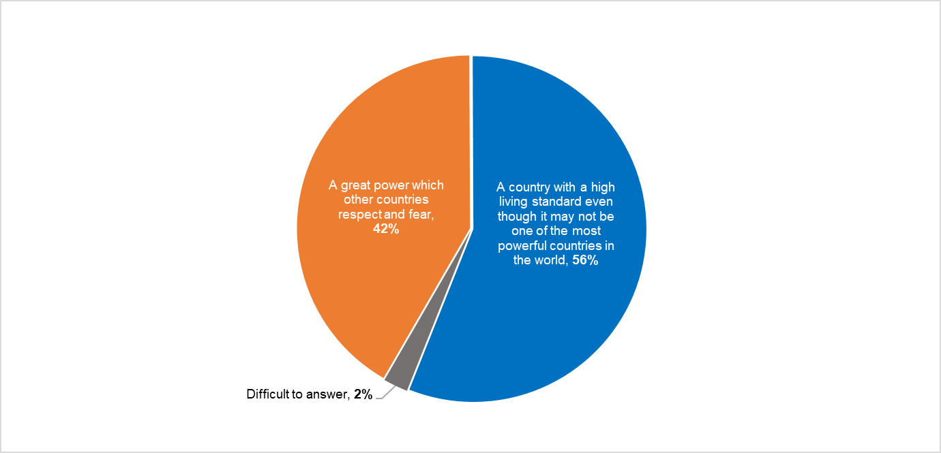
Figure 8: Would you prefer Russia to be first and foremost...? (Levada, March 2017, % of participants who chose that answer)

The October 2016 study of the Institute of Sociology provides further evidence that a majority of Russians do not prioritize hard power or an aggressive foreign policy. According to the Institute’s report, Russia’s war with Georgia in 2008, its conflict with Ukraine and the West beginning in 2014, and its recent intervention in Syria did not foster a belief in society that Russia should become a militarized great power reminiscent of the Soviet Union. Broadly in line with the results of other surveys, the Institute’s study found that only 26% of its survey respondents wanted Russia to recapture its Soviet past in terms of expansive military capacity.

The Dimension of Elites: Approaches to Threats, Power, and Identity
To what extent do the opinions of Russian elites resemble the preferences of mass publics examined above? Do Russia’s elites support an aggressive, expansionist foreign policy? Are they concerned that the external environment poses significant threats to the Russian state that require militarization? Do they emphasize hard or soft power as the foundation of a resurgent Russia?

Although detailed and reliable information about the attitudes of Russia’s elites (political, economic, security, and cultural) after the annexation of Crimea is much more scarce than data on the views of the general public, a few important sources are available for analysis. Four are particularly useful: Sharon Werning Rivera, et al., The Russian Elite 2016; the survey of elites (2015) of the Institute of Sociology of the Russian Academy of Sciences; the theses published in 2016 under the auspices of the Council on Foreign and Defense Policy (SVOP); and the joint study of the Russian International Affairs Council (RIAC) and the Center for Strategic Research (CSR), published in 2017.

The Russian Elite 2016 analyzes the latest wave of the Survey of Russian Elites, the long-term study of the attitudes of Russian elites on foreign and domestic conditions and policies. The respondents are leaders from political and bureaucratic institutions (the legislature, federal administration, etc.), private and state-owned enterprises, the security services (including the military), the media, and academic research institutions. Providing a rare measurement over time of Russian elite opinion, the Survey of Russian Elites includes seven waves: 1993, 1995, 1999, 2004, 2008, 2012, and 2016. The most recent wave (as analyzed in The Russia Elite 2016) provided a questionnaire to 243 Moscow-based elites.

The Russian Elite 2016 reveals that Russia’s elites and the general public differ over the primary sources of national power. In answering the question “What determines a state’s role in the world?” respondents in the The Russian Elite 2016 could choose one of two responses: “the economic and not the military potential of a country determines its influence and place in the world” or “military force will always ultimately decide everything in international relations.” (p. 17) When Putin assumed office at the turn of the century, only 22% of foreign policy elites felt that military power was the key factor in determining a state’s global position. The Russian Elite 2016 marked the first time that a majority of elites (52.9%, up from 35.8% in 2012) agreed that military capacity was the decisive determinant of a country’s power. “Economic potential” suffered a corresponding decline as the perceived foundation of national influence (46.5% in 2016, down from 64.2% in 2012). (p.17) Only those elites born in 1971 or later felt that “economic potential” was more important than “military force” (52.6%). By contrast, almost 77% of respondents born in 1950 or before believed that military power determined a state’s position in the world. (p. 18)

My survey commissioned from Bashkirova and Partners in late 2016 asked the same question of the general population: “What determines a state’s role in the world?” Unlike the almost 53% of respondents in The Russian Elite 2016, only 34% of the participants in my Bashkirova survey believed that “military force will ultimately decide everything in international relations. Among different demographic groups, only those with incomplete secondary education and older Russians (over 60 years) felt that military potential outstripped economic strength as the ultimate determinant of national power.

Despite these differences, the attitudes of elites and masses on the importance of military power share an upward trend. Recall that the top two answers to the related question in the Levada March 2017 survey (“What constitutes a great power?”) were: “the well-being of its citizens” (61.8%); and “the economic and industrial potential of a country” (58.4%). “Military power” came in third at 48% (up to three answers were permitted). If we track responses to this question over time in other Levada surveys of mass publics, we find that only 30% of respondents selected “military power” in 1999, the eve of the Putin era. By 2012, “military power” was chosen by 44%, and by 2017, 48% of respondents. During the same period (1999-2017), the percentage of responses for “well-being of its citizens” and the “economic and industrial potential of a country” remained about 60%, straying by only a few percentage points, plus or minus.

If belief among elites and masses in the positive effect of military power on Russia’s international status continues to increase, even if at somewhat different rates for each group, approval of forms of militarization is likely to grow as well. Such a development might, in turn, encourage external confrontation, weaken elite and popular support for balanced economic development, and strengthen acceptance of domestic political regimentation as society’s understanding of a great power rests increasingly on military factors.

Working against this possible outcome is the continued, strong preference of elites and mass publics to prioritize a national agenda that tackles domestic problems. The data in The Russian Elite 2016, drawn from the 2016 wave of the Survey of Russian Elites, indicate that the great majority of respondents (80.8%) believed the United States poses a threat of some kind to the security of their country. Yet, in line with the March 2017 Levada survey and other polls of the Russian public, most of the elites did not perceive America to be a grave or immediate military or political menace.

As analyzed in The Russian Elite 2016, the 2016 wave of the Survey of Russian Elites asked respondents to evaluate several potential dangers to Russia on a five-point scale, with five representing an “utmost threat.” A plurality of respondents (32.1%) thought that the “Inability to solve domestic problems” was an “utmost threat” (36.7% selected this response in the 2012 wave of the survey) while 22.2% considered “Terrorism” in the same light. The “Growth of the U.S. military vis-à-vis the Russian military” trailed far behind, with only 7.4% of respondents selecting this factor as an “utmost threat” – the lowest level since the 1993 wave (7.1%). Earning even lower percentages were “Border conflicts in the CIS countries” (4.5%), “Ethnic (domestic) tensions” (3.3%), “Information war conducted by the West” (2.5%) and “Color Revolution” (2.2%).

It is significant that the participants in different waves of this survey of elites found domestic problems much more worrisome than U.S. military power, American information warfare, or a “color revolution” fomented by the West, each of which the Kremlin has framed as important threats in its efforts to mobilize domestic supporters and isolate opponents. These results and other data suggest that a significant number of Russia’s elites do not support costly policies designed to offset U.S. military power or other potential American threats.

The Institute of Sociology conducted a survey in late 2015 which offers additional insight into the political attitudes and policy preferences of key segments of the Russian elite. In its report based on the survey, the Institute analyzed the views of an occupational cross-section of influentials similar to that of the Survey of Russian Elites project, including 154 leaders (94 in Moscow and 60 in different regions) in the following categories: government, business, the “third sector” (NGOs, civil society), mass media, and science. The stated purpose of the survey was to elicit assessments of the health of Russia’s society and political system as well as views on the prospects for national development over the next five years.

Gathered during the patriotic upsurge of 2015, the results of the survey challenge to an important extent the claim that Russia now enjoys significantly greater solidarity within society and between society and the state due to the mobilizing effects of the Sochi Olympics, the annexation of Crimea, the ensuing conflict with Ukraine, and particularly the subsequent confrontation with the West. While these events buoyed the standing in society of the president and the armed forces as well as bolstered patriotic pride in Russian identity, their positive effect on how elites evaluate the socio-political system appears limited. The survey also confirms that diverse Russian elites often remain more preoccupied with domestic problems than with threats from the external environment or with Russia’s status as a great power.

Using a scale of 1 (lowest) to 10 (highest), the first question of the survey asks respondents to “evaluate the current condition of Russian society” according to “important characteristics” that might be found in any country. A list of 13 items, such as the “level of inter-ethnic tensions” and the “level of tolerance,” was given to the participants. At a time (2015) when one might expect to find robust evidence of the “Crimea effect,” the “level of patriotism” scored only 5.8 on the 10 point scale. Respondents placed the “physical and psychological health” of society at a relatively low 4.3, while the “moral condition of society” registered 4.2. The degree of trust in government was scored at 3.9, and interpersonal trust in society at 3.5. Confidence in Russia’s “democratic values and institutions” (elections, parties, and the media) came in last at 2.9.

The responses to other questions in the survey underline the policy priorities of the elites and their evaluation of foreign and domestic threats. In a question on dangers emanating from the external environment, the participants identified the dependence of the Russian state budget on international oil and gas markets as the greatest threat (8.3) among the 13 items on a list, a clear reference to the vulnerabilities of Russia’s economic model. The prospect of Russia being drawn into a broader conflict in Ukraine was next (8.1), followed by capital flight and the decline in foreign and domestic investment (7.6). Although respondents were fearful of a new Cold War accompanied by an arms race (7.2), they placed the “information-psychological warfare” of the West, as well as the threat of a “fifth column,” last on the list, at 5.0.

When the participants were asked in another question what conditions were necessary for Russia to achieve the “desired situation in…society by 2020,” the selection “restoration of Russia’s strong role in international politics” lagged behind domestic issues, placing seventh (6.4) on a list of nine items. Instead, the elites in the survey viewed political reform and authentic democratization as most important. The “rotation” (replacement) of political elites “in the center and regions” came in first (8.5) and holding “transparent and legitimate elections with societal controls at all levels of government” took second place (8.1).

Figure 9

The respondents recognized that comprehensive political renovation would require fundamental changes in Russian political culture, particularly the need to overcome widespread political apathy and alienation. In a final, related question, participants were asked to identify the conditions and processes that would promote the development of Russian society. They selected as their first choice (8.1, out of nine items) the need to cultivate civic activism and “socio-political activity” which would pressure ruling elites “to change existing conditions.”

Resisting Threat-Based Narratives: Calls for Domestic Reform and External Caution
Other survey data show that a significant number of Russia’s political, economic, and cultural elites are concerned by the regime’s failure to address chronic socio-economic and political problems. In mid- 2016, Russia’s leading foreign policy think tank, the Council on Foreign and Defense Policy (SVOP), published a high-profile program advocating reform. The theses of the program (entitled Strategiia XXI) were intended to shape a new foreign policy Concept for Putin’s expected fourth presidential term. The theses are of particular importance given SVOP’s proximity to centers of power in the Kremlin.

Although the theses of Strategiia XXI begin with praise for Russian foreign policy under Putin, they temper their positive assessment with clear warnings, particularly against a new arms race that might replicate the militarized overextension that gravely weakened the Soviet Union. They also warn against policies of aggressive ethno-nationalism, maintaining that demands within Russia to “protect the Russian world” (particularly in the “near abroad”) with military force are both “unrealistic and counterproductive.” Building on these sober assessments, the theses emphasize that Russia must better evaluate dangers emanating from the West. The American threat, according to the theses, is not from military power or a U.S.-inspired color revolution. Stung by failure in Iraq, Afghanistan, and Libya, America is said to increasingly devote its energy to economic development as the core element of its national power. China similarly continues to bet on sound economic growth as the primary base of its international influence.

For Strategiia XXI, the primary peril for Russia as a resurgent great power is the state’s misuse and waste of the nation’s socio-economic resources --- a threat made pressing by the multiplier effects of the global technological revolution. Echoing the dominant preferences identified above in mass and elite surveys, and challenging the position of many foreign policy elites that military capacity is the central attribute of national power, the theses emphasize that strong and balanced economic development remains the “primary determinant” of a state’s international influence (p. 4).

Refusing to blame the West for Russia’s quandary, the document notes that Russia has failed to confront the economic stagnation that emerged several years before (emphasis added) the conflict with the West over Ukraine. (p. 16) According to the theses, Russia should immediately promote durable economic growth by preserving, developing, and recovering its “human capital” through the political, moral, and economic “modernization” of the country. (p. 18) Although the theses do not outline specific reforms to accomplish these objectives, the position papers and other materials produced in support of Strategiia XXI acknowledge that the mobilization of human capital will require far-reaching changes. These include large increases in state funding for health care and education; the expansion of civil and socio-economic freedoms made possible by a significant retraction of the state’s role in regulating society; and the development of the rule of law.

Strategiia XXI concludes that the primary task of Russian foreign policy is to ensure that Russia successfully confronts the steering crisis which today “endangers its long-term interests in the world” and even “its sovereignty.” Foreign policy must now generate forms of international cooperation in support of the primary goal of economic, scientific, and technological progress.
Yet Sergei Karaganov, the creative force behind Strategiia XXI, observes that ruling elites in Russia have failed to provide strategic direction to the country for years. Instead, they have exaggerated external threats in order to preserve the status quo and derail pressures for reform.

Conclusion
The Russian Elite 2016, the Institute of Sociology studies, and the SVOP theses demonstrate that while Russia’s elites are sensitive to international threats, a significant number do not believe that the West, particularly the United States, poses a critical military or political danger to the Russian state or regime. Numerous large-N surveys of the Russian public reveal similar perspectives. Both obliquely and directly, such attitudes challenge the Kremlin’s core narrative of Russia as a resurgent great power threatened by the United States and its fifth columnists.

Analysis of the views of elites and mass publics also suggests that a majority of Russians define a great power and its priorities more in terms of domestic socio-economic development than in the production and demonstration of hard power. From this standpoint, Russians often view the pathologies of their country’s developmental and political model as the most important threat to Russia’s international influence and domestic well-being.

As the plausibility of the Kremlin’s meta-narrative weakens (and as the “Crimea effect” decays) an important question is whether (or to what extent) the perspectives of much of Russian society and its elites will influence the Kremlin’s domestic and foreign policy. Incentivized by the approaching presidential election to respond favorably to these views, the Kremlin announced in mid-2017 cuts in the military budget, demonstrating that Russian hard power was not exempt from the burdens of economic stringency. Putin also seemed to signal important policy shifts in his “state of the nation” address in early March 2018 on the eve of the presidential election. Although Putin showcased Russia’s new military arsenal, he devoted more attention in the speech to ambitious plans for advancing Russia’s socio-economic modernization. His program envisioned dramatic increases in economic output, technological competitiveness, and social welfare.

In language strongly reminiscent of Strategiia XXI and the dominant attitudes in elite and mass surveys, the president acknowledged that the government must now take long-deferred “tough decisions” to foster the growth of human capital, which he identified as the fulcrum for a “genuine breakthrough” in the modernization of both society and polity: “we must expand freedom in all [socio-economic] spheres, strengthen democratic institutions, local governments, civil society institutions, and courts….We need to get rid of anything that…prevents people from fully unleashing their potential….Otherwise, there will be no future for us…the main threat and our main enemy is the fact we are falling behind.”

Despite this forceful statement, the new cabinet appointed after Putin’s electoral victory in March 2018 suggests, at least for now, continuity with the past. Although Putin is likely to provide opportunities to the liberal “camp” to influence the policy agenda, this group remains overshadowed by the greater cohesion, resources, and political influence of the siloviki and like-minded groups who guard their sectoral interests in part by framing the United States as a military, political, and cultural threat that requires commensurate policy responses. The evidence also suggests that Putin shares their interest in maintaining the basic contours of the status-quo, which is legitimated by threat-based and great power accounts. And if relations with the United States continue to deteriorate, the political resonance of the “fortress Russia” narrative, now in decline, will likely regain strength.

The weakness of sustained pressures from below also dilutes the impulse for socio-economic reform and external caution. While the Kremlin has crippled organized political opposition, support for Putin is authentic: much of the population still credits Putin with restoring political stability after the chaotic 1990s, enabling socio-economic growth in the 2000s, and then forging a foreign policy in the 2010s that revived Russia as a great power and restored national confidence. Surveys suggest that while many Russians reject all or part of this story they often acquiesce in Putin’s leadership because they prioritize domestic stability and perceive no viable political alternatives. These and other (particularly cultural) sources of caution and apathy are joined by understandable fear of a coercive state.

The likelihood of domestic reform and a less aggressive foreign policy is also undercut by the growth of anti-Americanism. Russian society possesses significant autonomy in its evaluation of official narratives; a majority does not perceive the United States as an imminent threat to the regime or the state. Nor do most Russians advocate a combative stance toward America, instead seeking to repair relations. At the same time, Russians continue to view the United States as hostile and usually absolve the Kremlin of significant responsibility for this condition. The persistence of strained relations with America would likely strengthen the conviction that the United States (and the West as a whole) is unalterably opposed to Russia’s vital national interests. In the October 2016 survey of the Institute of Sociology, 72% of respondents believed that the West viewed Russia solely as a source of raw materials, particularly gas and oil.

If the perceived normative, strategic, and material value of close relations with the West continues to decline in Russia, the possibility of substantial socio-economic reform is likely to further recede, with the prospect of political liberalization becoming more distant still. Such perceptions would likely reinforce the Kremlin’s “pivot to the East” and closer ties to authoritarian China, further weakening the possibility for reform in Russia.

Despite these complex political conditions, the fact remains that public opinion matters to the Kremlin and that much of Russian society at the mass and elite levels values restraint in foreign policy and attention to domestic socio-economic development. These attitudes should help justify an American policy of careful engagement with Russia based on sober dialogue as well as cooperation in areas of common interest. Washington should also dispassionately examine whether the West, led by the United States, bears a measure of responsibility for the worsening of relations with Russia across the post-Soviet era. This approach would not constitute concession or appeasement but a needed effort to better manage an often hazardous bi-lateral relationship. Engagement and self-reflection would also likely weaken the standing and agenda of the opponents in Russia of an U.S.-led West.

See Fiona Hill and Clifford Gaddy, Mr. Putin. Operative in the Kremlin (Washington, D.C.: Brookings Institutions, 2015).
facebook.com/igor.klymakin/posts/2148289898624793 April 2019). Also see Paul Goble, “Impulses Behind Stalin’s Anti-cosmopolitan Campaign Haven’t Disappeared,” Window on Eurasia, http://windowoneurasia2.blogspot.com/2019/04/impulses-behind-stalins-anti.html
Sergei Guriev, “It’s Not the Economy, Stupid,” New York Times, December 25, 2016, at http://www.nytimes.com/2016/12/25/opinion/in-russia-its-not-the-economy-stupid.html?_r=0, accessed December 2, 2017. See also Vladimir Ryzhkov, “Russians Feel That Great Power High Again,” Moscow Times, May 12, 2014, at http://www.themoscowtimes.com/opinion/article/russians-feel-that-great-power-high-again/499980.html; and Alexander Baunov, “Ever so Great: The Dangers of Russia’s New Social Contract,” June 15, 2015, Carnegie Moscow Center, at http://carnegie.ru/commentary/?fa=60401, accessed December 15, 2017.
According to respondents in a recent Levada survey (April 2018), “returning Russia to the status of a great power” is Putin’s most important achievement. https://www.levada.ru/2018/05/07/vladimir-putin-6/, accessed July 9, 2018.
Stephen Kotkin, “Russia’s Perpetual Geopolitics,” Foreign Affairs, May-June 2016, p. 9.
See Henry E. Hale, “How Nationalism and Machine Politics Mix in Russia,” in Pål Kolstø and Helge Blakkisrud, eds., The New Russian Nationalism. Imperialism, Ethnicity, and Authoritarianism, 2000-2015 (Edinburgh: Edinburgh University Press, 2016, pp. 221-248, at p. 246.
Hill and Gaddy, p. 245.
Dmitri Trenin, “The Revival of the Russian Military,” Foreign Affairs, May-June 2016, at https://www.foreignaffairs.com/system/files/pdf/articles/2016/95304.pdf, accessed November 24, 2017. On Putin’s interest in public opinion surveys, see https://www.washingtonpost.com/...putins...approval-ratings/.../17f5d8f2-d5ba-11e5-a65b-587e721fb231_story.html, accessed November 28, 2017. For an opposing view that the Kremlin ignores popular preferences, see Lev Gudkov, the director of the Levada Center: “95% rossiyan protiv vvoda voysk v ukrainu….” (no date), at http://slon.ru/russia/95_rossiyan_protiv_vvoda_voysk_v_ukrainu_no_putina_eto_ne_smushchaet-1149169.xhtml, accessed November 5, 2017.
Hans Morgenthau, Politics Among Nations. The Struggle for Power and Peace (New York: Knopf, 1967), p. 129.
The survey was supported through the use of personal funding.
William Zimmerman, Sharon Werning Rivera, and Kirill Kalinin, Survey of Russian Elites, Moscow, Russia, 1993-2016. Ann Arbor, MI: Inter-university Consortium for Political and Social Research [distributor], 2018-06-13. https://doi.org/10.3886/ICPSR03724.v5; https://www.icpsr.umich.edu/icpsrweb/ICPSR/studies/3724
For a general examination of the politics of historical memory in the late Soviet period and the post-Soviet era, Thomas Sherlock, Istoriia, pamiat’ i politiki v Sovetskom Soiuze i postsovetskoi Rossii (Moscow: Rosspen, 2014), chap. 7; and Thomas Sherlock, Historical Narratives in the Soviet Union and Post-Soviet Russia (New York: Palgrave-McMillan, 2007).
When available, percentages for survey data are provided to the first decimal place; otherwise, percentages are displayed as whole numbers. The study Public Opinion on the Soviet Collapse in the Countries of the Post-Soviet World is part of a research project conducted by the Eurasia Monitor Agency in the CIS countries during October-November 2016. See http://www.eurasiamonitor.org/frmtext/EM_2016_USSR_25.pdf Additional information can be found at: http://www.eurasiamonitor.org/eng/.
Levada Center, “Grazhdane sozhaleiut o raspade SSSR,” December 5, 2016, at http://www.levada.ru/2016/12/05/grazhdane-sozhaleyut-o-raspade-sssr/, accessed January 12, 2017.
Svetlana Boym, The Future of Nostalgia (New York: Basic Books, 2002).
Levada Center, Obshchestvennoe mnenie. Ezhegodnik, 2015 (Moscow: Analiticheskii Tsentr Iuria Levady, 2016), table 23.1, p. 211 (print version).
Ibid.
Levada Center, “Ukrainskii krizis: uchastie rossii i ozhidaniya,” March 4, 2015, at http://www.levada.ru/old/04-03-2015/ukrainskii-krizis-uchastie-rossii-i-ozhidaniya, accessed September 15, 2017.
According to one poll in August 2014, 46% of Russian respondents had “relatives, friends, or acquaintances” in Ukraine. FOM, “O situatsii na Ukraine,” August 26, 2014, at http://fom.ru/Mir/11687, accessed October 24, 2017.
Levada Center, “Ukrainskii krizis: uchastie rossii i ozhidaniya”; and Levada Center, Obshchestvennoe mnenie. Ezhegodnik, 2016, table 26.22, p. 212 (print version).
Levada Center, “Ukraina: vnimanie i otsenki,” February 2, 2015, at http://www.levada.ru/05-02-2015/ukraina-vnimanie-i-otsenki, accessed September 21, 2017.
Levada Center, Obshchestvennoe mnenie. Ezhegodnik, 2017 (Moscow: Analiticheskii Tsentr Iuria Levady, 2018), electronic version/pdf available at https://www.levada.ru/sbornik-obshhestvennoe-mnenie/, table 24.2, p. 181.
Levada Center, Obshchestvennoe mnenie. Ezhegodnik, 2017 (Moscow: Analiticheskii Tsentr Iuria Levady, 2018), electronic version/pdf available at https://www.levada.ru/sbornik-obshhestvennoe-mnenie/, table 23.1, p. 180.
Institut sotsiologii, Rossiiskoe obshchestvo v usloviyakh krizisnoi real’nosti, at http://www.isras.ru/files/File/Doklad/Ross_obschestvo_v_usloviyah_krizisn_realnosti.pdf, p. 12, accessed November 20, 2017.
A Pew survey in early 2017 that addressed Russian military involvement in Syria found that most respondents believed that “limiting civilian casualties” and “fighting terrorist groups” should be the top priorities for Russian forces. Only 25% of respondents felt that “ensuring Assad stays in power” (serving as a regional ally for Russia) was most important. In a Levada poll in August 2017, 49% of participants selected the response: “Russia must end its military operations in Syria,” while 30% supported the continuation of Russia’s military presence. Reflecting the Kremlin’s sensitivity to public opinion, and with echoes of its careful behavior in eastern Ukraine, casualty aversion has influenced Russia’s military operations in Syria to an important extent.
The Economist, August 1-7, 2015, p. 47.
Theodore Gerber and Jane Zavisca, “Does Russian Propaganda Work?” The Washington Quarterly, vol. 39, no. 2 (Summer) 2016, pp. 79-98, at p. 94. Their careful study also examines the uneven results of Russian propaganda in Ukraine, Azerbaijan, and Kyrgyzstan. See also Theodore Gerber, “Foreign Policy and the United States in Russian Public Opinion,” Problems of Post-Communism, vol. 62 (2015), pp. 98-111.
See D.M. Mackie, et al., “Intergroup Emotions: Explaining Offensive Action Tendencies in an Intergroup Context,” Journal of Personality and Social Psychology, vol. 79, pp. 602-616; and D. M. Mackie, A.T. Maitner, and E.R. Smith, “Intergroup Emotions Theory,” in Todd Nelson, ed. Handbook of Prejudice, Stereotyping, and Discrimination (New York: Psychology Press, 2009), pp. 285-307. See also Douglas M. Gibler, Marc L. Hutchison, and Steven V. Miller, “Individual Identity Attachments and International Conflict: The Importance of Territorial Threat,” Comparative Political Studies 45(12), 2012, pp. 1655-1683; and Marc L. Hutchison and Douglas M. Gibler, “Political Tolerance and Territorial Threat: A Cross-National Study,” The Journal of Politics 69(1), 2007, pp. 128-142.
Predatory imminence theory logically suggests that group and individual defensive responses are determined by psychological proximity to the threat. Possible reactions to danger are located on a “predatory imminence continuum.” See M.S. Fanselow and L.S. Lester, “A Functional Behavioristic Approach to Aversively Motivated Behavior: Predatory Imminence as a Determinant of the Topography of Defensive Behavior,” in R. C. Bolles and M. D. Beecher, eds., Evolution and Learning (Hillsdale, NJ: Lawrence Erlbaum Associates, 1988), pp. 185-212.
Professor Rivera of Hamilton College kindly provided me with the Russian language version of this question from her survey on Russian elites.
Levada Center, Obshchestvennoe mnenie. Ezhegodnik, 2014 (print version), table 22.80, p. 184.
Levada Center, “Russia and the World,” October 22, 2014, at http://www.levada.ru/eng/russia-and-world, accessed October 4, 2017.
Credit Suisse, Research Institute, Global Wealth Report, 2016, at https://www.credit-suisse.com/us/en/about-us/research/research-institute/news-and-videos/articles/news-and-expertise/2016/11/en/the-global-wealth-report-2016.html, p. 53, accessed December 4, 2017. For additional authoritative data and analysis of socio-economic conditions through 2018, see the studies by the Presidential Academy of the National Economy and Public Administration (RANEPA), at https://www.ranepa.ru/eng/research-academy/monthly-monitoring-of-socio-economic-situation
I am grateful to the Levada Center for providing the data for this survey question.
M.K. Gorshkov and N.E. Tikhonova, eds., Rossiiskoe obschestvo i vyzovy vremeni, vol. 3 (Moscow: Ves Mir, 2016), chapter 4, “Ot chego gotovy otkazat’syia rossiyane radi svoei strany,” p. 90.
Gorshkov and Tikhonova, eds., Rossiiskoe obschestvo i vyzovy vremeni, vol. 3 (Ves Mir, 2016), chapter 4, “Ot chego gotovy otkazat’siia rossiiane radi svoei strany,” pp. 90, 96.
Ibid., p. 102, and Gorshkov and Tikhonova, eds., Rossiiskoe obshchestvo i vyzovy vremeni, vol. 3, “K zakliucheniiu,” pp. 392-405.
Gorshkov and Tikhonova, eds., Rossiiskoe obschestvo i vyzovy vremeni, vol. 3, p. 102.
M.K. Gorshkov, et al., Rossiiskoe obshchestvo v usloviiakh krizisnoi real’nosti, Moscow: Institut sotsiologii Rossiiskoi akademii nauk, 2016, pp. 5, 7, 9-10, at http://www.isras.ru/rezyume_ross_obschestvo_v_usloviyah_krizis_realnosti, accessed January 15, 2018.
On the effect of external threats on institution-building and political culture, see Charles Tilly, "Reflections on the History of European State-Making," in Charles Tilly, ed., The Formation of National States in Western Europe (Princeton: Princeton University Press, 1975); and Jeffrey Herbst, “War and the State in Africa,” International Security, Vol. 4, No. 4 (Spring, 1990), pp.117-139.
M.K. Gorshkov and N.E. Tikhonova, eds., Rossiiskoe obschestvo i vyzovy vremeni, vol. 3 (Moscow: Ves Mir, 2016), chapter 5 (“Vlast’ i obshchestvo,”), p. 128. See also M.K. Gorshkov and N.N. Sedova, “‘Samodostatochnye’ rossiiane i ikh zhiznennye prioritety,” Sotsiologicheskie issledovaniia, No. 12, 2015, pp. 4-16.
See M.K. Gorshkov, Russian Society in the Context of Crisis Realities. Internal and External Factors (Moscow: Ves Mir, 2017), p. 14; and M.K. Gorshkov and N.N. Sedova, “Samodostatochnye rossiiane i ikh zhiznennye prioritety,” Sotsiologicheskie issledovaniya, No. 12, 2015, pp. 4-16.
Levada Center, Obshchestvennoe mnenie. Ezhegodnik, 2017 (Moscow: Analiticheskii Tsentr Iuria Levady, 2018), electronic version/pdf available at https://www.levada.ru/sbornik-obshhestvennoe-mnenie/, table 14.1, p. 128. Also see Levada Center, “Doverie SMI i tsenzura,” November 18, 2106, at http://www.levada.ru/2016/11/18/doverie-smi-i-tsenzura/, accessed November 25, 2017; and Levada Center, “Rossiiane stali men’she doveriat’ televideniiu,” November 18, 2016, at http://www.levada.ru/2016/11/18/rossiyane-stali-menshe-doveryat-televideniyu/, accessed November 25, 2017.
Editorial, “Doverie k televideniiu vpervye opustilos’ nizhe ‘krasnoi cherty’,” Nezavisimaya gazeta, July 25, 2017, at http://www.ng.ru/editorial/2017-07-25/2_7036_red.html, accessed July 2, 2018.
See http://actualcomment.ru/gosudarstvennye-smi-teryayut-doverie-rossiyan-1811231130.html, accessed November 27, 2018.
For this point, also see the commentary by Alexander Rubtsov, “Mifologiia velichiia,” RBK, February 26, 2016, at https://www.rbc.ru/opinions/society/26/02/2016/56cfe95f9a7947ed925e57de?from=typeindex%2Fopinion, accessed October 2017.
See table 2, p. 28, in V.V. Petukhov and N.N. Sedova, “Vnutrennie ugrozy vs vneshnie ugrozy dlia Rossii: dinamika obshchestvennykh nastroeniy,” Vlast, no. 6, 2015, pp. 23-29.
Institut sotsiologii, Rossiiskoe obshchestvo v usloviyakh krizisnoi real’nosti, p. 12.
In April 2017, a Russian NGO with close ties to the Kremlin commissioned opinion surveys from three Russian companies: Romir, FOM, and VTsIOM. One purpose of the polls was to rank-order the policy priorities of the respondents who identified themselves as supporters of Putin. In one of the surveys (Romir), “Strengthening Russia’s position in the world” lagged substantially behind “Health,” “Increase in income,” “Comfortable surroundings,” and “Education of one’s children.” In another of the surveys (VTsIOM), respondents expressed a strong preference for “stability” and a “peaceful life.” See Civil Society Development Foundation (FCDS), Putinskoe bol’shintsvo, May 2017, at http://civilfund.ru/mat/view/103, accessed November 9, 2017.
Sharon Werning Rivera, et al., The Russian Elite 2016. Hamilton College Levitt Poll, May 2016, at https://www.hamilton.edu/documents/russianelite2016final.pdf The 2016 survey was directed by Sharon Werning Rivera, Hamilton College (Principal Investigator), William Zimmerman, University of Michigan (Co-Principal Investigator), and Eduard Ponarin, National Research University Higher School of Economics, St. Petersburg (Co-Principal Investigator). See also William Zimmerman, Sharon Werning Rivera, and Kirill Kalinin, Survey of Russian Elites, Moscow, Russia, 1993-2016. Ann Arbor, MI: Inter-university Consortium for Political and Social Research, 2018-06-13. https://doi.org/10.3886/ICPSR03724.v5; https://www.icpsr.umich.edu/icpsrweb/ICPSR/studies/3724
How elites conceptualize Russia’s national interests also underwent important changes since the previous survey in 2012, which was administered approximately two years before the events in Crimea. Perhaps most significant was the increase in the belief among respondents in 2016 that the national interests of Russia extend beyond its current borders. In 2012, about 43% of Russian elites held this opinion, reflecting a steady decline from a high of 82.3% in 1999. The “Crimea effect” and tensions with the West, as well as Russia’s military intervention in Syria, helped reverse this trend, driving the percentage back to the 1999 level of precisely 82.3%. (p. 16) Although this renewed interest by elites in Russia’s regional and global position contrasts with the more restrained views of much of the general population, it broadly reflects the stronger external orientation of elites in other powerful, influential states.
The survey was administered in mid-October, 2016 by Bashkirova and Partners, which also managed earlier waves of the Survey of Russian Elites. Total sample size was 1,500. I thank Professor Rivera for providing me with the Russian language versions of the questions.
21% selected “don’t know/refuse to answer.”
http://www.levada.ru/old/11-12-2014/68-rossiyan-schitayut-rossiyu-velikoi-derzhavoi
As noted above, the survey I commissioned from Bashkirova in October 2016 borrowed these questions.
For further context and survey analysis, see William Zimmerman, et al., The Russian Elite – 2020 (Moscow: Valdai Discussion Club, 2013). Stephen Walt usefully revises the theory of balance of power. He develops the concept of “balance of threat” in which perceptions of the threat posed by other states are a major determinant of foreign policy attitudes -- not necessarily perceptions of the objective power of other countries. See Stephen Walt, The Origins of Alliances (Ithaca: Cornell University Press, 1987).
Institut sotsiologii, Rossiiskoe obshchestvo – 2020. Ekspertnyi obraz budushchego. Analiticheskii otchet po itogam ekspertnogo oprosa, December 3, 2015, at http://www.zircon.ru/upload/iblock/0f6/ESPM-2015_Rossiyskoe_obshestvo-2020%20_ekspertniy_obraz_budushego_ov2.2c.pdf, p. 10, accessed March 5, 2018.
Ibid., p. 14.
Ibid., p. 18.
Ibid., p. 35.
Ibid., p. 32.
Kenneth Wilson, “Modernization or More of the Same in Russia: Was There a Thaw under Medvedev?” Problems of Post-Communism, vol. 62, issue 3 (2015), pp. 145-158.
For the theses, see Strategiia dlia Rossii. Rosiiskaia vneshniaia politika: konets 2010-kh – nachalo 2020-kh godov (Moscow: Sovet po vneshnei i oboronnoi politike, 2016), at http://svop.ru/wp-content/uploads/2016/05/%D1%82%D0%B5%D0%B7%D0%B8%D1%81%D1%8B_23%D0%BC%D0%B0%D1%8F_sm.pdf, accessed October 22, 2017. For a summary of the main points of the theses, see the article by Karaganov, “Rossiiskaia vneshniaia politika: novyi etap?” May 25, 2016, at https://rg.ru/2016/05/25/specialisty-predstavili-svoe-videnie-prioritetov-vneshnej-politiki-rf.html, accessed October 23, 2017.
“Vvedenie v ‘Strategiiu XXI,’” at http://svop.ru/wp-content/uploads/2014/02/00strategy21_intro.pdf, p. 12.
Karaganov, “Rossiiskaia vneshniaia politika: novyi etap?” Despite its negative assessment of the status quo, Strategiia XXI does not cross the boundary of within-system change. It does not question the main contours of the existing political system even though its call for the healthy renewal of political elites, which it deems essential for Russia’s renovation, would require a significant redistribution of power from the executive branch to the legislature and also civil society.
Karaganov, “Rossiiskaia vneshniaia politika: novyi etap?” and http://svop.ru/wp-content/uploads/2014/02/00strategy21_intro.pdf; http://svop.ru/wp-content/uploads/2016/05/тезисы_23мая_sm.pdf, p. 18.
Sergei Karaganov “We Are Smarter, Stronger and More Determined,” Der Spiegel, July 13, 2016, at http://www.spiegel.de/international/world/interview-with-putin-foreign-policy-advisor-sergey-karaganov-a-1102629.html, accessed December 5, 2017.
For additional useful data on the significant weakening of the “Crimea effect” since 2014, see the surveys by VTsIOM (to September 2018) at https://wciom.ru/news/ratings/ocenka_vlastej/
https://apostrophe.ua/article/world/ex-ussr/2018-03-31/v-okrujenii-putina-vedut-borbu-dve-partii-a-zapad-gotovitsya-k-dolgoy-voyne/17706
In its May 2018 report, the Stockholm International Peace Research Institute calculated that Russian military spending in 2017 was 20% lower than in 2016. See https://www.sipri.org/media/press-release/2018/global-military-spending-remains-high-17-trillion, accessed May 5, 2018. The size and nature of the cuts are still in some dispute.
For Putin’s March 1, 2018 Address to the Federal Assembly, see http://en.kremlin.ru/events/president/news/56957, accessed April 10, 2018.
Max Seddon, “Putin’s new cabinet dashes hopes of Russian reform,” Financial Times, May 18, 2018, at https://www.ft.com/content/109bb4c8-5a97-11e8-bdb7-f6677d2e1ce8, accessed May 23, 2018.
For an important assessment of the extensive scholarly literature on the siloviki, see David W. Rivera & Sharon Werning Rivera, “The Militarization of the Russian Elite under Putin,” Problems of Post-Communism, 65:4 (2018), 221-232. On why analysts should not overestimate the coherence and cohesion of the bureaucracies that make up the siloviki, especially in a time of political crisis, see Brian Taylor, “The Russian Siloviki and Political Change,” Daedalus, vol. 146, issue 2 (Spring) 2017, pp. 53-63. It is important to note that Putin has imposed greater controls over the siloviki over the past few years, reducing their autonomy vis-à-vis the Kremlin. See Andrei Soldatov, “Putin’s Secret Services: How the Kremlin Corralled the FSB,” Foreign Affairs, May 31, 2018, at https://www.foreignaffairs.com/articles/russia-fsu/2018-05-31/putins-secret-services?cid=int-rec&pgtype=art (accessed June 15, 2018).
In their answers to two 2017 Levada survey questions -- “Putin represents the interests of which groups?” and “On which segments of the population does Putin most rely?”-- respondents selected as their first choice “the siloviki” (which tied in the first question with “bureaucrats” at 41%). The “common people” was selected by 17% for the first question and 16% for the second. Levada Center, Obshchestvennoe mnenie. Ezhegodnik, 2017 (Moscow: Analiticheskii Tsentr Iuria Levady, 2018), electronic version/pdf available at https://www.levada.ru/sbornik-obshhestvennoe-mnenie/, tables 9.2.8 and 9.2.9, p. 88 and 89.
75% of respondents in a December 2017 Levada survey “definitely” or “likely” wanted to “repair” relations with the West. Levada Center, Obshchestvennoe mnenie. Ezhegodnik, 2017 (Moscow: Analiticheskii Tsentr Iuria Levady, 2018), electronic version/pdf available at https://www.levada.ru/sbornik-obshhestvennoe-mnenie/, table 26.11, p. 193. This perspective has remained relatively constant since 2015. See Levada Center, Obshchestvennoe mnenie. Ezhegodnik, 2015 (print version), table 26.23, p. 253.
See the survey question at http://www.isras.ru/files/File/Doklad/Ross_obschestvo_v_usloviyah_krizisn_realnosti.pdf, p. 10, table 2.1.
If this shift accelerates, it is likely to strengthen neo-imperial interpretations of Eurasianism. See Marlene Laruelle, Russian Eurasianism: An Ideology of Empire (Washington, DC: Woodrow Wilson Center Press: 2008).

