Thomas Sherlock
How Russian Society Challenges Putin’s Grand Narrative: Perceptions of
Domestic Problems and External Threats after Crimea

Chart 1

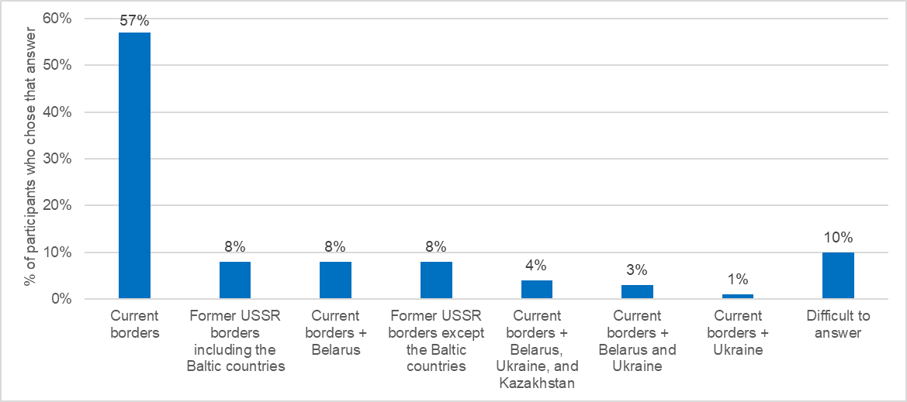
Figure 1: What should the borders of Russia be? (Levada, March 2015)

Chart 2

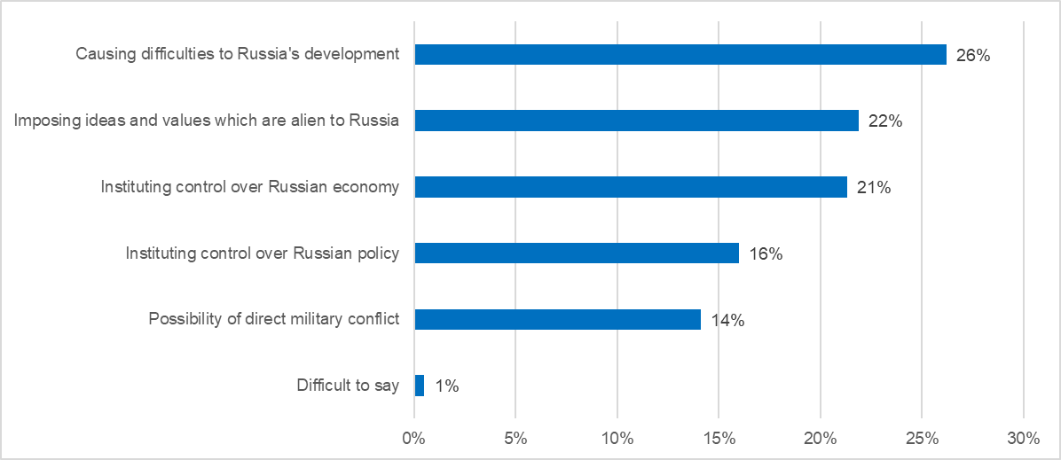
Figure 2: What kind of threat does the United States currently pose to Russia? Choose all that apply (for respondents who view the United States as a threat) (Levada, March 2017)

Chart 3

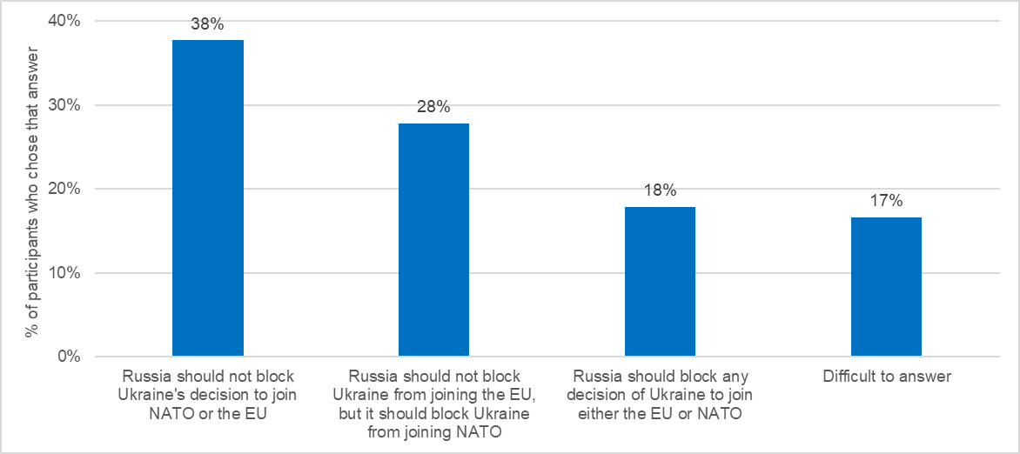
Figure 3: If Ukraine accepted an invitation to join NATO or the EU, should Russia block its decision? (Levada, March 2017)

Chart 4

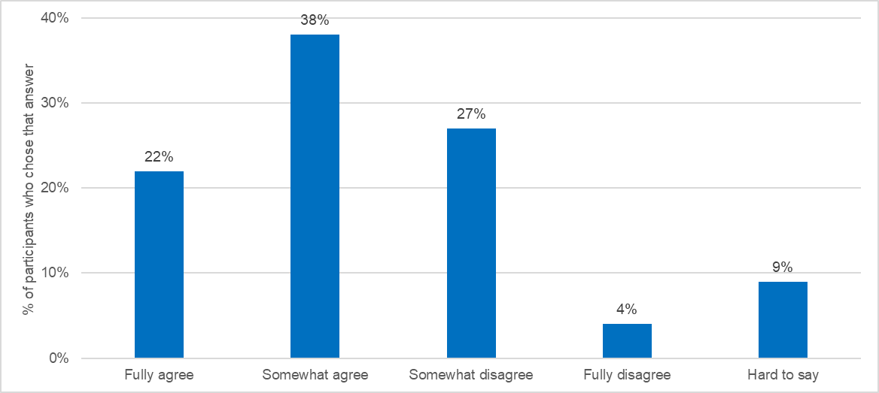
Figure 4: Do you agree or disagree with the following statement: "The internal problems of Russia are now more serious than external threats"? (Levada, August 2017)

Chart 5

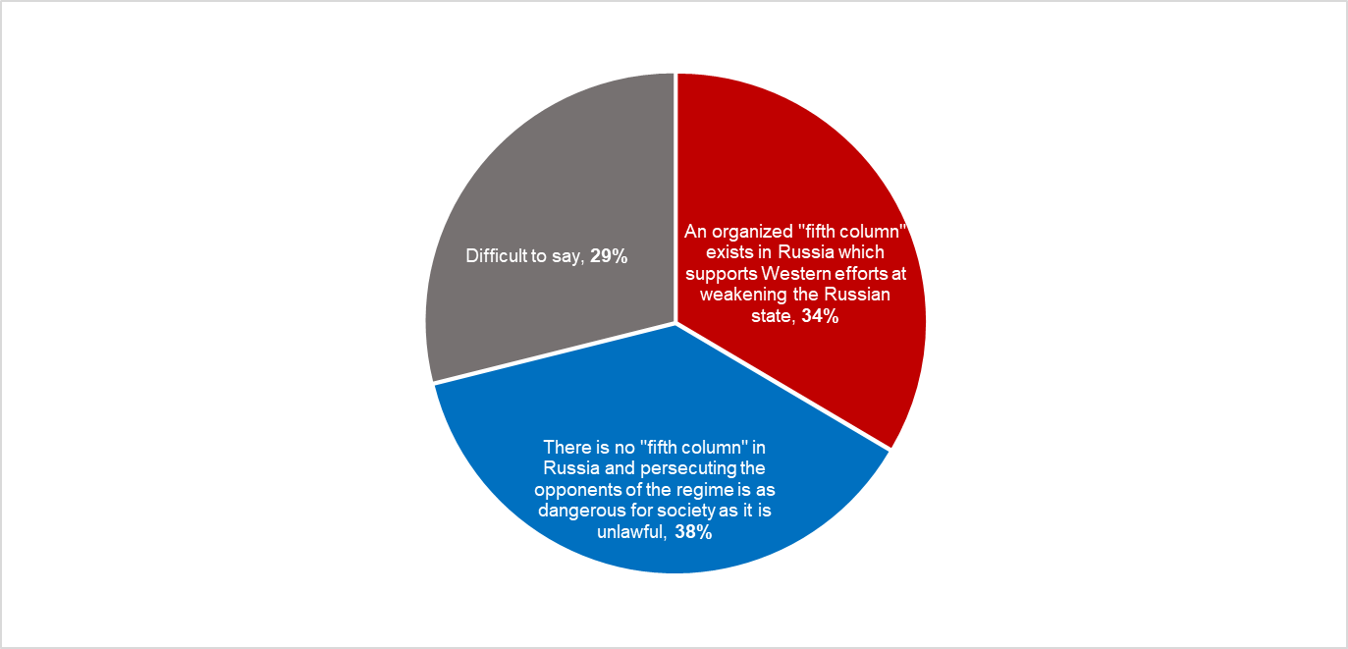
Figure 5: Which of the following positions is closest to your own view concerning a "fifth column"? (Levada, March 2017, % of participants who chose that answer)

Chart 6

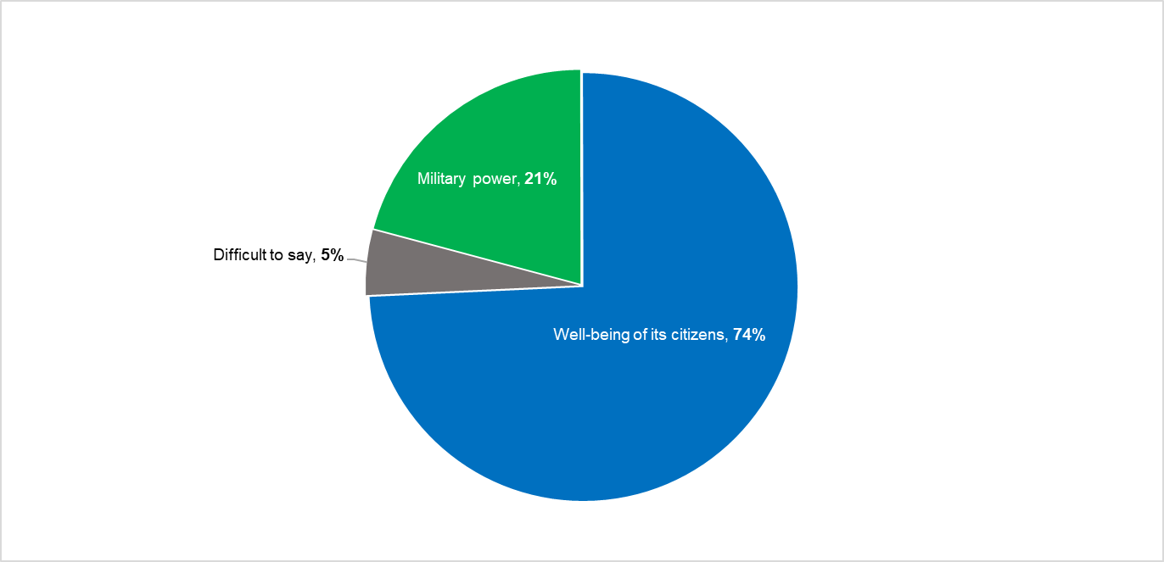
Figure 6: Would you prefer that Russia direct its efforts to building up its military power or the well-being of its citizens? (Levada, March 2017, % of participants who chose that answer)

Chart 7

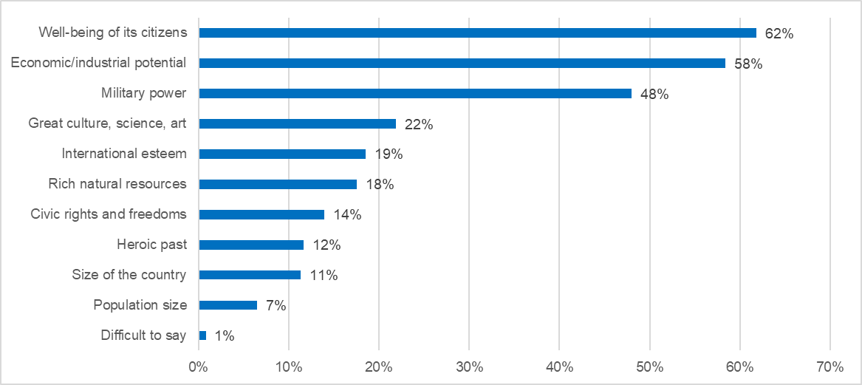
Figure 7: In your opinion, what constitutes a “superpower”? Select up to three items (Levada, March 2017)
Chart 8

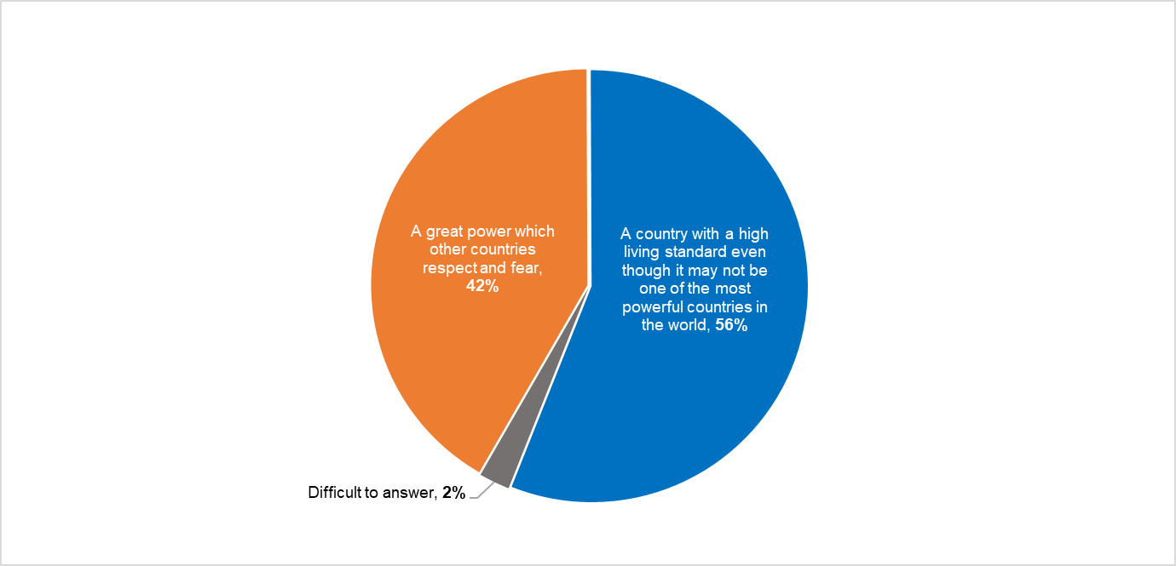
Figure 8: Would you prefer Russia to be first and foremost...? (Levada, March 2017, % of participants who chose that answer)

Chart 9

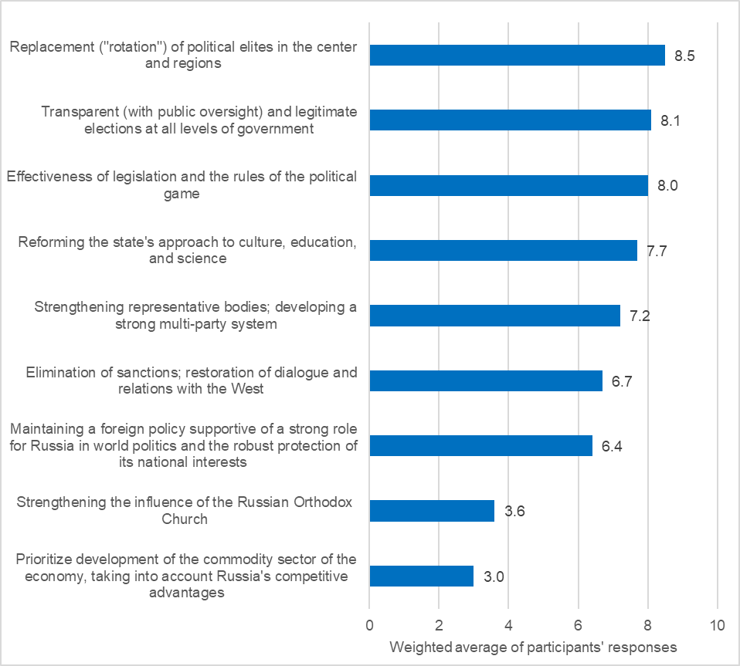
Figure 9: To what extent are the following conditions necessary to achieve the desired situation in Russian society by 2020? Scale: 1-10 (1 = no need; 10 = highest need) (Institute of Sociology, 2015)

