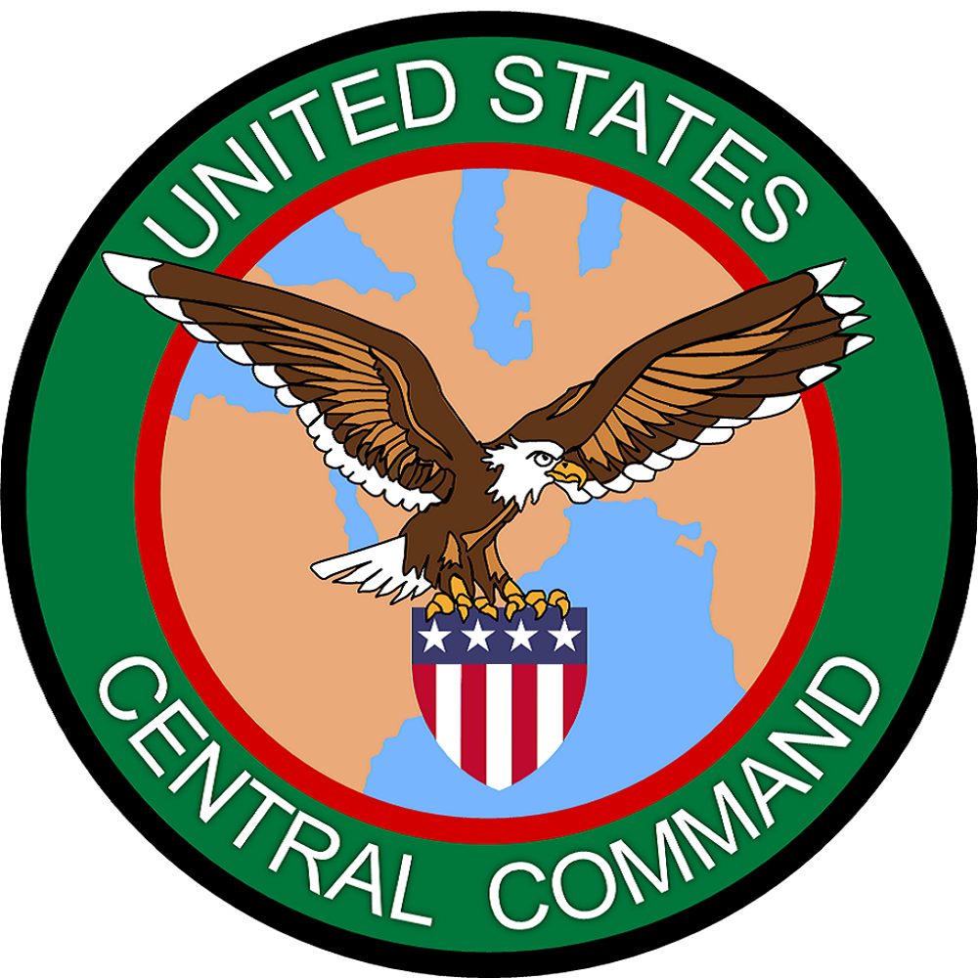
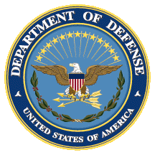
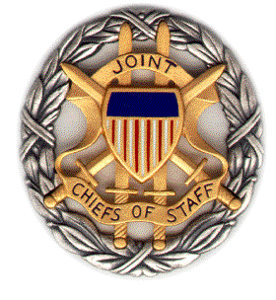

Naval Postgraduate School (NPS)
Iran Panel Discussion

In Support of SMA*
& USCENTCOM

21 June 2019
1230-1400 ET

Dial (866) 712-4038; Passcode 37250264#

*Strategic Multi-Layer Assessment (SMA) provides planning support to Commands with complex operational imperatives requiring multi-agency, multi-disciplinary solutions that are NOT within core Service/Agency competency. Solutions and participants are sought across USG and beyond. SMA is accepted and synchronized by Joint Staff/J-39 DDGO and executed by ASD (EC&P).

Agenda

Panel Description: On 21 June 2019, 1230-1400 ET, NPS will convene a panel discussion to address the eight questions posed by US Central Command regarding the Islamic Republic of Iran and the Persian Gulf countries. The panelists will address the questions guiding the study, listed below.

- Understanding that Iran wants to operate at a level below armed conflict, what actions by the U.S. would be considered a redline for Iran and why?
- If armed conflict arises, where will Iran engage the U.S. military forces and through what branch (Artesh, IRGC, IRGC Qods Force, Proxies)?
- What are the differing perceptions of proportionality between Iran and U.S.?
- How and where can the Gulf Arab States militarily assist with neutralizing Iran’s regional destabilizing behavior?
- Assessment of the emerging military leaders in Iran (post Iran-Iraq War generation).
- What action could the USG take that might improve GCC rift relationship during an Iran crisis?
- How does Iranian regime perceive U.S. actions and messaging and how does that perception influence their decisions?
- Are there historical examples of the Iranian regime changing policy due to external pressure?

Speakers: The speakers for this discussion will include:

Dr. John Arquilla (NPS)
Dr. Afshon Ostovar (NPS)

Speaker Biographies

Dr. John Arquilla (NPS)

Dr. John Arquilla is professor and chair of defense analysis at the Naval Postgraduate School where he has taught in the irregular warfare program since 1993. He is best-known for having predicted, back in the mid-‘90s, the rise of terrorist, insurgent, and transnational criminal networks. His books include Networks and Netwars (2001), The Reagan Imprint (2006), and Insurgents, Raiders, and Bandits (2011). He contributes regularly to The New York Times, Foreign Policy, and Politico.

Dr. Afshon Ostovar (NPS)

Dr. Afshon Ostovar is an Assistant Professor of National Security Affairs at the Naval Postgraduate School. He has come to NPS after a decade of experience working on Department of Defense and federally-funded projects related to national security and the Middle East. He was most recently a Research Scientist in the Center for Strategic Studies at CNA, a not-for-profit research organization in the Washington D.C. area. Previously, he was a Fellow at the Combating Terrorism Center at West Point and has taught at Johns Hopkins University.
Dr. Ostovar’s research focuses on conflict and security issues in the Middle East, with a specialty on Iran and the Persian Gulf. His book, Vanguard of the Imam: Religion, Politics, and Iran’s Revolutionary Guards (Oxford University Press, 2016), examines the rise of Iran’s most powerful armed force—the IRGC—and its role in power politics, regional conflicts, and political violence. The book is both the first comprehensive history of the IRGC and a thematic history of the Islamic Republic, from the roots of its revolutionary system in the Islamic revivalism of the 19th century, to the impact of sanctions and the Arab Spring on Iranian foreign involvement.
Other publications include, The Rebel Alliance: Why Syria’s Armed Opposition Has Failed to Unify, a report that looks at how outside private funding encouraged fracturing within Syria’s rebellion and emboldened Salafi and Jihadist groups; and “Iran’s Basij: Membership in an Militant Islamist Organization,” which explores the recruitment, training, and incentives for membership in Iran’s largest pro-regime organization, the Basij popular militia. He currently has three articles and book chapters in preparation examining the visual culture of jihadist organizations, sectarianism and Iranian foreign policy, and Iran’s way of war in Syria and Iraq.
Dr. Ostovar is a contributor to War on the Rocks and Lawfare, and his commentary regularly appears in Politico, Foreign Policy, Vox, The Guardian, and other popular media such as New York Times, Reuters, Bloomberg, and National Public Radio. He earned a B.A., summa cum laude, in Near Eastern Studies from the University of Arizona and a Ph.D. in history from the University of Michigan.

