David S. H. Rosenthal Bio
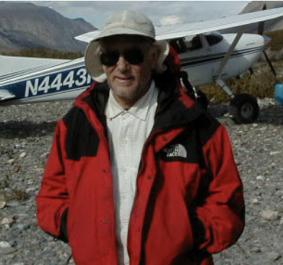
In 1998 at the Stanford Libraries David Rosenthal and Vicky Reich started the LOCKSS Program with funding from NSF. It is aimed at long-term preservation of web published materials (e-journals, books, blogs, websites, archival materials, etc). From 1999-2002 he worked on it at Sun Labs. From 2002 until he retired in 2017 he worked on it at the Stanford Libraries.

David built and tested the initial prototype, developed the OpenBSD-based network appliance technology that LOCKSS peers used for the first 5 years of production, and was part of the research team that developed the award-winning fault- and attack-resistant peer-to-peer network technology that underlies the LOCKSS network. This was a decentralized consensus system using proof-of-work published more than five years before Satoshi Nakamoto published the Bitcoin protocol, for a different application.

David started blogging in 2007 at https://blog.dshr.org/. As well as the LOCKSS technology, he has written on economic models for long-term storage, emulation as a preservation strategy, DNA as a storage medium, the decentralized Web, the economics of peer-to-peer systems, and many other topics. The blog features the complete text of his many presentations, with links to the sources, and expanded versions of some of his recent technical publications.

David joined Sun Microsystems in 1985 from the Andrew project at Carnegie-Mellon University, where he had worked on window systems with James Gosling. He worked on window systems with James at Sun, and was part of the teams which developed both NeWS and the X Window System, now the open-source standard. He also worked on graphics hardware, the operating system kernel, and on system and network administration.

David left Sun in 1993 to be Chief Scientist and employee #4 at Nvidia, now the leading supplier of high-performance graphics chips for the PC industry, where he worked on I/O architecture. In 1996 he joined Vitria Technology, now a leading supplier of e-business infrastructure technology. There, he worked on reliable multicast protocols and on testing industrial-strength software.
David was educated at the Haberdashers' Aske's School, Elstree at a time when it was a "direct grant school". He received an MA degree from Trinity College, Cambridge and a Ph.D. from Imperial College, London. From 1976 to 1983 he was a post-doc at EdCAAD, Edinburgh University's computer-aided architectural design group run by Aart Bijl, including spending 1982 on sabbatical teaching at the Universiteit van Amsterdam and researching at what was then the Mathematisch Centrum, and is now the Centrum Wiskunde & Informatica. He is the author of many technical publications and holds 23 patents. His interests include backpacking and the theater.

