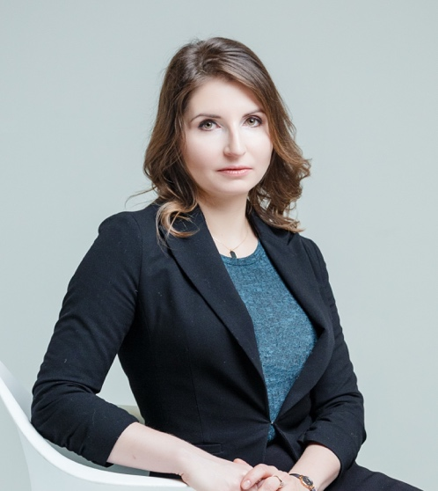
Maria Snegovaya Bio
I am a Post-Doctoral Fellow at the Johns Hopkins University School of Advanced International Studies, and an Adjunct Fellow at the Center for European Policy Analysis. I hold a Ph.D. in Political Science from Columbia University.
My research focus is the democratic backsliding and the spread of populist actors in East Central Europe. My dissertation explains the success of these parties in the region as a function of the economic policy choices made by left-leaning parties of the post-Communist era. I also explore the commonality in factors underlying the decline of leftist parties and the rise of populist right across Europe.
My main research interests also include Russia’s domestic and foreign policy, the political situation in Ukraine, and the Russian-Ukrainian conflict. In particular, I research how the factors of Russia’s domestic politics affect its foreign policy dynamics.
Throughout my time in the doctoral program, I have collaborated with the Institute for the Study of War, the Brookings Institution, Eurasia Group, and Freedom House. I have authored several reports and studies, including “Stifling the Public Sphere: Media and Civil Society: Russia,” for the National Endowment for Democracy; and “Putin’s Information Warfare in Ukraine. Soviet Origins of Russia’s Hybrid Warfare. Analytical Report,” for the Institute for the Study of War.
My publications have appeared in peer-reviewed journals, the Washington Post‘s political science blog the Monkey Cage; the Huffington Post; the New Republic; Politico; and the American Interest. My research has been referenced in publications such as the New York Times, Bloomberg, the Economist, the Dish, and the Telegraph. I am frequently invited to give talks at U.S. universities and think tanks, including the Kennan Institute at Wilson Center, the Atlantic Council and the Carnegie Endowment for International Peace.
I hold an M.A. and MPhil in Political Science from Columbia University as well as a Candidate Degree in Economics and a B.A. in Economics and Finance from the Higher School of Economics.

