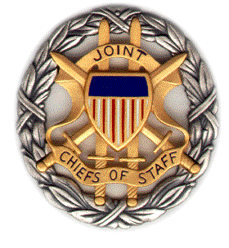

SMA Panel Discussion

The Opioid Crisis: China,
National Security, and
the Undeclared Conflict

Booklet
6 September 2019
1100-1200 ET

Dial (866) 712-4038; Passcode 37250264#

Strategic Multi-Layer Assessment (SMA) provides planning support to Commands with complex operational imperatives requiring multi-agency, multi-disciplinary solutions that are NOT within core Service/Agency competency. Solutions and participants are sought across USG and beyond. SMA is accepted and synchronized by Joint Staff/J-39 DDGO and executed by ASD (EC&P).

Agenda

Panel Description: On 6 September 2019 from 1100-1200 ET, SMA will host a panel discussion, entitled “The Opioid Crisis: China, National Security, and the Undeclared Conflict.”
The opioid crisis is an example of the ways that China has and could continue to pulse internal events within United States socio-economic culture in order to opportunize direct or proxy activities to evoke disruptive effects via non-kinetic engagement.
This briefing addresses the background, processes, and implications of China’s involvement in the opioid crisis; describes prior and current efforts of the Drug Enforcement Agency; discusses ways that the Department of Defense might optimize its role in mitigation and prevention; and defines potential, possibilities and problems of non-kinetic engagement.

Topics of Discussion: The speakers for this discussion and their topics of discussion will include:
- Dr. James Giordano (Georgetown University)- Introduction (5 min.)
- CAPT (Ret.) L. R. Bremseth- The Undeclared Conflict America is Losing (10 min.)
  - China's distribution of opioids via the Mexican cartels as one of numerous forms of non-kinetic warfare against the U.S. in concert with the teachings and philosophy of Sun Tzu
- Ms. Angela S. von Trytek (Drug Enforcement Administration)- The DEA Effort (10 min.)
  - DEA’s mission in combatting the trafficking of illegal fentanyl from China
- Brig. Gen. David G. Reist (Knowledge Management Inc. (KMI))- The Ideal DoD Effort (10 min.)
  - The DoD is currently engaged along the border. This part of the discussion will include thoughts on Rules of Engagement, military readiness, and opportunities to best employ the force
- Dr. James Giordano (Georgetown University)- Engaging Non-Kinetically (10 min.)
  - Non-kinetic engagements (NKEs) can be leveraged as activities of multiple level disruption. NKEs provide distinct advantages for the instigator, and disadvantages for the recipient(s), which make defense difficult. These factors will be discussed in light of developing both a stance of preparedness and resources and methods of mitigation and prevention.
The final 15 min. will be reserved for questions and answers.

Speaker Biographies

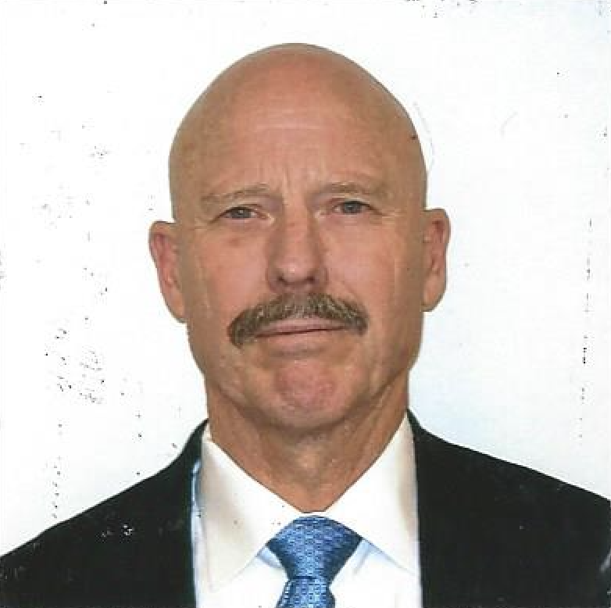
CAPT (Ret.) Loren R. (Rick) Bremseth

(Deputy Senior Director)
(Integration Support Directorate)

Rick Bremseth served as the Deputy Senior Director of the Integration Support Directorate (ISD) for the Department of the Navy (DON). As such, he was a key advisor to the Secretary, Under Secretary and Deputy, Under Secretary of the Navy for sensitive activities. He was responsible for the synchronization, facilitation, overall planning, coordination, and execution within the DON for Sensitive Activities, Irregular Warfare, and Special Operations Forces support. He served as a primary liaison and interface for these areas from the DON to the Office of the Secretary of Defense, the Chief of Naval Operations, the Commandant of the Marine Corps, the Naval Criminal Investigative Service, and various other departments and agencies of the U.S. Government.
Mr. Bremseth was appointed to the Defense Intelligence Senior Level on 26 August 2012. He worked in the ISD for over six years and served as the Director, Operations and Executive Director prior to his appointment as Deputy Senior Director. He retired from the Navy in 2006 with twenty-nine and a half years of service. He earned a Bachelor of Arts degree in psychology from the University of California, Riverside, and a Master of Science degree in Strategic Studies from the U.S. Marine Corps War College.
Mr. Bremseth’s naval service was all within the Naval Special Warfare community. His assignments were varied and included tours of duty at three separate Theater Special Operations Commands. He commanded SEAL Team EIGHT (1996-1998) and his major command tour was at Naval Special Warfare Group THREE (2003-2005). He served as Deputy Commander, Special Operations Command, Pacific and Deputy Commander, Combined/Joint Special Operations Task Force, Bosnia-Herzegovina. He also commanded the Joint Special Operations Task Force, Operation Enduring Freedom – Philippines.
His military awards include the Defense Superior Service Medal, Legions of Merit, and associated joint, unit, and campaign awards and decorations by the Department of Defense and the Department of the Navy.

Dr. James Giordano (Georgetown University)

James Giordano, PhD, is Professor in the Departments of Neurology and Biochemistry, Chief of the Neuroethics Studies Program of the Pellegrino Center for Clinical Bioethics, and Co-Director of the O’Neill-Pellegrino Program in Brain Sciences and Global Law and Policy. As well he is J5 Donovan Group Senior Fellow, Biowarfare and Biosecurity, at US Special Operations Command, (USSOCOM). He has served as Senior Science Advisory Fellow to the SMA Group of the Joint Staff of the Pentagon, and as an appointed member of the Neuroethics, Legal and Social Issues Advisory Panel of the Defense Advanced Research Projects Agency (DARPA). He is an elected member of the European Academy of Science and Arts, and a Fellow of the Royal Society of Medicine (UK).

Brig. Gen. David G. Reist (Knowledge Management Inc. (KMI))

Serving 31 years in the Marine Corps, Dave Reist served in various positions as a logistics officer. After retirement, he spent five years at the Potomac Institute, eventually accepting a position with Knowledge Management Inc. (KMI). He is currently the KMI Program Manager for the Enterprise Ground Equipment Management (EGEM) program supporting the Deputy Commandant, Installations & Logistics. In the Marine Corps he commanded on six separate occasions at all levels, culminating in leading an 8,000+ unit that supported operations globally. Combat tours in Iraq witnessed support to I MEF to leading the economics and governance efforts in Anbar Province. Across his career, he served as a MAGTF Officer supporting Marines in tactical environments to executive staff positions focusing on support for Joint and Marine Corps operations and logistics processes. He retired as a Brigadier General on 1 Sept 2009 while serving as the Director of Logistics Plans & Policies, Headquarters, US Marine Corps.

Ms. Angela S. von Trytek (Drug Enforcement Administration)

ANGELA S. VON TRYTEK
Supervisory Special Agent / Liaison Officer to U.S. Southern Command
Office of Foreign Operations
Drug Enforcement Administration
Ms. von Trytek was appointed as the Liaison Officer to the United States Southern Command (SOUTHCOM), in the Office of Foreign Operations, Drug Enforcement Administration (DEA) Headquarters, Arlington, Virginia in September 2018. Prior to her SOUTHCOM assignment, she was the Section Chief overseeing the Confidential Source Section in the Office of Operations Management.
Ms. von Trytek has thirty years of law enforcement experience. Beginning in 1999, she was assigned as a Special Agent in the Anchorage, Alaska Resident Office, where she led complex polydrug investigations. In 2003, she was reassigned to the El Paso Intelligence Center (EPIC) as a Watch Operations Officer. In this position she provided real time intelligence support to domestic and foreign EPIC interagency counterparts.
In 2005, Ms. von Trytek was assigned to the South-Central Aviation Resident Office as a Special Agent/Pilot (SA/Pilot) in Fort Lauderdale, Florida where she became the first woman helicopter pilot in the history of DEA Aviation. She flew single and multiengine helicopters in support of domestic and foreign DEA investigations and operations. In 2009, she was reassigned overseas with DEA to the Kabul Afghanistan Country Office. She worked with our interagency partners and the Government of Afghanistan in furtherance of DEA and United States Embassy counterdrug policies and objectives. Upon departing Afghanistan in 2010, Ms. von Trytek was promoted and selected to serve as the Resident Agent in Charge of the South-Central Aviation Resident Office, becoming the first woman supervisor in the history of DEA’s Aviation Division. During Ms. von Trytek’s tenure with DEA, she has earned a reputation for her communication skills, drive, insight, managerial, and organizational skills. Prior to her tenure with DEA, she was a Deputy Sheriff with the Harris County Sheriff’s Office in Houston, Texas.
Ms. von Trytek served twenty-five years in the U.S. Army and Army Reserve retiring at the rank of Captain in July 2008. During her military career, she was an Enlisted Soldier, Warrant Officer, and Commissioned Officer. Ms. von Trytek served three combat tours comprised of Operation Desert Shield/Storm (1990/1991), Task Force Able Sentry, Macedonia (1996), and Operation Enduring Freedom (2007/2008).
Ms. von Trytek is an alumna of the University of Houston with a bachelor’s degree in Interdisciplinary Studies. She holds a Master of Science in Criminal Justice Leadership and Management from Sam Houston State University and she is currently a doctoral candidate in Leadership Studies at Our Lady of the Lake University, San Antonio, Texas. She has received numerous awards and commendations from DEA and the Harris County Sheriff’s Office in recognition of her leadership, service, and vision.

