Computation and Artificial Intelligence for Joint Planning

Joint doctrine is based on systems theory. As understanding of these systems has advanced the concepts describing them have also been called complex systems, complex adaptive systems or simply complexity. The fact that complex systems theory has only recently become studied and is spreading across numerous fields is because of the development of computers. Computers are as essential a tool for analyzing these systems as a telescope is for astronomers or a stethoscope is for medical doctors. Appreciating the necessity of computation as a tool to analyze complex systems and enable joint planning, combined with an assessment of the general strengths and weaknesses of different categories of computational tools allows for a holistic assessment of their integration into the Joint Planning Process.
To integrate computational tools into Joint processes it is first necessary to understand that there is Artificial Intelligence (AI) is a discipline not an intelligence. AI is a variety of computational tools each with their own conceptual background, and each with their own strengths and weaknesses. Generically, the AI toolkit can be broken down into two overlapping categories: (1) classify and perceive tools (2) simulation tools. The most widely known AI tools are those which have excelled in industry because they help parse incredible amounts of data. These AI tools fall into the classify and perceive category and can be further subdivided into machine learning and deep learning categories. Machine learning (ML) has a variety of approaches which includes tools like Support Vector Machine, Bayesian classification, and Regression, and each ML category can be further subdivided and most parameterized. Deep learning uses artificial neural networks in a mind-boggling variety of configurations. These classify and perceive tools are supported by rich open source libraries which users can employ with very few lines of code and minimal training. However, despite their popularity these tools are only part of the whole toolset.
Simulation tools have been used by the DoD for a long time, but the field has grown substantially and not necessarily incorporated. Notably, Agent Based Models (ABMs), considered distributed AI, have emerged as an intuitive tool to support policy development as virtual laboratories that simulate complex phenomenon from cell behavior to the world population. ABMs are being used for analysis and decision making and are even being used daily to help formulate national level economic policy. ABMs are primed to be operationalized and move simulations from a niche tool to an essential tool of the Joint Planning Process. Currently, ABMs lack a rich ecosystem, like the one that supports classify and perceive tools, to allow for easy employment. This lack of an ecosystem, however, is an organization problem not a production problem. Nascent attempts are being made to rectify this situation and this situation provides to the opportunity for the DoD to become a leader in the area if it acts quickly. Simulations are at the cusp of being moved from a niche field to a basic tool of analysis and planning. Based on the theoretic implications of complex systems, operationalization of ABMs is not a luxury but a competitive necessity.
Intertwined with the classify and perceive toolkits and the simulation toolkits is the need for the Joint workforce to improves its technical capability and employ basic computation at all levels. All the AI tools help humans understand, and represent only a portion of what computation can do to aid understanding. The professional knowledge of the Joint workforce is unequaled. Computation provides the capacity for these professionals to encode their knowledge. This will not only allow them to exponentially increase their productivity but also pass their knowledge across their networks to more effectively share best practices and insights. Furthermore, customizing and employing AI tools can help them gain new insights which they can in turn leverage to further advance their understanding and develop new tools. Leveraging only existing AI tools or those developed outside the Joint workforce, ignores the vast knowledge embedded in the professional Joint workforce. Enabling them with improved technical capability will vastly improve the Joint force’s ability to leverage the ever-expanding suite of AI tools and add new customized computational tools particular to their area of the Joint problem set.
Understanding computation as a vast toolkit, which covers everything from existing and emerging fields of AI to customized algorithms, produces the need to integrate these different tools in the correct spot of the Joint Planning Process. As these tools primarily help humans understand their detailed integration is most evident in as subprocess of the Joint Planning Process, the Joint Intelligence Process (see figure). Although these tools can be employed at any point, generally, classify and perceive tools are most applicable to aid collection, and the processing and exploitation of the ever-increasing collection of data. Classify and perceive tools are a necessity in finding the right data with the right perspective for one’s problem out of the overwhelming amount of collected information. Simulations are most applicable to the analysis and production, and the dissemination and integration portions of the Joint Intelligence Process. Simulations will allow users to simulate the impacts of their data and how the adversarial force or foreign population is processing and employing the resources at their disposal. This serves to aid rigor by enabling analysts to simulate their assessment and see if it replicates the observations they are making on the ground. Once developed, these simulations can then be used by planners to try different policies or courses of action by serving as a virtual laboratory. Critically, these simulations will not provide answers as much as enhance understanding. Simulations then serve as a dynamic representation of the Joint force’s understanding and planning implementation in a format far beyond what is in use today.
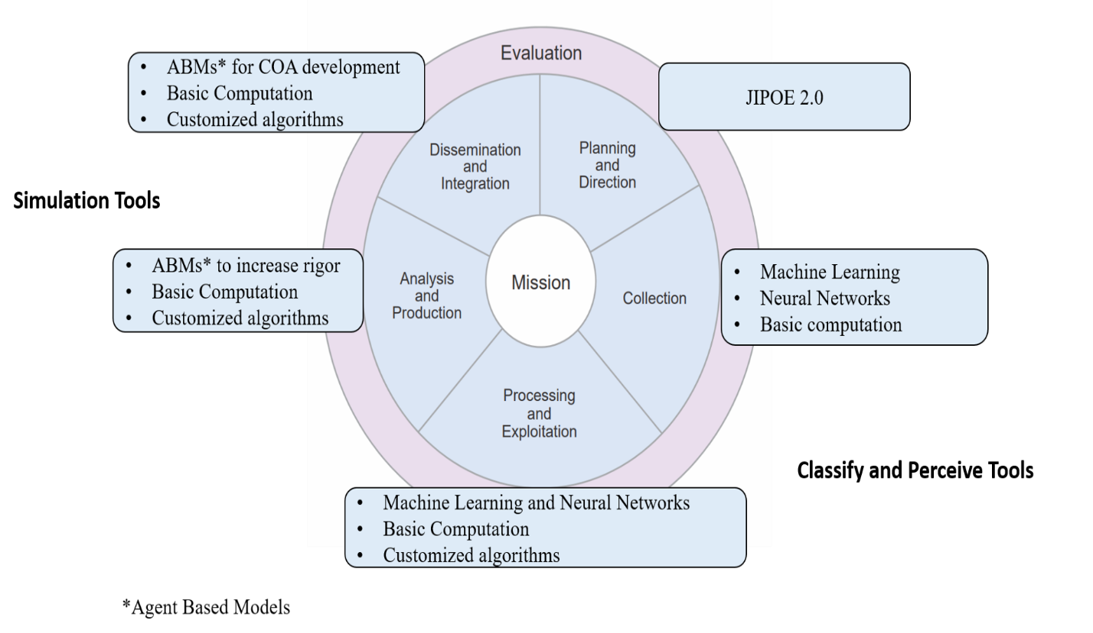
The integration of computation into the Joint Planning Process is a necessity. Understanding the nature of computational tools allows for a better assessment to determine their integration into Joint processes to ensure the Joint force maximizes their use and maintains a competitive advantage.

