Analysis and Artificial Intelligence in Integrated Campaigning

Thomas Pike, Ph.D.

LTC, USA
thomas.d.pike.mil@mail.mil

**The views in this paper are the author’s own and do not reflect those held by the U.S. Army, Department of Defense or U.S. Government**
Abstract: Integrated Campaigning requires the development and execution of U.S. foreign policy across the whole of the U.S. Government (USG). Such coherent policy development and implementation necessitates a common perspective to analyze the situation that provides (1) an accurate description of operating environment and (2) supports synergistic action across the USG with minimal coordination. The current analytic approach for the Department of Defense, the Joint Intelligence Preparation of the Operating Environment (JIPOE), has a strong foundation but can be improved to better accomplish these requirements and more effectively support Integrated Campaigning. Advancing from the JIPOE’s systems foundation, the USG must adopt a perspective which views the behavior of a foreign entity as the result of the adaption and competition of layers of interdependent groups. Although this description may defy intuition an updated JIPOE framework and some examples will help develop intuition for the dynamics of complex adaptive systems. Due to the complexity of these systems, computational tools are inextricably intertwined with their analysis and have the added benefit of being able to encode knowledge for more effective coordination. An improved analytic framework combined with an understanding of existing and emerging artificial intelligence (AI), a subset of computational tools, allows for an assessment of how computation fits into both the Joint Intelligence Process and Joint Planning Process to support Integrated Campaigns. This shift in understanding has far reaching consequences for all joint staffs but particularly the J2, J3, and J5 and has the potential to revolutionize the conduct of foreign policy.

Improving our Perspective
Integrated campaigning requires the development and execution of U.S. foreign policy across the whole of U.S. Government (USG) (Joint Concept for Integrated Campaigning 2018). Although a holistic USG approach does not exist, the Department of Defense (DoD) argues for such an approach through its Joint Concept of Integrated Campaigning and its Joint doctrine provides a well-documented process for coherent course of action (e.g. policy) development. Coherent policy development and implementation across large organizations requires a common perspective to analyze the situation that provides (1) an accurate description of the situation and foreign policy dynamic and (2) supports synergistic action with minimal coordination. The current analytic approach for the Department of Defense, the Joint Intelligence Preparation of the Operating Environment (JIPOE), has a strong foundation but can be improved to better accomplish these requirements and effectively support Integrated Campaigning, particularly if it is to spread beyond the DoD. JIPOE adopts a categorical approach, notably Political, Military, Economic, Social, Information and Infrastructure (PMESII) to understand the operating environment but categories fail to account for interdependencies with the foreign population system. This is fundamentally at odds with the current understanding of complex systems, which is the foundation of JIPOE (Joint Intelligence Preparation of the Operating Environment, 2014). The USG must adopt a perspective which views the behavior of a foreign entity as the result of the adaption and competition of layers of interdependent groups within the foreign entity. Because this approach reflects the current understanding of complex systems, an analysis of interdependent and adapting groups provides a more accurate assessment of the situation. The challenge is analyzing the interdependencies and possible adaptions of layers of foreign groups defies both human cognitive capacity and analytic equations.
Due to the literal complexity of complex adaptive systems, computational tools are inextricably intertwined with their analysis and are able to encode knowledge for more effective coordination across the USG. An improved analytic framework combined with an understanding of existing and emerging artificial intelligence (AI), a subset of computational tools, allows for an assessment of how computation fits into both the Joint Intelligence Process and Joint Planning Process to support integrated campaigns. This symbiosis of emerging technology into the everyday processes of military affairs has been the historic catalyst for revolutions in military affairs (Boot, 2006), and this integration of technology and perspective through Integrated Campaigning has the potential to not only revolutionize the conduct of military affairs but the whole of foreign policy.
The Joint Concept for Integrated Campaigning (JCIC) acknowledges the historic perspectives of peace and war make foreign policy harder and an integrated approach across the U.S. Government (USG) with a more nuanced understanding is necessary (Joint Concept for Integrated Campaigning, 2018). The JCIC describes “Integrated Campaigning as Joint Force and interorganizational partner efforts to enable the achievement and maintenance of policy aims by integrating military activities and aligning non-military activities of sufficient scope, scale, simultaneity, and duration across multiple domains.” It then goes on to provided four interrelated elements for the conduct of Integrated Campaigning, (1) understanding the operating environment (OE), (2) design and construct the campaign, (3) employ the integrated force and secure gains, (4) assess and adapt the campaign (2018) (Figure 1). Interwoven through this concept is the competition continuum (Figure 2) and the JCIC examines implementation of each of the four elements along this continuum. This study furthers the JCIC by providing a complex adaptive systems approach to support Integrated Campaigning. Applying a complex systems approach provides immediate recommendations for Joint doctrine and provides an assessment on the integration of computational tools.
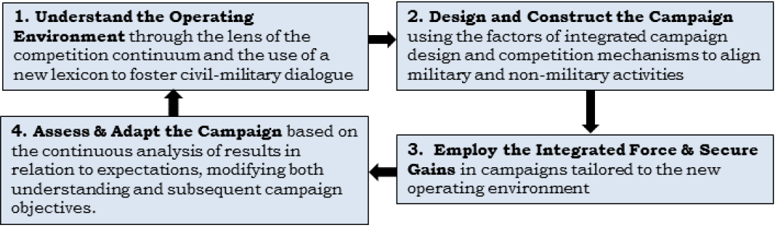
Figure 1: Competition Continuum (Joint Concept for Integrated Campaigning, 2018)

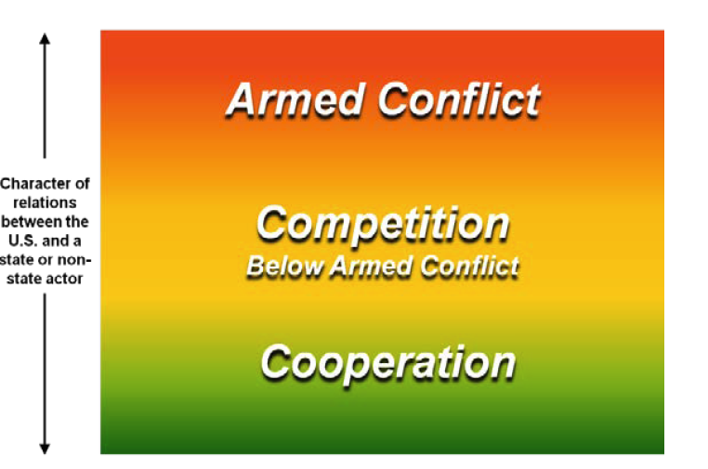
Figure 2: Competition Continuum (Joint Concept for Integrated Campaigning, 2018)

This study is organized into two layers for shorter and longer readings. Each layer provides recommendations to further develop JIPOE, the Joint framework to understand the OE, and recommendations for how to integrate computational tools into the USG’s foreign policy system to enhance Integrated Campaigning. The first layer provides the foundational understanding of complex systems, a description of the implications to the JIPOE, and a description for the integration of computational tools. The second layer then provides an upgraded JIPOE framework, a discussion about the dynamics of computation, and how different Artificial Intelligence (AI) tools can be overlaid on existing Joint processes to support Integrated Campaigning.

On Complex Adaptive Systems
Complex adaptive systems provides a scientific perspective to explore everything from physics and biology to economics and political science (Axtell & Epstein, 1996; Beinhocker, 2006; Cioffi Revilla, 2017; Mitchell, 2009; Simon, 1997; Smith & Morowitz, 2016). Over the past decade, a complex systems perspective has become the dominant focus of policy studies (Dunn, 2018) and is ubiquitous in the study of conflict from counter insurgency to high intensity conflict (Clausewitz, Howard, & Paret, 1976; Joint Intelligence Preparation of the Operating Environment, 2014; Kilcullen, 2010, 2013; Lawson, 2014). Complex systems can be understood at numerous degrees of difficulty, which is essential as it will be shown that this perspective needs to be applied by 18-year-old Servicemembers and senior Foreign Service Officers.
Presenting complex systems in their simplest construct, they are adaptive networks (Krakauer, 2018), where the interdependencies (e.g. edges, links) are important (Miller & Page, 2007; Mitchell, 2009). For example, a family is in a homeostasis with each member through its interdependencies to the others. This homeostasis shapes the behavior of the members. If a parent is an alcoholic or nurturing, there are known impacts on child behavior. If the homeostasis changes, a parent becomes sober or a parent dies, the resources flowing (e.g. information, mood, money) across the interdependencies change and the family network adapts. This new configuration results in a new homeostasis and a change in both the individual and emergent family behavior. (Sapolsky, 2017; Shonkoff & Phillips, 2000). Groups of interdependencies also exist simultaneously (e.g. home group and work group) and at multiple levels in constructs such as families, neighborhoods, cities and nations. This layered structure of subgroups is essential as it provides resilience to the system (Cioffi Revilla, 2017; Holland, 1995; Miller & Page, 2007; Simon, 1997).
Unlike the classical view of science which has analytic equations to explain behavior, simple mechanisms combined with numerous interactions are more helpful in understanding complex systems (Grimm et al., 2005). A critical element in these interactions is uniqueness, each group even if similar or using the same processes is in a slightly different situation, and this uniqueness influences the emergent behavior of the system (Axtell et al., 2002; Lorenz, 1963). This uniqueness is literally a part of us, as each human has a unique genetic code and this code is not only unique to each person but even expressed differently based on that individual’s environmental exposure. Complex adaptive systems are therefore a network whose behavior emerges from the adapting interdependencies of numerous groups at multiple levels. Although this description may strain intuitive understanding its implications can be explored through an analysis of the JIPOE framework.

JIPOE and Complex Adaptive Systems
JIPOE does use a systems approach, but does not account for the unique interdependencies of groups at numerous levels. JIPOE focuses on a categorical analysis of elements within the OE, without explicit descriptions of how resources flow across the network to understand the interdependencies between groups. This approach is epitomized by the PMESII (Political, Military, Economic, Social, Information and Infrastructure) construct (Joint Intelligence Preparation of the Operating Environment, 2014). PMESII’s categorical breakdown implies these are the universal elements of any society, which produce its emergent behavior. A cursory examination of any two nations reveals this is not true; each nation is composed of unique groups. Even taxonomically similar groups, such as the military, are vastly different across nations in their organization and behavior due to their local interdependencies. In addition, a core component of complex systems is different levels of groups whose functioning defies the PMESII breakdown. Failing to account for the system’s unique groups at multiple levels implicitly causes an underestimation of the system’s resilience, since there are no layers of subcomponents (Simon, 1997). Identifying the unique groups then requires an understanding of each group’s interdependencies (e.g. income, relationships) which reveals how the groups survive and compete within their system. This analysis provides the possibility of assessing how altering interdependencies may weaken some groups, strengthen others or cause sub-group(s) to realign. JIPOE accounts for the main elements of complex systems by viewing them as networks, but it misses the essence of these dynamic systems whose behavior is determined by the flow of resources through the layers of groups.
Understanding that the groups and their interdependencies are what produces the emergent behavior of the foreign system means altering the interdependencies (including the internal processes of the sub-groups) is how to alter the behavior of the foreign nation. Identifying these groups then allows for analysis of each group’s interdependencies and their internal processing of those resources. Analysis of the groups and their interdependencies shows how they survive and compete within their system and this understanding provides the foundation with which to develop effective policy and anticipate how that policy will influence foreign behavior.
Pakistan serves as a clear example of why the groups which compose the foreign population must be the focal point and the system cannot be broken down in common categories. The military, the M in PMESII, has its own businesses preventing its control by the government (Siddiqa, 2017), and occasionally acts as a political entity when it takes control of the government. When the military becomes a political entity it becomes subject to the same patronage dynamic of the other major political parties all of whom must dole out patronage to the kinship groups and be supported by the professional bureaucrats (Lieven, 2011; Talbot, 2012). The interdependencies of the military shape its emergent behavior. Having its own financial resources provides it autonomy, with less consequences for coups, while when it is in political power it is still subject to the same government interdependencies with the kinship and bureaucratic groups that also shape the behavior of Pakistan’s political parties. PMESII’s categorical breakdown places a dynamic group like the military into one category without capturing its economic dynamic or allowing it to adapt into a political entity. The component parts of complex systems are not general categories, but the unique groups and their interdependencies of the foreign system of interest.
Understanding how the groups within the foreign population survive and how they can adapt must be the focal point of analysis and it must be understood that processes of a group under one condition may not work under another. For example, Sparta, after defeating Athens in the Peloponnesian War, was defeated by Thebes only 33 years later as the Spartan system which made it initially successful, undermined its strength when it transitioned from a local to a regional power. Becoming a regional power changed the flow of resources into the Spartan system, as these new resources where processed through the Spartan socio-political system, they unexpectedly disintegrated the core of the Spartan army (Bueno De Mesquita, Smith, Siverson, & Morrow, 2003). Analyzing complex systems is challenging because the emergent behavior at each level is the result of the functioning and interdependencies of those groups at a moment in time.
The reality of layers of adapting groups provides foundational support to the concept and justification for Integrated Campaigning. The U.S. foreign policy system must work coherently at multiple levels and across specialties if it is to effectively influence the interdependencies of a complex and adapting foreign system in pursuit of policy goals. Colloquially, how do you organize and enable the enterprise to work together to influence the functioning of the foreign socio-political-economic system. Computational tools which are an essential tool to understand the operating environment (OE), further increase in importance as they enable more effective interdependencies within the U.S. foreign policy system as it works accomplish its policy goals.

Integrating Computation
It is not a coincidence that complex systems have come to the forefront of many disciplines at the same time computational power has increased and the entry barrier to employ code has lowered. Repeated interaction of unique and adapting entities defies closed form analytic equations, but computers are able to simulate these interactions. Complex systems were previously ignored as the mathematical and scientific tools to analyze them were too cumbersome. They are now being embraced because computers allow them to be analyzed (Cioffi Revilla, 2017; Gleick, 1987; Prigogine & Stengers, 1984; Simon, 1997). In addition, the ability of computers to do a large number of calculations allows for not only simulations of complex systems but has allowed for the explosion of the prevalent AI tools of machine learning and neural networks (Goodfellow, Bengio, & Courville, 2016). Computer code also allows for the storage and transfer of these processes so they can be compartmentalized and combined in unique and novel ways by any user (Booch et al., 2007). Computation provides an essential tool to analyze complex systems, process the overwhelming amount of data collected, and store these techniques so they can propagate across the U.S. foreign policy system.
Based on the capabilities of computational tools, they can be integrated in three ways. First, as tools to reduce processing challenges due to the ubiquity of data. Second, as virtual laboratories to test analysis and experiment in silico with policies (i.e. courses of action) and third, as technical bridges to allow expert algorithms to support analysis and planning. In a practical narrative, collection assets obtain large amounts of data from the OE and use AI to help curate and process the data. The team then further studies and processes this data integrating it with its qualitative understanding of the local dynamics based on group interdependencies. The team then ‘plugs and plays’ advanced, vetted algorithms by domain experts, to custom build distributed AI simulations (e.g. Agent Based Models) to grow the main dynamics of their OE in silico. Successfully growing the observed dynamics provides a more rigorous test of one’s understanding of the OE and then provides a virtual laboratory to try different campaign designs prior to execution which is then updated as the team assesses and adapts during execution. As unique groups exist at multiple level across the foreign policy system, this approach, at varying levels of complexity, must be employed from the battalion and/or USAID team in a village to the National Security Council.

Integrated Campaigning Analysis and Planning
The ‘right’ perspective for understanding the OE is critical to the success of Integrated Campaigns. Complex adaptive systems provide the right perspective and is used by all disciplines which make up the U.S. foreign policy system. The Joint application of complex adaptive systems, through the JIPOE, needs to immediately change the focus from a categorical breakdown to group identification and analysis. The USG must further integrate computational tools to share knowledge, process data and conduct more effective analysis and planning. Incorporating distributed AI will allow analysts to grow in silico their OE of interest, providing a more rigorous check on their assessments. Planners can then use validated models as a virtual laboratory to develop and test their designs. The holistic integration of both improved concepts and emerging technology is the historic recipe for major advances in the conduct of war (Boot, 2006) and in this case will include an unprecedented impact on foreign policy in general. The next sections delve deeper into these dynamics providing an updated JIPOE framework and provides a more detailed discussion on the integration of different computational tools.

JIPOE 2.0

An Updated Framework
An improved understanding of complex adaptive systems makes the task of updating JIPOE fairly straightforward. First, the focus must be on the groups within the system. As these groups will be unique, they must first be identified. Second, the interdependencies of the groups are how the groups survive and competes and so shape their behavior, so each group’s interdependencies must be identified. Third, each group will have historic behaviors, these can be understood as their typical policies or courses of action when dealing with the various situations they face. This section then falls into the familiar pattern of intelligence analysis, where the analysts provides possible behaviors (i.e. courses of action) for the specific situations of interest (Joint Intelligence Preparation of the Operating Environment, 2014). Fourth, simulate this assessment and compare its emergent behavior to that of the system (table 1). A comparison to test the models behavior against reality is known as validation (Grimm & Railsback, 2005). An upgraded JIPOE shifts the focus from the categorical breakdown of a population to the identification and analysis of the unique groups and their interdependencies within the population, while incorporating simulations as an essential part to test one’s analysis and add rigor to the process.

JIPOE 2.0
Identify the groups within the System
Identify each group’s interdependencies (e.g. flow of resources)
Identify each group’s possible behaviors (e.g. policies, courses of action)
Simulate the OE and validate the model behavior against observed behavior
Table 1: JIPOE updated to reflect a focus on group identification and analysis

Weaknesses of JIPOE 2.0
The obvious challenge with this approach is complex systems are groups ‘all the way down.’ This begs the question, if an analyst is looking at the nation level, does one need to include a neighborhood organization in a suburb of the city or even each person and their unique behavior? The unrealistic answer is yes. Complex systems are known to be deterministically unpredictable, which means the past determines the future, but the future cannot be predicted past its prediction horizon (Gleick, 1987; Strogatz, 2003). This is important to understand because it tempers expectations, custom simulations will not simulate the future, they will enhance understanding. These simulations are a more rigorous representation of one’s understanding which can be more effectively conveyed and tested across the foreign policy system. The realistic answer, then, is one needs to focus their analysis at the level appropriate for the organization they are supporting, whether that is a village or a global assessment. Despite these unavoidable obstacles, even a generic application without simulation, provides a fundamentally different narrative for U.S. foreign policy.

A New Understanding of U.S. Foreign Policy Objectives
If a foreign country is the emergent behavior of its particular layers of interdependent groups then where does a democracy fit within this framework? The short answer is from elementary school civics; it is the country where there is a balance of power. A more developed answer comes from political science, specifically Selectorate theory (Bueno De Mesquita et al., 2003). Implicitly, Selectorate theory adopts a complex system approach as the government of a country is determined by its winning coalition (which is a coalition of groups and individuals within the system), while every other group is in either the real selectorate (e.g. actual voters) or nominal selectorate (e.g. people who can vote) (Bueno De Mesquita et al., 2003). Selectorate theory then predicts under what dynamic a country switches from a dictatorship to a democracy based on size of the winning coalition and dynamics of the selectorate. Briefly, if the winning coalition is small it is easier to pay off the members with private goods then it is to provide public goods such as infrastructure or rule of law (Figure 3) (Bueno De Mesquita et al., 2003). This then provides an objective for U.S. Foreign policy; keep the winning coalition large so the government must provide public goods.
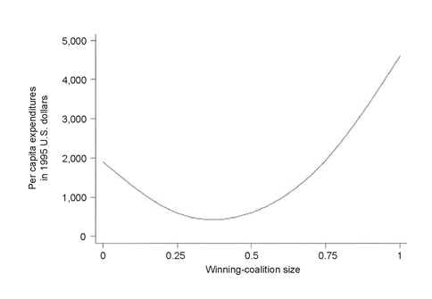
Private Goods*
Public Goods
Figure 3: Empirical relationship between coalition size and distribution of goods (Bueno De Mesquita et al., 2003) * Author added for clarity

These conclusions played out in real life in Afghanistan as the power and support the U.S. gave the Karzai administration was used to maintain power and not provide public goods to the population (Kilcullen, 2013). They are also seen in the numerous case studies explored in The Logic of Political Survival (Bueno De Mesquita et al., 2003) and are produced in even simple agent based simulations (Pike, 2018). An understanding of interdependent groups competing inside a foreign government then leads to a profound insight. The power of the U.S. can work against its goals of establishing governments responsive to the population, because by supporting a group or small number of groups, those groups dramatically increase their power and are able to keep their winning coalition size small.
Changing JIPOE from a category focus to a group focus fundamentally alters how the U.S. foreign policy system will understand the situation. First, the U.S. will understand its objectives as keeping winning coalitions large to stimulate the government to provide public versus private goods. Second, the U.S. foreign policy system will understand itself and the resources it provides not as an ally to others espousing democracy, but as an interdependency the internal groups of the foreign system will use for their personal gain. This approach, however, is not a panacea. The complexity of foreign populations will continue defy understanding and any simulation will only be a more complex representation of the U.S. foreign policy’s understanding. This understanding can still be flawed due biases, misunderstanding and personal interest. Overall, this approach should improve understanding as it more accurately represents reality improving foreign policy, but it can still result in failures and challenges.

Computational Integration
Computation provides three advantages to Integrated Campaigning. First, computation can help process the ubiquity of data, which technology can now collect. Second, computation can help simulate the OE for analysts to test their assessments and for planners to use as a virtual laboratory during campaign design and adaption. These two capabilities then represent the third benefit, computation encodes knowledge in a dynamic way to allow more effective sharing and understanding of knowledge across the foreign policy system. Code serves as a technical bridge to provide analysts and planners expert tools to help them more effectively explore and understand their OE. This encoding also allows planners and analysts to share dynamic assessments and plans across the foreign policy system. To explore these advantages this study begins with the concept of encoding knowledge.

Encoding Knowledge
To understand how code can store knowledge and be activated by being put into different processes, this study will briefly discuss the dynamics of AI. To understand AI, it is first important to understand there is no universal or even generalizable algorithm (Domingos, 2018). With the recent surge of artificial intelligence, it is tempting to think there is a general artificial intelligence algorithm. The reality is AI is a discipline that is made up of several sub-disciplines and consist of a large suite of computational tools. Each of these tools do well on certain types of problems and poorly on others. In addition, many can mutually support each other. Furthermore, most AI algorithms must be trained with specific data and then are used in the specific context of their training data with limited or no applicability to other datasets.
AI is really several categories of different computational tools. Figure 4 shows a Venn diagram of different AI categories and figure 5 focuses on machine learning and shows a decision map of which machine learning tools to use based on generic data situations. If there was a general algorithm, companies could just apply this application to their data get insightful outputs and make decisions. Instead, companies are hiring specially trained data professionals to apply the suite of tools to find insights and aid decisions for their specific context. The challenge, just like all analysis, becomes what tool to use when. This situation is further complicated by the fact that many tools have additional parameters, which the practitioner must adjust or to which must be adjusted with training data. Furthermore, if one manipulates the data or the tools enough, you can get the tools to give you whatever answer you want and a clever adversary can find ways to defeat or mislead them (Goodfellow et al., 2016; James, Witten, Hastie, & Tibshirani, 2013). AI is a discipline which consists of a collection of tools, each of which does well in specific situations.
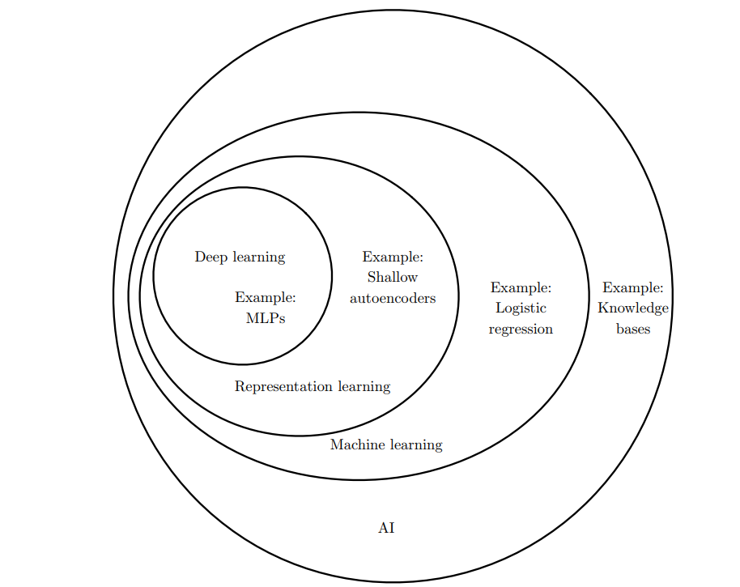
Figure 4: Venn Diagram of Artificial Intelligence (AI) (Goodfellow, Bengio, and Courville 2016) (MLP = Multi-Layer Preceptron)

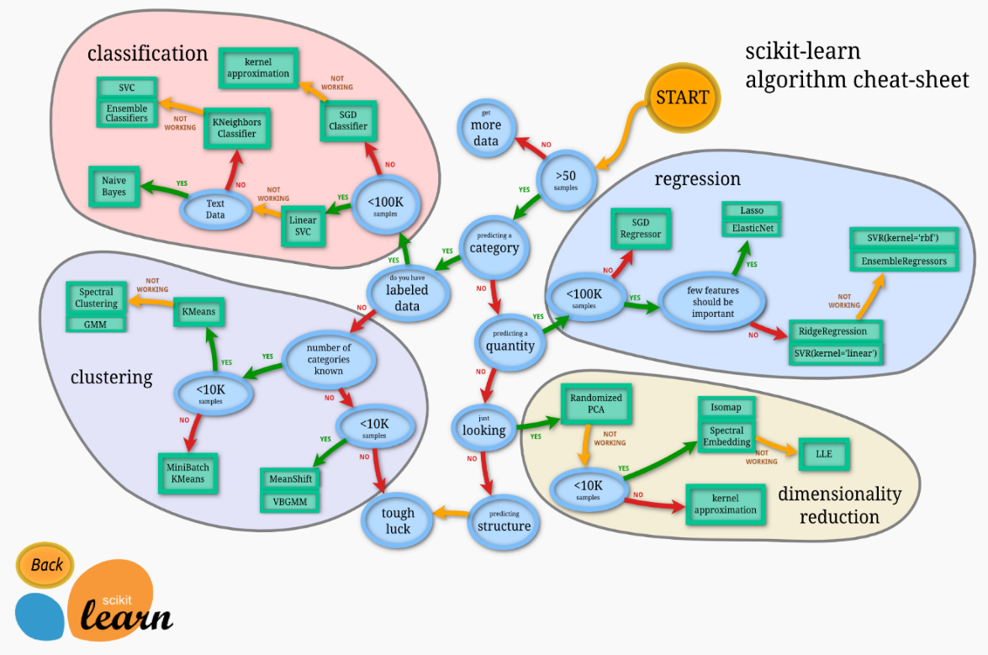
Figure 5: Machine Learning Algorithm Cheat Sheet
What makes AI powerful however is not just how it computes but that fact that it makes advanced algorithms available to everyday practitioners. AI tools are stored in open source libraries which allow large numbers of people to test, employ and improve them. Instead of constantly rewriting the code, an individual applying a machine learning algorithm, building an artificial neural network or performing any number of other computational tasks, relies on a package of code which can be invoked with just a line or a few lines of code. This is significant because the packages not only encode knowledge but also allow that knowledge to be reemployed with different data or with different combinations of encoded knowledge (i.e. other code packages) and passed through the policy or industrial enterprise.
The effect of encoding is a more precise method to share Tactics, Techniques and Procedures (TTPs) or Lessons Learned. Like Soldiers sharing techniques for zeroing the 25mm gun on a Bradley Fighting Vehicle, clearing a route of Improvised Explosive Devices, or briefing terrain features, researchers and practitioners share code to be more successful and make their work more efficient. As an example, using Python based AI tools, the library Scikit Learn provides highly optimized packages for the machine learning algorithms while Tensor Flow provides a similar service for artificial neural networks. Both are free to use and allow individuals to submit improvements. This approach saves time and provides better code. Encoding means analysts and planners do not have to build their own AI or other computational tools, they just need to understand how to apply it. This can increase the coherence of U.S. foreign policy as assessments and plans can be encoded in simulations and dispersed across the foreign policy enterprise.
Appreciating how computers store and share knowledge provides the foundation for the rest of this discussion. With this understanding the next challenge is to understand what tools are best for the different portions of Integrated Campaigning, specifically elements one (understand the OE), two (design and construct the campaign) and four (assess and adapt the campaign).

Artificial Intelligence and Understanding the Operating Environment
Using AI to understand the OE works at all points across competition continuum, likewise the Joint Intelligence Process is applicable across the continuum and provides the basis for common terminology and procedures (Joint Intelligence, 2013). Using the Joint Intelligence Process as the template, one can apply different categories of AI tools to each part of the process (Figure 5). This allows for a discussion of the strengths of the categories of tools against the backdrop of the Joint terminology. Although a simplification, in general there are two types of tools, (1) tools which classify and perceive (Cielen, Meysman, & Ali, 2016; Wright, 2018) and (2) tools which simulate (Gilbert & Troitzsch, 2005).
Tools which classify and perceive are the pervasive AI tools which fall broadly into two categories of machine learning and artificial neural networks. First, machine learning uses a variety of statistical techniques and can help able to identify cancers, personal shopping habits, outliers or any other number of data intensive tasks (Cielen et al., 2016; James et al., 2013). Second, neural networks are good at perception which includes analyzing images and videos and conducting natural language processing (Goodfellow et al., 2016). The prerequisite for machine learning and deep learning tools is data. Machine learning, as shown in figure 5, requires at least 50 data samples from the collection of interest, while a deep learning algorithm which meets or exceeds human capability typically requires 10 million labeled samples (Goodfellow et al., 2016). This represents the fundamental dynamic of these tools; they produce outputs based on the data they are given (the data sets the parameters of the algorithm). This dynamic leads to a core trade-off which is the bias-variance trade-off. In essence, this means these tools are brittle. At a certain point they become so tuned to the specific data set that if they are given a similar but different data set their performance is reduced (James et al., 2013). Deep learning is susceptible to adversarial action, where the algorithms can be subverted (Goodfellow et al., 2016). Despite these weaknesses, machine learning and neural networks are not only able to conduct impressive data analysis sometimes beyond human capability, they are essential to help process the overwhelming amount of data.

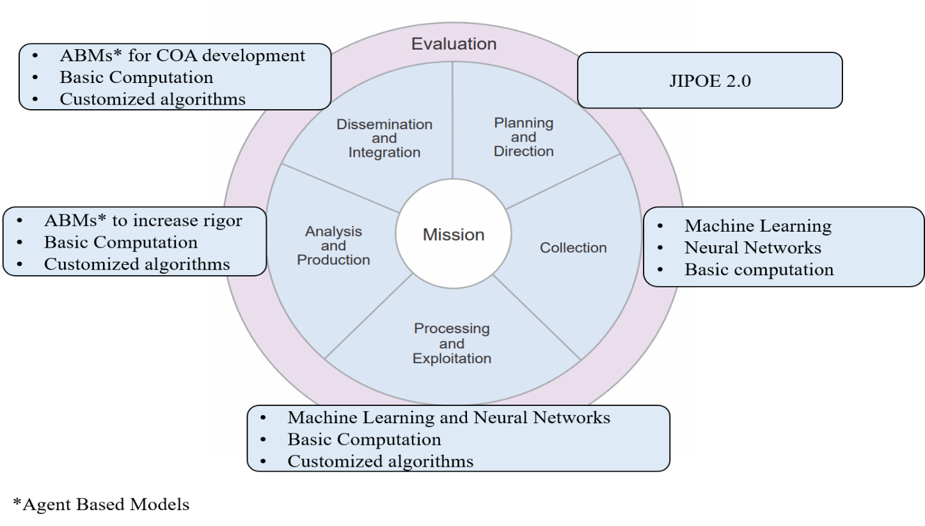Figure 6: Joint Intelligence Process (Joint Intelligence, 2013) with different AI tools
Based on these capabilities machine learning and neural networks are most applicable to the collection, processing and exploitation of the intelligence process (figure 6). One obvious capability is for processing images and alerting individuals in real time to specific events or sorting them for use by analysts later as they conduct deeper assessments. These tools can also be used to process and categorize events through a variety of reporting streams. For example, the Integrated Conflict Early Warning System (ICEWS) processes bilateral actions between actors, at varying levels across the globe, using open source reports, a suite of AI tools, and some customized algorithms to help classify the hostility or cooperativeness of different events (Lautenschlager, 2015; Schrodt, 2017). Machine learning and neural networks are able to help process overwhelming amounts of data which can be of constant aid to integrated campaigning by providing better situational awareness. AI tools however are only a few categories of tools that domain experts can craft based on their own experience and trained intuition.
The knowledge of domain experts already embedded throughout the USG cannot be ignored and encoding their knowledge will only help further aid the campaign. For these reasons, basic computation and customized algorithms (Figure 6) are included in the JIP and will likely prove as beneficial if not more beneficial than existing AI tools. Encoding this knowledge, however, represents a truth the USG must recognize, technology will help considerably, but increasing the technology capability of its members is essential to truly exploit the computation’s potential. For example, again using ICEWS, new actors may emerge which the AI is not tuned to collect and more likely an analyst will be interested in particular events for their OE which were not considered at the global scale. With a little coding, an analyst can add those features into his or her stream (Schrodt, 2017). This not only works for advanced AI tools, but also for simple processes such as building a web scraper for specific concerns, downloading a large number of reports and simplifying them, or even developing a unique algorithm for a specific problem set. In addition, USG members need to have the skills to be able to adapt immediately to foreign efforts to influence the data and employ at least partial solutions minimizing the time it may take for experts to fix the issue. Furthermore, useful tools are always under development, ICEWS is already being surpassed as political scientists and other researchers constantly improve them, and just like TensorFlow or Scikit-learn they are available through open source (Schrodt, 2017). AI tools are only part of a vast potential toolkit, USG members need to be able to manipulate those tools to their specific context for the data to be of real value and can craft their own based on their experience and understanding.
The Joint Intelligence Process can then be further enhanced by the incorporation of simulations. Although there are six general types of simulations analysts can use to help them understand the OE (Gilbert & Troitzsch, 2005), this study will focus on Agent Based Models (ABMs). An ABM is a self-contained program which contains agents. Agents are a simplistic representation of entities such as animals or people or entities on the internet of things. These agents then make decisions based on their “perceptions” of the situation (Gilbert and Troitzsch 2005). ABMs are considered distributed AI and have some unique suitability for intelligence analysis due to their ability to simulate the operating environment one is trying to understand. If an analyst is unable to grow the phenomenon he are she is trying to analyze then the analysts did not understand it (Epstein 2006). ABMs have the added benefit of being able to tune the amount of data used to build them. If collected data is available, it can be incorporated, but if the analyst must rely on qualitative assessments, ABMs can be built on purely qualitative assessments and still produce insightful results. ABMs are also directly related to the updated JIPOE framework. Agents are the groups and the model simulates what happens as groups pursue different behaviors and interdependencies change, such as increases or decreases to revenue, new or broken alliances, or new capabilities. Through the incorporation of ABMs, analysts will be able to simulate their assessment of the OE.
Like all the other computational tools, a practitioner could manipulate the simulation to produce desired results. This is no different than the normal biases analysts must avoid in their daily work (Heuer, 1999). However, the process of formalizing one’s inferences and testing them through the development of an ABM increases rigor and can provide critical insights. In addition, a technically capable workforce will be able to review it and assess the simulations veracity, just as intelligence products are reviewed now.
The other weakness of ABMs compared with the more common AI tools is a lack of infrastructure. The goal is for analysts to be able to ‘plug and play’ advanced algorithms into their specific agent population and against their specific concerns so they can rapidly develop representative simulations. Although there are several ABM libraries in a number of different coding languages, none of them have a supporting suite of algorithms for agent behaviors which analysts can employ. A nascent attempt has been started in the Python ABM library Mesa. Mesa packages looks to serve as an algorithm hub so analysts can find relevant behavior and ‘plug and play’ them (Pike, 2018). These algorithms can be understood as Structured Analytic Techniques (SATs) where analysts employ not only a technique but a combination of techniques in their model of the OE. The hard part of having a pipeline to fill this repository already exists. DARPA and IARPA fund projects which must rely on algorithms to analyze populations dynamics. Requiring the algorithms be compatible with preferred ABM libraries will then allow them to be vetted and made available for analysts use almost immediately. For ABMs to be readily accessible to the daily efforts of analysts it will need more developed infrastructure so they can employ combinations of algorithms to build models faster and the USG already has a ready pipeline, which with a few tweaks can help build this infrastructure.

Artificial Intelligence and Campaign Design and Adaption
Establishing how AI tools can integrate into intelligence analysis sets the conditions for discussing how AI can integrate into element two (design and construct) and element four (assess and adapt) of Integrated Campaigning. Although specific actions identified through collection and processing with machine learning and neural networks may cause immediate changes to the campaign, these dynamics are fairly well established in that if a specific action is detected then a specific leader needs to know about it immediately (e.g. priority intelligence requirements). ABMs, however, represent a new way to analyze the OE and construct campaigns, but even they are fairly straightforward to integrate.
Using the same approach as the previous section, I overlay ABM employment over the Joint Planning Process (figure 7). From the updated JIP, analysts should pass a validated model which grows the dynamics of interest of the OE. Planners then take this model and add in their own code to influence the OE. This action then constitutes constructing and designing the campaign (e.g. course of action development). At this point, the ABM becomes a virtual laboratory to experiment with policies prior to implementation. From this experimentation, the impact of different policies can be compared and recommended to decision makers.
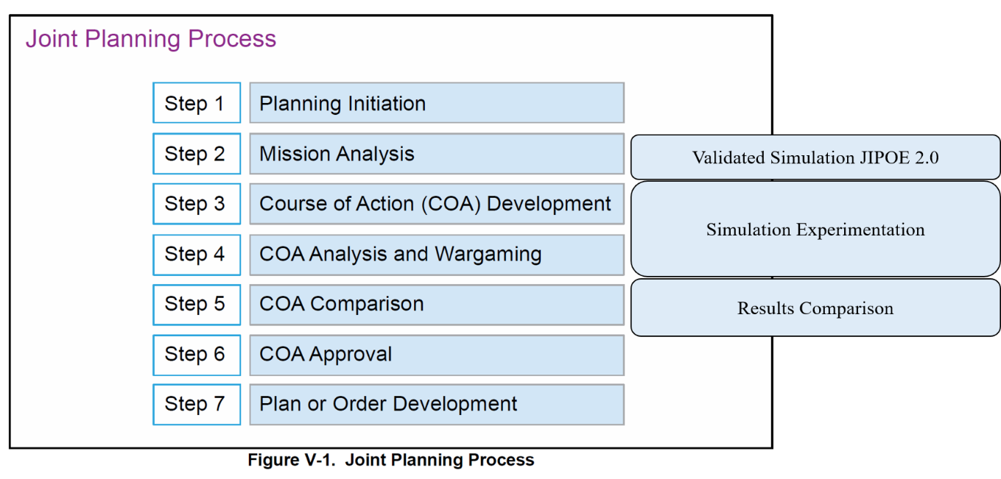Figure 7: Joint Planning Process (Joint Planning, 2017) with ABM (simulation) integration
This integration of computational tools into intelligence analysis and campaign design is then repeated through the assessment and adaption stage of the integrated campaign until the policy objectives are achieved. This need for constant assessment and adaption reiterates the point that simulations are not solutions. Although analysts may have grown the observed dynamics, there could be several different dynamics which produce that emergent behavior (Epstein, 2006). As the campaign is executed AI tools will still have to support the collection and processing of data and the ABM of the OE will have to incorporate this data and be adjusted to correct mistakes and improve the validation of the simulation. Planners will then need to reassess their design and adjust it as appropriate. The inclusion of AI tools is a constant and ongoing effort that will not replace Integrated Campaigning processes but enhance them.
The inclusion of ABMs to support decisions at the national level is already being done and is not merely a conceptual recommendation. A discussion of a housing market model will substitute as it is a model that conducted analysis and is now supporting decision making in two different countries in a demonstration of the process just described. In 2012, George Mason, Oxford and Yale Universities published the results of a housing model which closely replicated the housing boom and bust cycle in the greater Washington D.C. area (Washington D.C., Northern Virginia and Maryland) from 1997 to 2009 (Geanakoplos, Axtell, Farmer, & Howitt, 2012). To do this, the authors leveraged several datasets to include the Multiple Listing Service (MLS) records, income, race and employment data. The researchers used this data to recreate the housing market and the associated generic population of the greater Washington, D.C. area. This population was instantiated with an agent housing decision-making process and then recreated most of the major statistics. The results and the associated conclusions were significant enough that today, both the central bank of England and the central bank of Norway use variations of this model customized to their specific data, to (1) test their understanding of their housing situation and (2) implement possible policies to see the potential impact. This example is just one of many ABMs which have been used to support decision making. Understanding how one’s policies may affect the system of interest is always a desire for decision makers. ABMs provide a proven tool to do so and as such should be a part of Integrated Campaigning.

Integrated Campaigning and Complex Adaptive Systems
Complex adaptive systems theory provides a common framework which can be employed across the whole of the U.S. foreign policy system to support Integrated Campaigning. Complex systems are already a part of the Joint Intelligence Process however, the process must be upgraded to focus on the groups and interdependencies within the population and not use a categorical breakdown. Intertwined with this upgrade is the fact that computational tools are required to analyze complex systems. Recent improvements in both computing power and in coding accessibility make this feasible for the entire foreign policy system. Improving the technological capability of the workforce is the critical piece to exploit ongoing technological advances.
Updating JIPOE and improving technological capability are the fundamental improvements necessary to exploit computational tools. Some tools, such as machine learning and neural networks are suited for processing the overwhelming amount of data which is being collected, but have limitations. ABMs help overcome these limitations by providing a tool for analyzing the dynamic behavior of these systems. ABMs can be used to test one’s assessments about the dynamics of the OE and used as a virtual laboratory to design and construct the campaign. These tools will then continue to be used to assess and adapt the campaign as actions take place and the system evolves in unexpected ways. A major challenge for ABMs is to develop improved supporting infrastructure so members of the foreign policy system can leverage advanced algorithms in their simulations. A nascent attempt, Mesa Packages, is already established as a common hub for such efforts and the other papers supporting this study work to further develop that infrastructure. A complex adaptive systems approach is the ‘right’ perspective for integrated campaigning and to be effective, it must be integrated appropriately into USG frameworks, be employed with a suite of computational tools, and be supported by a technologically enabled workforce.

Bio: Lieutenant Colonel Tom Pike is a Joint qualified, Strategic Intelligence officer in the U.S. Army. Tom earned his PhD in Computational Social Science (CSS) from George Mason University in 2019. Tom has studied complex systems and its application to foreign policy from the tactical to the strategic level for the past decade and this interest drove him to attend both the CSS PhD program (as the program is based on complex systems) and the prestigious Santa Fe Institute’s Complex Systems Summer School. Tom is currently in his utilization tour at the National Intelligence University. He has served in the infantry (both light and mechanized) and military intelligence specialties.

Bibliography
Axtell, R., & Epstein, J. (1996). Growing Artificial Societies: Social Science From the Bottom Up. Washington D.C.: Brooking Institution Press.
Axtell, R., Epstein, J. M., Dean, J. S., Gumerman, G. J., Swedlund, A. C., Harburger, J., … Parker, M. (2002). Population growth and collapse in a multiagent model of the Kayenta Anasazi in Long House Valley. Proceedings of the National Academy of Sciences, 99(1), 7275–7279. https://doi.org/10.1073/pnas.092080799
Beinhocker, E. D. (2006). The Origin of Wealth. Boston, Massachusetts: Harvard Business School Press.
Booch, G., Maksimchuk, R. A., Engle, M. W., Conallen, J., Houston, K. A., & Ph.D, B. J. Y. (2007). Object-Oriented Analysis and Design with Applications, Third Edition (3rd ed.). Retrieved from http://proquest.safaribooksonline.com/book/software-engineering-and-development/object/9780201895513
Boot, M. (2006). War Made New: Technology, Warfare, and the Course of History 1500 to today. New York: Gotham.
Bueno De Mesquita, B., Smith, A., Siverson, R. M., & Morrow, J. D. (2003). The Logic of Political Survival. Cambridge, Massachusetts: The MIT Press.
Cielen, D., Meysman, A. D. B., & Ali, M. (2016). Introducing Data Science. Manning Publications.
Cioffi Revilla, C. (2017). Introduction to Computational Social Science: Principle and Applications (2nd ed.; F. B. Schneider, D. Gries, & O. Hazzan, Eds.). https://doi.org/10.1007/978-3-319-50131-4
Clausewitz, C. von, Howard, M., & Paret, P. (1976). “On War.” Princeton, New Jersey: Princeton University Press.
Domingos, P. (2018). The Master Algorithm – Machine Learnings. 1–5.
Dunn, W. (2018). Public Policy Analysis: An Integrated Approach (6th ed.). New York: Routledge Taylor and Francis.
Epstein, J. M. (2006). Generative Social Science: Studies in Agent-Based Computational Modeling.
Geanakoplos, J., Axtell, R., Farmer, D. J., & Howitt, P. (2012). Getting at Systemic Risk via an Agent-Based Model of the Housing Market. The American Economic Review, 102(3), 53–58.
Gilbert, N., & Troitzsch, K. G. (2005). Simulation for the Social Scientist (2nd, Kindl ed.). New York: Open University Press.
Gleick, J. (1987). Chaos: Making a New Science. New York: Penguin.
Goodfellow, I., Bengio, Y., & Courville, A. (2016). Deep Learning. Cambridge, Massachusetts: The MIT Press.
Grimm, V., & Railsback, S. (2005). Chapter One: Introduction. In Individual-based Modeling and Ecology.
Grimm, V., Revilla, E., Berger, U., Jeltsch, F., Mooij, W. M., Railsback, S. F., … DeAngelis, D. L. (2005). Pattern-Oriented Modeling of Agent-Based Complex Systems: Lessons from Ecology. Science, 310(5750), 987–991. https://doi.org/10.1126/science.1116681
Heuer, R. J. (1999). Psychology of Intelligence Analysis. Washington, D.C.: Center for the Study of Intelligence, Central Intelligence Agency.
Holland, J. H. (1995). Hidden Order: How Adaption Builds Complexity. New York: Helix Books.
James, G., Witten, D., Hastie, T., & Tibshirani, R. (2013). An Introduction to Statistical Learning (Vol. 103). Retrieved from http://linkinghub.elsevier.com/retrieve/pii/S0166531607000570%0Ahttp://link.springer.com/10.1007/978-1-4614-7138-7
Joint Concept for Integrated Campaigning. (2018). United States Department of Defense.
Joint Intelligence. (2013). Washington, D.C.: U.S. Department of Defense.
Joint Intelligence Preparation of the Operating Environment. (2014). U.S. Department of Defense.
Joint Planning. (2017). United States Depatment of Defense.
Kilcullen, D. (2010). Counterinsurgency. Oxford: Oxford University Press.
Kilcullen, D. (2013). Out of the Mountains: The Coming Age of the Urban Guerilla. Oxford: Oxofrd University Press.
Krakauer, D. (2018). Adaptation, Inference & Representation.
Lautenschlager, J. (2015). ICEWS Events and Aggregations. Lockheed Martin Advanced Technology Laboratories.
Lawson, S. (2014). Nonlinear Science and Warfare : Chaos, Complexity and the U.S. Military in the Information Age. New York: Routledge.
Lieven, A. (2011). Pakistan: A Hard Country. New York: PublicAffairs.
Lorenz, E. (1963). Determinstic Nonperiodic Flow. Journal of the Atmospheric Sciences, 20(2), 130–141. https://doi.org/10.1175/1520-0469(1963)020<0130:DNF>2.0.CO;2
Miller, J. H., & Page, S. E. (2007). Complex Adaptive Systems: An Introduction to Computational Models of Social Life (Vol. 27). Retrieved from http://books.google.com/books?id=XQUHZC8wcdMC&pgis=1
Mitchell, M. (2009). Complexity: A Guided Tour (1st ed.). Oxford: Oxford University Press.
Pike, T. D. (2018). Integrating Computational Tools into Foreign Policy. Complexity and Policy Journal.
Prigogine, I., & Stengers, I. (1984). Order out of Chaos: Man’s New Dialogue with Nature. New York: Bantam Book.
Sapolsky, R. M. (2017). Behave: The Biology of Humans at Our Best and Worst. New York: Penguin Books.
Schrodt, P. A. (2017). A Practical Guide to Current Developments in Event Data. International Methods Collqium.
Shonkoff, J. P., & Phillips, D. A. (Eds.). (2000). From Neurons to Neighborhoods: The Science of Early Childhood Development. Washington, D.C.: National Academy Press.
Siddiqa, A. (2017). Military, Inc.: Inside Pakistan’s Military Economy (2nd ed.). Pluto Books.
Simon, H. a. (1997). The sciences of the artificial, (third edition) (Vol. 33).
Smith, E., & Morowitz, H. J. (2016). The Origin and Nature of Life on Earth: The Emergence of the Fourth Geosphere (Kindle). Cambridge: Cambridge University press.
Strogatz, S. H. (2003). Sync: How Order Emerges from Chaos in the Universe, Nature, and Daily Life (First). New York: Hyperion.
Talbot, I. (2012). Pakistan: A New History. New York: Columbia University Press.
van Rossum, G. (1999, August). Computer Programming for Everybody (Revised Proposal) A Scouting Expedition for the Programmers of Tomorrow.
Wright, N. (Ed.). (2018). AI, China, Russia, and the Global Order: Technological, Political, Global, and Creative Perspectives. A Strategic Multilayer Assessment (SMA) Periodic Publication.

Scikit Learn weblink --- http://scikit-learn.org/stable/ ; Tensor Flow --- https://www.tensorflow.org/
Computational tools can also assist with element three, employing the integrated force and securing gains, by providing decision makers better understanding of logistics, movements and every other data related aspect of the campaign. This however, exceeds the scope of this study which focuses on how to understand the OE and how to improve integrated actions necessary to influence the OE towards U.S. policy objectives.
https://github.com/projectmesa/mesa/wiki/Mesa-Packages
It is interesting to note in this context that Python 2 was a DARPA funded program under the title Coding for Everyone. (van Rossum, 1999)

