ISIS: Past, Present, and Possible Futures Panel Discussion Biographies

William Braniff

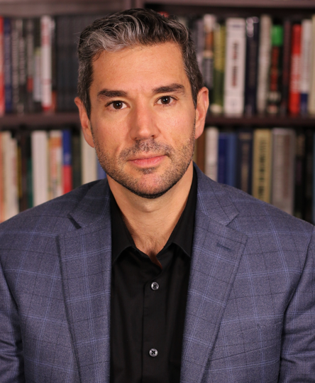
William Braniff is the Director of the National Consortium for the Study of Terrorism and Responses to Terrorism (START) and a Professor of the Practice at the University of Maryland. He previously served as the director of practitioner education at West Point’s Combating Terrorism Center (CTC) and an instructor in the Department of Social Sciences. Braniff is a graduate of the United States Military Academy. Following his Company Command in the U.S. Army, Braniff attended the Johns Hopkins University School of Advanced International Studies (SAIS) where he received a master’s degree in international relations. Braniff then served as a foreign affairs specialist for the National Nuclear Security Agency. He lectures frequently for counterterrorism audiences including the Federal Bureau of Investigation, Joint Special Operations University, National Defense University, the Foreign Service Institute, the Defense Intelligence Agency, the Diplomatic Security Service Antiterrorism Assistance Program, the United States Attorneys’ Office and for DHS Homeland Security Investigators. Braniff has also taken a keen interest in the field of countering violent extremism (CVE), and his input has been sought out by the Department of Justice, the Department of State, the FBI and the National Security Staff, and the National Counterterrorism Center. He spoke at the White House Summit on Countering Violent Extremism in February 2015. Braniff has testified before Congress on four occasions, and appears regularly in national and international news media. His research focuses on domestic and international terrorism, counterterrorism and countering violent extremism (CVE). He is a member of the Editorial Board of the International Centre for Counter-Terrorism-The Hague (ICCT), the RESOLVE Network Research Advisory Board, and the Prosecution Project Advisory Board.

Daveed Gartenstein-Ross
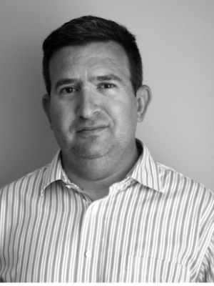
A scholar, practitioner, and entrepreneur, Dr. Daveed Gartenstein-Ross is the chief executive officer of Valens Global, which was recognized in both 2018 and 2019 by Entrepreneur Magazine’s list of the best entrepreneurial companies in America. The International Herald Tribune has described him as “a rising star in the counterterrorism community.” Dr. Gartenstein-Ross’s previous positions include senior advisor to the director of the U.S. Department of Homeland Security’s Office for Community Partnerships, fellow with Google’s think tank Jigsaw, adjunct assistant professor in Georgetown University’s Security Studies Program, and senior fellow at the Foundation for Defense of Democracies.

Dr. Gartenstein-Ross has extensively studied the problem of sub-state violence. His recent work has examined the intersection of sub-state violence with emerging technologies. His work on ISIS and al-Qaeda includes several books and monographs about the two groups, including Islamic State vs. al-Qaeda: Strategic Dimensions of a Patricidal Conflict (New America Foundation, 2015), which was adapted from a report he produced for the Strategic Multilayer Assessment. Dr. Gartenstein-Ross has testified on his areas of core competency before the U.S. Senate and House of Representatives over a dozen times, as well as before the Canadian House of Commons, including several testimonies about ISIS and al-Qaeda.

The author or volume editor of twenty-three books and monographs, Dr. Gartenstein-Ross also has a book forthcoming from Columbia University Press that explores how jihadist groups engage in organizational learning. He has published widely in the popular and academic press, and is also a member of the Editorial Board of the leading peer-reviewed journal Studies in Conflict & Terrorism.

Dr. Gartenstein-Ross holds a Ph.D. in world politics from the Catholic University of America and a J.D. from the New York University School of Law, and recently earned a Certificate in Entrepreneurship through the Goldman Sachs Foundation’s 10,000 Small Businesses program. He can conduct research in five languages.

Lawrence A. Kuznar
Dr. Lawrence Kuznar is Chief Cultural Sciences Officer with NSI, Inc. and Professor of Anthropology at Purdue University-Fort Wayne. Dr. Kuznar conducts anthropological research relevant to counterterrorism and other areas of national security. His current research focuses on discourse analysis of Daesh leadership messaging to provide leading indicators of intent and behavior and has applied this methodology to Eastern European State and non-State Actors, Iran, and polities in the Middle East and Asia. He has developed computational models of genocide in Darfur and tribal factionalism in New Guinea, mathematical models of inequality and conflict, and integrated socio-cultural databases for predicting illicit nuclear trade and bioterrorism. He has conducted discourse analysis of the expression of conflict and enmity in Arabic, Farsi and Pashto, to identify leading indicators of conflict. Dr. Kuznar’s recent research has been funded by academic sources, the Office of the Secretary of Defense Strategic Multilayer Analysis, Air Force Research Lab (AFRL), the Human Social Cultural Behavior (HSCB) modeling program of the Department of Defense, and by the US Army Corps of Engineers. He has also served on the HSCB Technical Progress Evaluation panel and a National Counterterrorism Center (NCTC) net assessment panel.

Gina Ligon
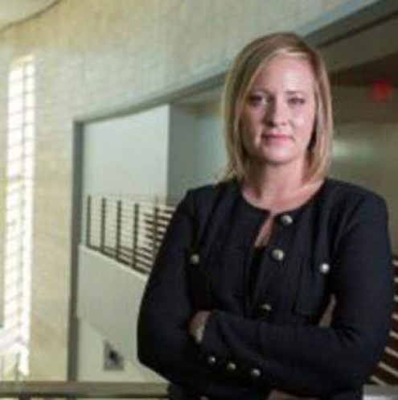
Dr. Gina Ligon is The Jack and Stephanie Koraleski Professor of Collaboration Science at the University of Nebraska at Omaha. She received her PhD in Industrial and Organizational Psychology with a Minor in Measurement and Statistics from the University of Oklahoma. She is a non-Resident Fellow for the George Washinton University Program on Extremism, and has been part of the Department of Homeland Security (DHS) Centers of Excellence since 2010. She is the Principal Investigator and originator of the Leadership of the Extreme and Dangerous for Innovative Results (LEADIR) database.
Her research interests include profiling leaders from afar, violent ideological groups, expertise and leadership development, and collaboration management. Prior to joining UNO, she was a faculty member at Villanova University in the Department of Psychology. She also worked in St. Louis as a management consultant with the firm Psychological Associates. She has published over 50 peer-reviewed publications in the areas of leadership, innovation, and violent groups, and she is the editor to the academic journal Dynamics of Asymmetric Conflict: Pathways toward Terrorism and Genocide.

