Skye Cooley (Ph.D., University of Alabama) is an assistant professor in the School of Media and Strategic Communications at Oklahoma State University. His research interests are in Russian political communication, global media and digital democracy, as well as civic deliberation online. Dr. Cooley holds certifications of accreditation in public relations (APR) and civilian service peace keeping operations (POTI). He has traveled actively through Europe, Latin America, Asia and Africa; publishing and presenting research on international political communication.
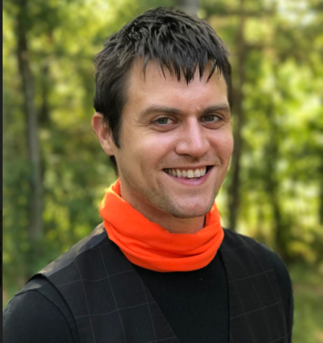

Robert Hinck (Ph.D., Texas A&M University) is Professor of Organizational Communication at Monmouth College. His program of research centers on organizational rhetoric, particularly regarding international and diplomatic rhetoric, public diplomacy, conflict and negotiation, as well as global media. His research projects address concerns regarding the formation and sustainment of political cooperation among distinct political communities, and the rhetorical means by which they structure and manage internal and external stakeholders.

