Dr. Nicholas D. Wright (Intelligent Biology)

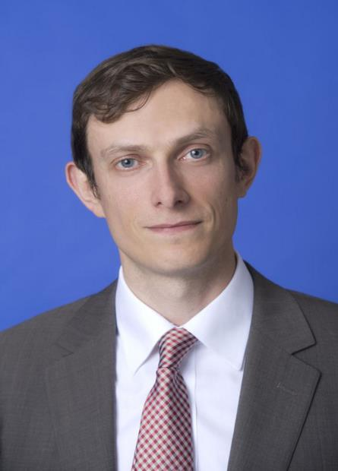
Dr Nicholas Wright is an affiliated scholar at Georgetown University, honorary research associate at University College London (UCL), Consultant at Intelligent Biology and Fellow at New America. His work combines neuroscientific, behavioural and technological insights to understand decision-making in politics and international confrontations, in ways practically applicable to policy. He leads international, interdisciplinary projects with collaborators in countries including China, the U.S., Iran and the UK. He was an Associate in the Nuclear Policy Program, Carnegie Endowment for International Peace, Washington DC and a Senior Research Fellow in International Relations at the University of Birmingham, UK. He has conducted work for the UK Government and U.S. Department of Defense. Before this he examined decision-making using functional brain imaging at UCL and in the Department of Government at the London School of Economics. He was a clinical neurologist in Oxford and at the National Hospital for Neurology. He has published academically (some twenty publications, e.g. Proceedings of the Royal Society), in general publications such as the Atlantic and Foreign Affairs, with the Pentagon Joint Staff (see www.nicholasdwright.com/publications) and has appeared on the BBC and CNN.
Wright received a medical degree from UCL, a BSc in Health Policy from Imperial College London, has Membership of the Royal College of Physicians (UK), has an MSc in Neuroscience and a PhD in Neuroscience both from UCL.

