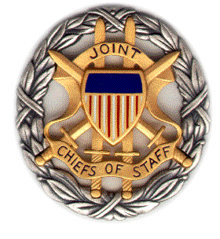
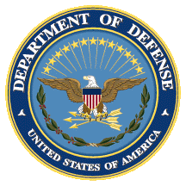

SMA CENTCOM
Panel Discussion

UK Perspectives on Deradicalization

Booklet
9 December 2019
0930-1100 ET

Dial (866) 712-4038;
Passcode 37250264#

Strategic Multi-Layer Assessment (SMA) provides planning support to Commands with complex operational imperatives requiring multi-agency, multi-disciplinary solutions that are NOT within core Service/Agency competency. Solutions and participants are sought across USG and beyond. SMA is accepted and synchronized by Joint Staff/J-39 DDGO and executed by ASD (EC&P).

Agenda

Panel Description: This panel draws on insights from UK-based scholars who examine deradicalization and radicalization in communities across the globe, from Northern Ireland to Sri Lanka.

Speakers: The speakers for this discussion will include:

- Dr. Noémie Bouhana (University College London Department of Security and Crime Science)
- Prof. Neil Ferguson (Liverpool Hope University)
- Dr. Joel Busher (Coventry University)
- Dr. Christopher McDowell (City, University of London)
- Dr. Nicholas Wright (Intelligent Biology)- moderator

Agenda: The following are brief descriptions of what each panelist will discuss during their presentation:

- Dr. Noémie Bouhana (University College London Department of Security and Crime Science)
  - Dr. Bouhana will discuss the critical importance of the physical environment in shaping behaviour amongst radicalised populations. Her work draws on criminology, ecology, and terrorism studies.
- Prof. Neil Ferguson (Liverpool Hope University)
  - Prof. Ferguson will explore lessons from the peace process in Northern Ireland illustrates that ‘deradicalization’ does not accompany disengagement, yet the rates of recidivism are very low (approx. 5%) indicating that full deradicalization may not be necessary to the process of desistance. The presentation will then move on to explore evidence from deradicalization programmes from across the globe to explore what benefits and challenges can be drawn from this research. Finally, he will explore the importance of identity in engagement and disengagement from violent extremism, and how moderating and identity through the encouragement of ordinary identities based on family role and employment can help lessen the importance of more ideological and political identities.
- Dr. Joel Busher (Coventry University)
  - While considerable research and development investment has gone into explaining how and why individuals or groups radicalise, our understanding of why they do not lags behind. Why do some ‘extremists’ or ‘extremist groups’ choose not to engage in violence, or only in particular forms of low-level violence? Why is it that even in deeply violent groups there are often thresholds of violence that members rarely if ever cross, even if they have the capability to do so? In his presentation, Joel Busher will discuss insights that can be leveraged from recent work that explores how actors within militant groups or networks themselves contribute to set and maintain the parameters of their own violence – the internal brakes on violent escalation – and how these insights might be used to inform strategies for assessing and responding to emergent threats.
- Dr. Christopher McDowell (City, University of London)
  - Drawing on 25 years research on mainly Tamil asylum migration from Sri Lanka, Christopher will consider the engagement of combatant groups in forced migration and settlement. He will examine the ways in which the international refugee system, and process of flight, encampment, onward movement and asylum seeking create opportunities for radicalisation. These dynamics came together in the UK in 2017 with attacks in Manchester (Ariane Grande concert) and London (London Bridge) where a number of the perpetrators of the attacks came from an asylum or refugee background.

Speaker Biographies

Dr. Noémie Bouhana (University College London Department of Security and Crime Science)

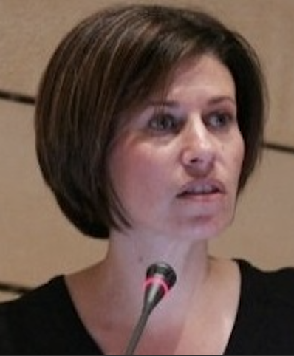
Dr Noémie Bouhana is Associate Professor of Security and Crime Science at University College London, where she leads the Counter-Terrorism Research Group. Her research investigates chiefly the ecological processes involved in the emergence of extremism-enabling environments and the mechanisms which underpin the vulnerability to extremist moral change. Her work has been funded by the European Union, the Defence Science and Technology Laboratory (DSTL), the Office of Security and Counter-Terrorism (OSCT), the Engineering and Physical Sciences Research Council (EPSRC), Public Safety Canada, and the US National Institute of Justice (NIJ), among others. At present, she directs the $1M project "The Social Ecology of Radicalisation", an international study supported by the US Department of Defense Minerva Initiative.

Dr. Joel Busher (Coventry University)

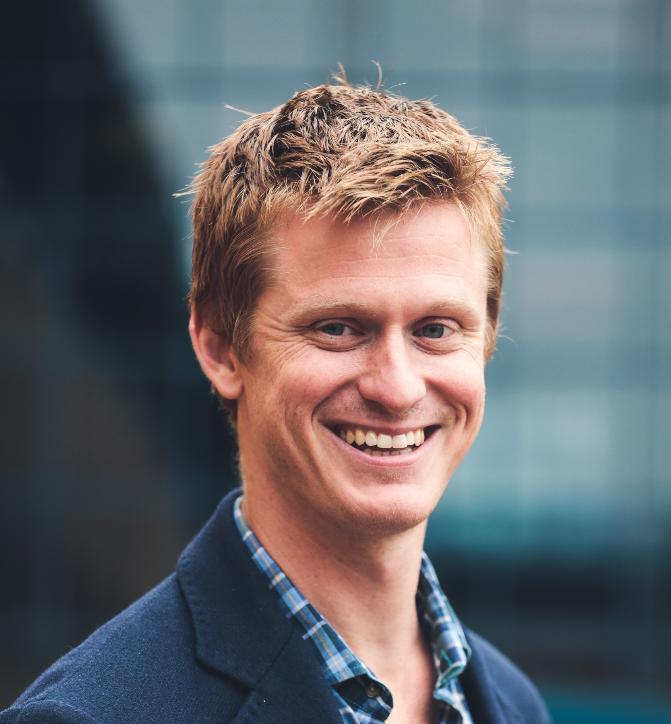
Dr Joel Busher is an Associate Professor at the Centre for Trust, Peace and Social Relations (CTPSR), Coventry University, and chair of the CTPSR Working Group on P/CVE. His primary research interests are in the escalation, de-escalation and non-escalation of political violence; far right and anti-minority politics; and the implementation of counter-terrorism policy and its societal impacts. He has published extensively on these topics, and his b ook, The making of anti-Muslim protest: Grassroots activism in the English Defence League (Routledge), was awarded the British Sociological Association’s Philip Abrams Memorial Prize. He is an Associate Editor of Behavioral Sciences of Terrorism and Political Aggression; a member of the editorial board of Research in Social Movements, Conflict and Change, joint editor of a forthcoming book, Researching the Far Right: Theory, Method and Practice (Routledge Studies in Fascism and the Far Right), and of a forthcoming special issue of Perspectives on Terrorism on ‘Explaining restraint: Why some “militants” do not do as much violence as they could’. He tweets @joel_busher.

Prof. Neil Ferguson (Liverpool Hope University)

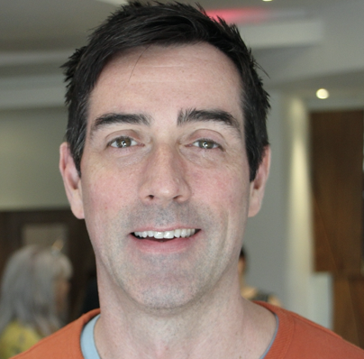
Neil Ferguson is Professor of Political Psychology at Liverpool Hope University and recently served as a Visiting Research Fellow to the Changing Character of War Programme at Pembroke College, Oxford. His research has focused on political conflict and its psychological implications since he studied towards his PhD at the University of Ulster. He previously served as the Director of the Desmond Tutu Centre for War and Peace Studies, a Research Fellow at University of St Andrews, and lectured at the University of Ulster. Professor Ferguson recently served as a member of the Governing Council for the International Society of Political Psychology (ISPP). He also serves on the editorial committees of the Journal of Moral Education, Journal of Deradicalization and the Journal of Social and Political Psychology, and is a trustee of the Journal of Moral Education Trust. His current research focuses on processes of engagement, involvement and disengagement from politically motivated violence focusing on paramilitary groups based in Northern Ireland. He has published in both psychological and politics journals, edited and contributed to a number of edited volumes and offered critical advice to various governments, security agencies and NGOs on issues around radicalization, terrorism, counter-terrorism and conflict transformation.

Dr. Christopher McDowell (City, University of London)

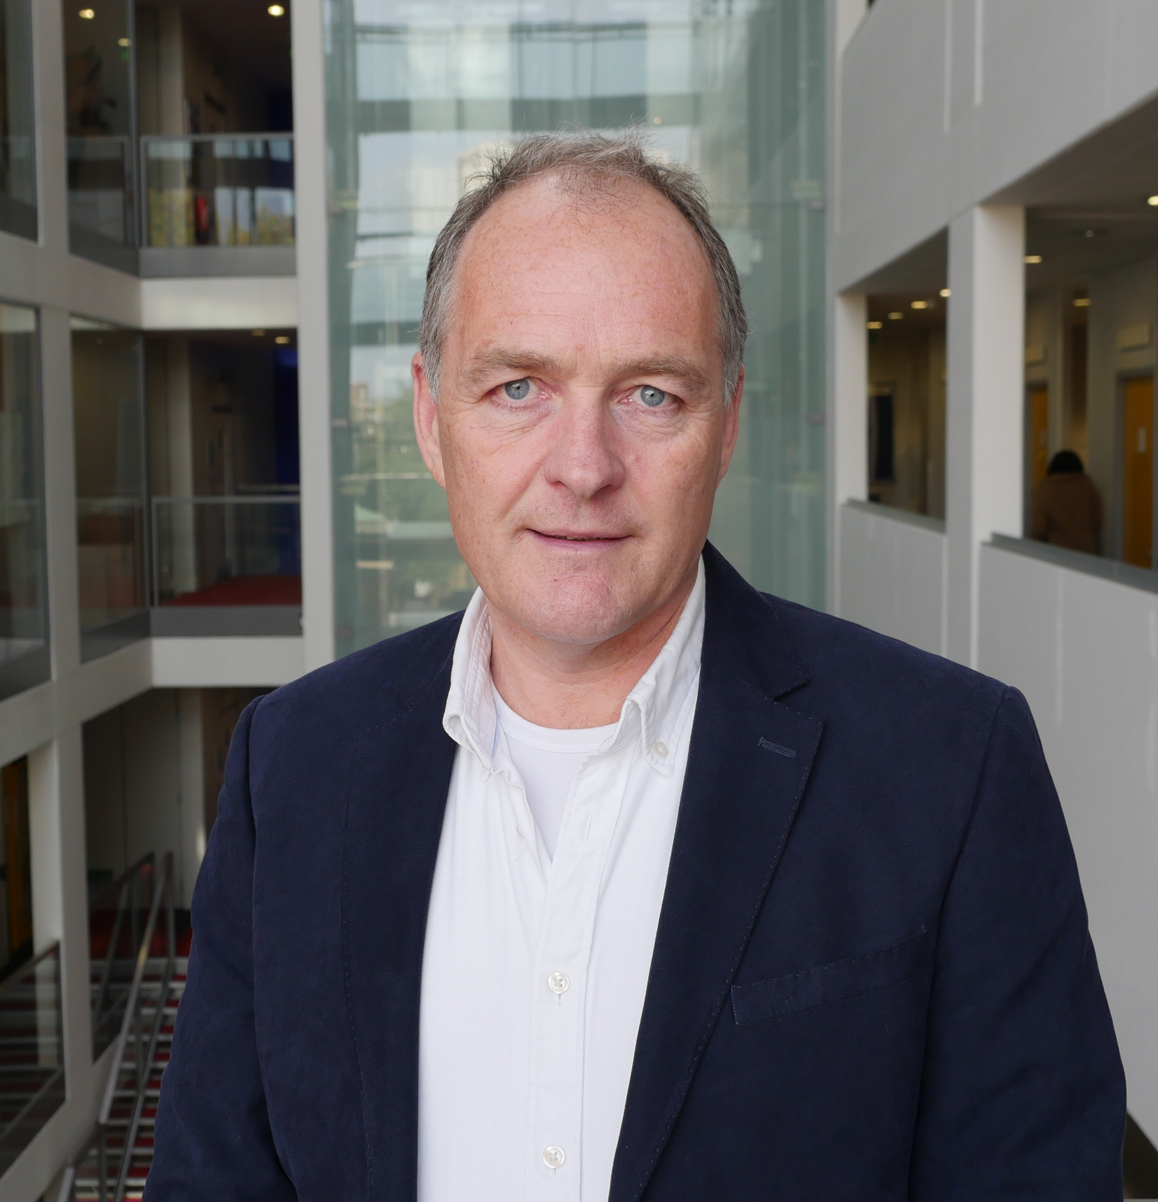
Christopher McDowell is Assistant Vice President (International) at City, University of London, and a Reader in Political Anthropology in the Department of International Politics. His research is on the politics of population displacement and forced migration in Asia, the Middle East, East and Central Africa and Europe, with a recent focus on the radicalisation of refugees and asylum seekers. This has included commissioned research for the UN on Syrian refugee resettlement, and a current GCRF funded project on coerced labour migration in south western Ethiopia.

Dr. Nicholas D. Wright (Intelligent Biology)

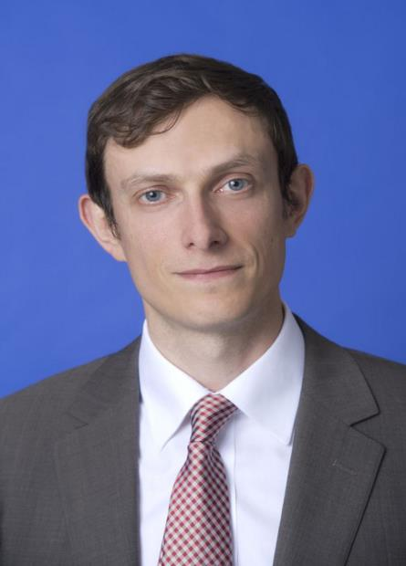
Dr Nicholas Wright is an affiliated scholar at Georgetown University, honorary research associate at University College London (UCL), Consultant at Intelligent Biology and Fellow at New America. His work combines neuroscientific, behavioural and technological insights to understand decision-making in politics and international confrontations, in ways practically applicable to policy. He leads international, interdisciplinary projects with collaborators in countries including China, the U.S., Iran and the UK. He was an Associate in the Nuclear Policy Program, Carnegie Endowment for International Peace, Washington DC and a Senior Research Fellow in International Relations at the University of Birmingham, UK. He has conducted work for the UK Government and U.S. Department of Defense. Before this he examined decision-making using functional brain imaging at UCL and in the Department of Government at the London School of Economics. He was a clinical neurologist in Oxford and at the National Hospital for Neurology. He has published academically (some twenty publications, e.g. Proceedings of the Royal Society), in general publications such as the Atlantic and Foreign Affairs, with the Pentagon Joint Staff (see www.nicholasdwright.com/publications) and has appeared on the BBC and CNN.
Wright received a medical degree from UCL, a BSc in Health Policy from Imperial College London, has Membership of the Royal College of Physicians (UK), has an MSc in Neuroscience and a PhD in Neuroscience both from UCL.

