Erik Gartzke
Bio Statement

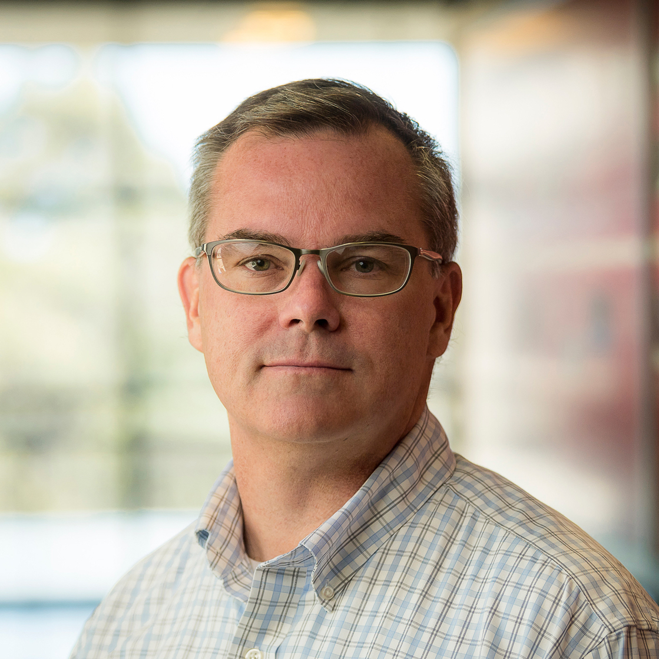
Erik Gartzke is Professor of Political Science and Director of the Center for Peace and Security Studies (cPASS) at the University of California, San Diego, where he has been a member of the research faculty since 2007. Previous permanent faculty positions include Columbia University in the City of New York (2000 to 2007) and the Pennsylvania State University (1997 to 2000). He has held temporary positions at Dartmouth University, the Ecole des Affaires Internationales (Sciences Po), the Naval Postgraduate School, UC Santa Barbara and at the University of Essex. Dr. Gartzke received a PhD in Political Science from the University of Iowa in 1997.

Professor Gartzke’s research focuses on war, peace and international institutions. His interests include deterrence, nuclear security, the liberal peace, alliances, information and war, cyberwar, and the evolving technological nature of interstate conflict. He has written on the effects of global commerce, development, system structure and climate change on warfare. Recent studies include the role of military automation on patterns of conflict, cross-domain deterrence and research contributing to the intellectual foundations of cyber conflict. Professor Gartzke’s research appears in numerous academic journals, including the American Political Science Review, the American Journal of Political Science, the British Journal of Political Science, International Organization, International Security, International Studies Quarterly, the Journal of Conflict Resolution, the Journal of Politics, Security Studies, World Politics, and elsewhere.

