Steve Sin
Director of the Unconventional Weapons & Technology Division, START
301-405-6656 | sinss@umd.edu
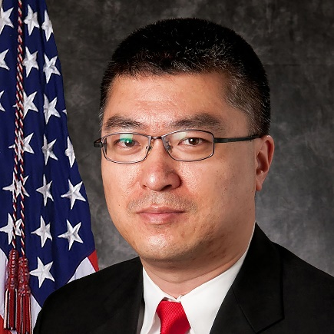
Steve S. Sin, Ph.D., is the Director of the Unconventional Weapons and Technology Division (UWT) of the National Consortium for the Study of Terrorism and Responses to Terrorism (START), headquartered at the University of Maryland, where he manages and leads a team of researchers conducting projects spanning across a broad range of international security, terrorism, and homeland security challenges. Dr. Sin’s expertise includes adversary human-social behavior modeling; emerging technology; improvised threat; radiological and nuclear (RN) terrorism; and the North Korean nuclear program, cyber capabilities, and intelligence apparatus.

Prior to joining START, Dr. Sin was the Senior Research Associate and Section Chief at the National Center for Security & Preparedness (NCSP), a strategic partner with the New York State Division of Homeland Security & Emergency Services (DHSES), headquartered at the State University of New York at Albany (University at Albany). Dr. Sin’s extensive experience also includes a career as a U.S. Army Officer.

