7 Things We’ve Learned Managing Virtual Teams
Allison Astorino-Courtois, NSI

For the last thirteen years, my colleagues and I have built and managed virtual project teams ranging from 10 to more than 60 people at NSI, Inc., a fully virtual consulting firm that provides human behavioral analytics to both US Government and commercial organizations. NSI has never had bricks or mortar and, thirteen years ago there were few (if any) textbooks that included managing and operating such companies. But over the course of that time, we have learned a couple of things.
As workers and managers everywhere struggle with defining new social patterns, new work realities, and the rules of social distancing, I thought I would weigh in on some of what we have learned about managing teams and producing high quality work without face-to-face interaction.
#1. Absolutely Everything Hinges on Trust
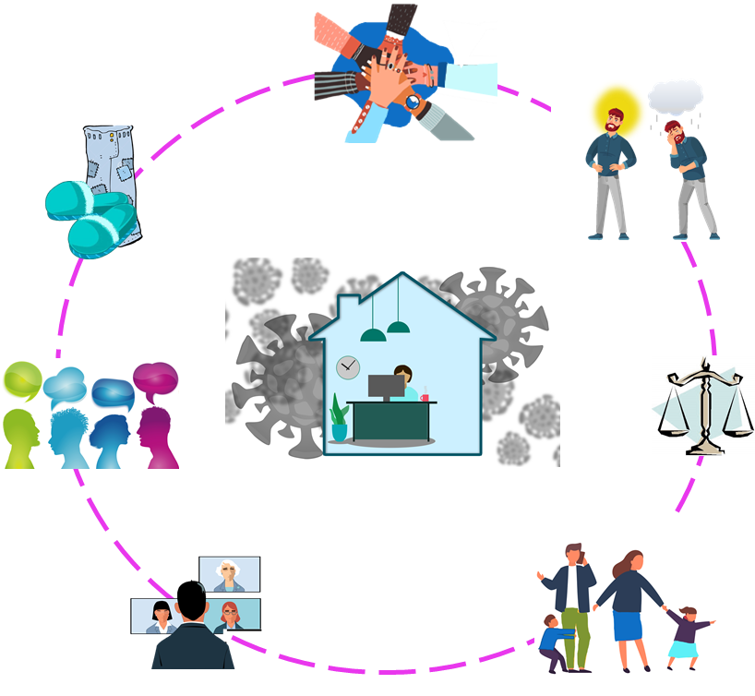
Maintaining and fostering trust between management and staff, and among team members, is the single most important task in managing a productive virtual team. When trust breaks down, we have found that the first thing to suffer is quality of someone’s or a team’s work. It can also diminish a team’s ability to function effectively or at all. This can happen much more quickly in a virtual environment than face-to-face. This is this the essential insight to a successful virtual workplace.
There are ways to help maintain trust, by recognizing the differences among team members –differences that may not be apparent or relevant in a physical setting; by recognizing that there are many fewer distractions at work than at home; and mitigating the isolation and disorientation that can emerge from such a rapid transition in one’s work environment and work flow.
#2. Not Everyone is Equally Cut Out for This
Knowing the orientation of your co-workers and team members to the quiet and isolationist components of prolonged work from home is critical to managing an effective virtual team. We have found that there are four types of workers: Lone Wolfs are people who need to work alone, generally in a quiet place, in order to thrive; Individualists prefer to work alone but can brook some distractions; Friendlies who prefer to work in a physical and social work environment, but can tolerate some isolation; and, Social Butterflies who thrive in a highly social work environment. If your work involves a team, ideally, you are surrounded by Individualists and Friendlies. While Lone Wolfs may enjoy the isolation of working from home, it can be difficult at times for managers to keep track of what they are up to. In a work at home environment it is easy for these people to recede even further from group interaction. Social Butterflies on the other hand, will feel the greatest impact, and psychological stress from the sudden switch to virtual work.

So, who’s on your team? Try asking team members how they felt about group projects in school. Answers along the lines of, “I considered to them to be acts of terror by my teachers, and always did all the group work myself” would be indicative of a Lone Wolf. “I hated them and would have preferred any other type of assignment” would indicate an Individualist; “I was not a fan but was OK hanging out with my groupmates” a Friendly, and “I loved them!” definitely a Social Butterfly. The point is, managers should expect team members to respond to find the precipitous CV-19 changes in their work environments differently, and require different management approaches.

#3. Find the Right Balance Between Big Brother and The Invisible Man
Some people are by nature self-directed, while others are less tolerant of the ambiguity and uncertainty that can come with at-home work. These people prefer, and even require significant management structure and presence to do their best work. Moving from an office setting to working from home inevitably introduces increased ambiguity and uncertainty to everyone’s workflow. This is the case both for the team member who may be accustomed to near immediate response to questions asked of co-workers for example, and for managers who can no longer observe the work in progress as readily as before. While more junior people will, on average, require more explanation of tasks, approaches and company processes than senior employees, there is not a one-to-one correlation between rank and need for structure. Again, understanding who on your team is of which type can help reduce tensions greatly. But, managers should beware: instituting structure in the form of required contacts, meetings, guidance sessions, and unbendable processes in order to reassure people who need structure, will be disruptive and likely seem like odious micro-management to others. It could also send the exact message that managers in a virtual setting want to avoid: I don’t trust you to work at home. Finding the proper balance for your particular team will be the trick.

#4. People Don’t Necessarily Believe That “I’m Working” Means “I Have to Fulfill My Professional Obligations to Get Paid!”
This is true of everyone with a human family, friends or roommates at home. Actually, my beagle struggles with this too, so... Managers should be aware that virtual workers can be hampered by the distractions of normal family life, and understanding that family adjustments can be unnerving for the employee can help reduce stress. Remember that much of what you are doing may not look like “work” to people at home with us. Reading, talking on the phone, are tasks they see you do at home all the time – even when you are not working. Dogs bark, children yell, and yes, work-at-home spouses may have their own telecons on speakerphone in the next room. Families will have to get used to your working from home as much or more so than you.

#5. Get Ready for Your Close-up!
Using video conferences can help maintain engagement among team members, discourage feelings of isolation and buoy managers’ trust in their teams. However, we have found that whenever possible, simply turning on your video cameras during teleconferences can go a long way. Use video rather than just audio for meetings of more than 3 people. In fact, it is critical to have face time meetings quite frequently, especially as managers are getting used to the fact that they cannot observe what their teams are doing during the day. A helpful hint: check the view from your camera before you “go live” on a videoconference. The camera angle may be showing more of your pajamas than you intended, you may be backlit, or —and this one is fun— you might have teenager drama happening in the background. Maybe that is just me.

Also, since you are not in the same room, it is even more critical for a video conference to have a “master of ceremonies” – who is not the one who called the meeting, but someone a bit junior empowered to make the call on which person speaks next (i.e., provides the crucial public services of mitigating the “Oh, sorry,” “No you go,” “No, after you” polka that can get out of hand). It is also important to stick to the agenda and advertised end point.
#6. Never Thought You’d Miss Hearing About Your Co-Worker’s Tuba Playing Toddler? You Will.
Humans are social animals and workers are no different. Sharing a work space and common experiences –even if it is just commiserating over how weird or unreasonable their bosses are—allows people to connect to others. Working from home can be isolating and lonely. Scheduling work time for people to catch up with each other is an essential way to reduce what for some can be a disorienting sense of isolation. Even people who prefer to work alone generally like their co-workers. We have found that making sure to schedule –and strongly encouraging team members to voluntarily participate in— “water cooler” time during larger meetings for people to share pictures, stories, etc. has been a good way to foster and maintain a sense of belonging and comradery among distributed teams. We also reserve some time at the outset of team meetings to talk about non-work topics, what we are doing at home, the immeasurable fun of home improvement projects, whatever. This small talk should be encouraged at any point of company interaction. One to two minutes of catching up can go a long way to reinforce bonds and moral even if there is a time crunch.

#7. Go Ahead, Be Grubby if That’s What it Takes!
Finally, working from home is an adjustment and can be isolating and disorienting for sure. However, it should also come with a sense of freedom (tempered with deadlines of course). So, wear what is comfortable. The advice to make sure you get dressed for work, and arrive at work in your house the same way you would in the office is never going to happen and is probably all kinds of baloney anyway. Also, in my experience grubby clothes are in no way correlated to productivity and effective work from home. They just make it more shocking for the rest of your family when you do occasionally dress like an adult.

These are a few practices that have worked for us, and I hope they are useful to you. Trust me, the new work situation can be navigated, and more comfortably than many think. Good luck!

Dr. Allison Astorino Courtois Biography:
Dr. Astorino-Courtois is NSI’s Chief Analytics Officer (CAO) and Executive Vice President. She has served as co-chair of a National Academy of Science’s study on Strategic Deterrence and served as the deterrence lead on the National Research Council’s recent Space Deterrence and Protection study for the Director of National Intelligence and Secretary of Defense. For the past 10 years Dr. Astorino-Courtois also has served as technical lead and provided the conceptual models and analytic frameworks for rapid turn-around projects sponsored by the Office of the Secretary of Defense. These efforts include design of a “Rich Contextual Understanding” analytic approach for the Intelligence Chief and Commander of Allied forces in Afghanistan (Com ISAF); development of NSI’s Stability Model (StaM) as a methodology for conducting provincial assessments for the ISAF Joint Command; assessments of national and sub-national drivers of political, economic, and social instability for USCENTCOM, USPACOM, USAFRICOM, and the intelligence community; and projects on deterrence and decision assessment models for USSTRATCOM. Previously, Dr. Astorino-Courtois was a tenured Associate Professor of International Relations at Texas A&M University where her research focus was cognitive aspects of foreign policy decision making. She has also taught at Creighton University and as a visiting instructor at the U.S. Military Academy at West Point. Dr. Astorino-Courtois earned her Ph.D. in International Relations/Research Methodologies from NYU. Her BA is in political science from Boston College.

Want to Find Out More?
COVID19 has rapidly transformed not only how work is done, but also the psychological threats, blind spots, and barriers that emerge as a result. NSI/NBI and the Oxford Brain Institute have formed a strategic partnership to leverage the latest research in psychology, group dynamics, organizational behavior, and neuro-leadership to help provide insight on what helps... and what hurts... the ability of your team to maintain psychological health and resilience. This short video summarizes the work of this partnership: Diagnosing the Psychological Health of Your Team
Please contact TeamHealth@NSIteam.com for more information

