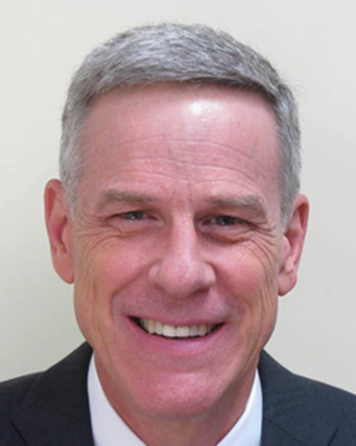

William A. Chambers

Major General William A. Chambers, USAF (retired) served in uniform for 35 years, culminating in duty as the Assistant Chief of Staff for Strategic Deterrence and Nuclear Integration, Headquarters U. S. Air Force, Washington D.C. In that role, he directed the policy, planning, advocacy, and assessment for Air Force nuclear weapon systems.

Since retirement from active duty in 2013, he has been employed by the Institute for Defense Analyses (IDA), a Federally-funded Research and Development Center, which provides studies for the Department of Defense on a full range of national security issues. At IDA, he leads research teams focused on nuclear weapons policy and strategy as well as strategic force structure modernization and Nuclear Enterprise infrastructure; his team recently provided analysis that fulfilled a statutory requirement to examine the issue of presidential decision-making regarding nuclear weapons. He also led analysis efforts that informed the 2018 Nuclear Posture Review and its ongoing implementation and helped lead IDA’s research in support of the congressionally-mandated Augustine-Mies Panel and their report, “New Foundations for Nuclear Security.” General Chambers also served on the Defense Science Board Task Force on Deterring, Preventing, and Responding to the Threat or Use of Weapons of Mass Destruction and co-chaired a panel on the Defense Science Board Summer Study on National Leadership Command Capabilities. He also serves on the DoD’s Threat Reduction Advisory Committee and the USSTRATCOM Strategic Advisory Group.

General Chambers was a master navigator and weapon systems officer; his operational experience included tours in Strategic Air Command flying the KC-135A and FB-111A. He served as a nuclear policy planner on the Joint Staff and as deputy executive assistant to the Chairman of the Joint Chiefs of Staff. He commanded the 11th Wing at Bolling Air Force Base, Washington, DC. He has also served in a variety of leadership roles in the Pentagon and in overseas commands. General Chambers served as Deputy Commanding General, Combined Forces Command-Afghanistan in Kabul during 2006-2007. From 2008-2010 he served as Director of Air and Space Operations and then as Vice Commander, U.S. Air Forces in Europe.

General Chambers graduated from the U.S. Air Force Academy in 1978. He conducted graduate work at the University of Colorado and Boston University and earned a Master’s degree in National Security and Strategic Studies from the Naval War College.

Air Force Bio: https://www.af.mil/About-Us/Biographies/Display/Article/104848/major-general-william-a-chambers/

