BRENDAN THOMAS-NOONE
Research Fellow, Foreign Policy and Defence Program, United States Studies Centre

Areas of expertise
- Australia-US relations
- US-Asia relations
- US foreign policy, defence and strategy
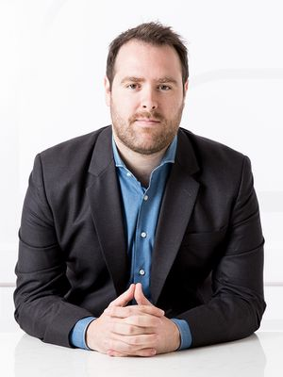
Brendan Thomas-Noone is a Research Fellow in the Foreign Policy and Defence Program at the United States Studies Centre where he works on national security and technology issues, US defence and foreign policy and Indo-Pacific security. A frequent media contributor, Brendan’s research has appeared in national and international newspapers including The Economist, the Australian Financial Review and The Washington Post.

Brendan was formerly a Research Associate in the International Security Program at the Lowy Institute where he worked on nuclear deterrence and policy in Asia, maritime security affairs and Australian defence policy. While at the Lowy Institute he was also an editor and contributor for The Interpreter. Over a five-month period, Brendan previously completed an internship with the Atlantic Council in Washington DC.

He holds a Bachelor of Arts with Honours and a Master of International Relations from the University of Melbourne. Brendan has also received a Master of Science in Global Politics from the London School of Economic and Political Science.

