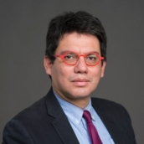
Carlos Arteta
Lead Economist, Development Prospects Group, World Bank

Carlos Arteta is a Lead Economist in the Development Prospects Group of the World Bank. Previously, he served as a Senior Economist in the Division of International Finance of the Federal Reserve Board and as Deputy Chief International Economist at the U.S. Treasury. His work experience includes research and policy work on international economics and macroeconomics, on a wide range of topics such as dollarization, exchange rates, financial crises, financial liberalization, international banking, and sovereign debt. He also has extensive country work experience on Europe and Latin America, including surveillance, analysis, and forecasting of economic conditions. He has published in the European Economic Review, the Journal of International Economics, the Journal of International Money and Finance, the Berkeley Electronic Journals in Macroeconomics, The Economic Journal, and other outlets. Mr. Arteta holds a Ph.D. in Economics from the University of California at Berkeley.

