Matthew Kroenig
Associate Professor

Bio and Featured Works
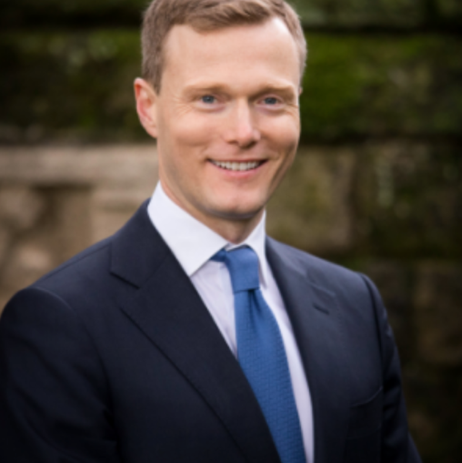
Matthew Kroenig is a Professor in the Department of Government and the Edmund A. Walsh School of Foreign Service at Georgetown University. A 2019 study in Perspectives on Politics ranked him as one of the top 25 most-cited political scientists of his generation.
Dr. Kroenig is the author or editor of seven books, including The Return of Great Power Rivalry: Democracy versus Autocracy from the Ancient World to the US and China (Oxford University Press, 2020), which was an Amazon Best Seller, including the #1 New Release in International Relations. The Logic of American Nuclear Strategy: Why Strategic Superiority Matters (Oxford University Press, 2018) was selected by the US Air Force for its professional reading list and was translated into Chinese and Korean. Exporting the Bomb: Technology Transfer and the Spread of Nuclear Weapons (Cornell University Press, 2010) was awarded the International Studies Association Best Book Award, Honorable Mention.
His articles have appeared in many publications, including: American Political Science Review, Annual Review of Political Science, Foreign Affairs, Foreign Policy, International Organization, International Security, Journal of Conflict Resolution, Journal of Peace Research, Journal of Strategic Studies, Politico, Security Studies, Strategic Studies Quarterly, The Atlantic, The New Republic, The New York Times, The Wall Street Journal, and the Washington Post, among others.
Dr. Kroenig is the Director of the Global Strategy Initiative and Deputy Director of the Scowcroft Center for Strategy and Security at the Atlantic Council. He writes a bi-weekly column for Foreign Policy. Dr. Kroenig has served as a national security adviser on the presidential campaigns of Mitt Romney (2012), Scott Walker (2016), and Marco Rubio (2016). He has served in several positions in the U.S. Department of Defense and the intelligence community in the Bush, Obama, and Trump administrations, including in the Strategy office in the Office of the Secretary of Defense and the CIA's Strategic Assessments Group. He regularly consults with a wide range of U.S. government entities. In 2005, he was the principal author of the first-ever, US-government-wide strategy for deterring terrorist networks. For this work, he received the Office of the Secretary of Defense's Award for Outstanding Achievement. He is a featured character in The New York Times bestselling book, Counterstrike: The Untold Story of America's Secret Campaign against Al Qaeda, by Eric Schmitt and Thom Shanker.
He has previously worked as the Stanton Nuclear Security Fellow at the Council on Foreign Relations, and as a research fellow at the Belfer Center for Science and International Security at Harvard University, and the Center for International Security and Cooperation at Stanford University.
Dr. Kroenig provides regular commentary for major media outlets, including PBS Newshour, Fareed Zakaria GPS, BBC, CNN, Fox News, NPR All Things Considered, and C-SPAN. He is a life member of the Council on Foreign Relations and holds an MA and PhD in political science from the University of California at Berkeley. He lives with his wife and children in Georgetown. Follow him on Twitter @kroenig.

Expertise
International Relations

Interests
Asian Studies, CH, European Studies, Military Science, Russia

Language(s)
Italian (Speak Read Write)

Featured Publications

- The Return of Great Power Rivalry: Democracy versus Autocracy from the Ancient World to the US and China

- The Logic of American Nuclear Strategy: Why Strategic Superiority Matters

- Exporting the Bomb: Technology Transfer and the Spread of Nuclear Weapons

- The Handbook of National Legislatures: A Global Survey

Academic Appointment(s)

Primary
Associate Professor, College - Department of Government

Education

University of California-Berkeley - Ph.D.
University of California-Berkeley - M.A.
University of Missouri-Columbia - B.A.

