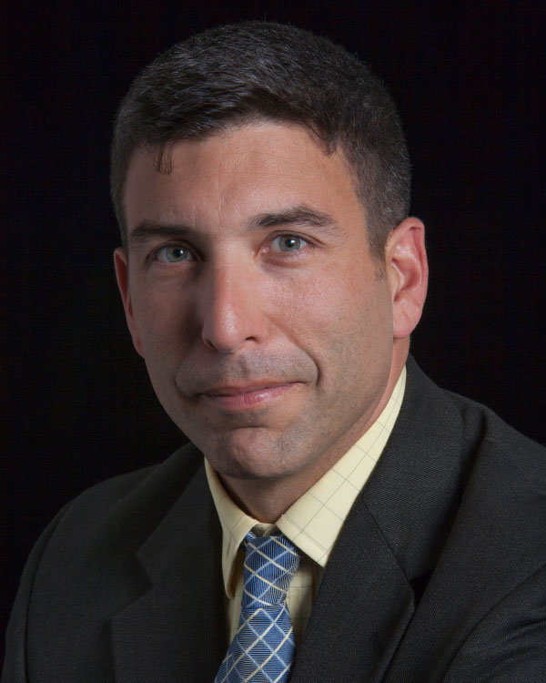
Craig A. Whiteside, Ph.D.

Associate Professor College of Distance Education
Lt. Col., U.S. Army, Retired

Contact Information
(831) 656-2743
CaWhites@nps.edu
@CraigAWhiteside
Areas of Expertise
- Counterterrorism
- Information Operations
- Irregular Warfare

Biography
Dr. Craig Whiteside is an associate professor of National Security Affairs at the U.S. Naval War College as part of the resident program, Naval Postgraduate School in Monterey, California. He is a senior associate with NWC’s Center on Irregular Warfare and Armed Groups and a fellow at the International Centre for Counter-terrorism – The Hague’s and the George Washington University’s program on extremism. He is a co-author of “The ISIS Reader” (Hurst/Oxford-2019). He holds a doctorate in political science from Washington State University and is a former U.S. Army officer.

Education
Ph.D., Washington State University, International Relations

