Michael C. Horowitz Bio

Director and Richard Perry Professor
horom@sas.upenn.edu

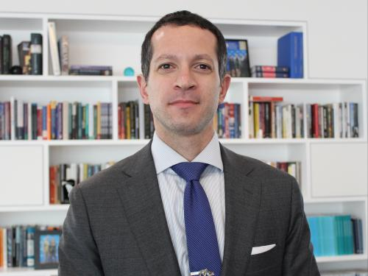
Michael C. Horowitz is Director of Perry World House and Richard Perry Professor at the University of Pennsylvania. He is the author of The Diffusion of Military Power: Causes and Consequences for International Politics, and the co-author of Why Leaders Fight. He won the 2017 Karl Deutsch Award given by the International Studies Association for early career contributions to the fields of international relations and peace research. He has published in a wide array of peer reviewed journals and popular outlets. His research interests include the intersection of emerging technologies such as artificial intelligence and robotics with global politics, military innovation, the role of leaders in international politics, and geopolitical forecasting methodology. Professor Horowitz previously worked for the Office of the Undersecretary of Defense for Policy in the Department of Defense. He is affiliated with the Center for a New American Security, the Center for Strategic and International Studies, and the Foreign Policy Research Institute. He is a member of the Council on Foreign Relations. Professor Horowitz received his Ph.D. in Government from Harvard University and his B.A. in political science from Emory University.

