Robert W. Gehl Biography

Robert W. Gehl is a Fulbright scholar and award-winning author whose research focuses on contemporary communication technologies. He received his PhD in Cultural Studies from George Mason University in 2010. After spending a decade at the University of Utah, he took up the F Jay Endowed Research Chair of Communication at Louisiana Tech University. He has published over two dozens articles in journals such as New Media & Society, Communication Theory, Social Media + Society, and Media, Culture and Society. His books include Reverse Engineering Social Media, which won the Nancy Baym Book Award from the Association of Internet Researchers, and Weaving the Dark Web, published by MIT in 2018. He also has published a co-edited collection of essays, Socialbots and Their Friends. He teaches courses on digital ethnography, the history of cultural studies, the communication technology/society relationship, and basic Web design.

Sean Lawson Biography

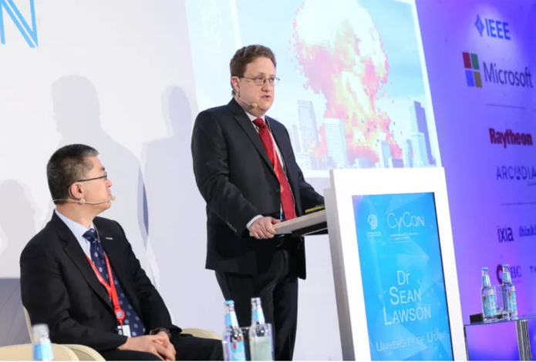
Sean Lawson is Associate Professor in the Department of Communication at the University of Utah, Non-Resident Fellow at the Brute Krulak Center for Innovation and Creativity at the Marine Corps University. In the 2019-2020 academic year, he served as an Adjunct Scholar at the Modern War Institute at West Point. He is author, most recently, of the book, Cybersecurity Discourse in the United States: Cyber-Doom Rhetoric and Beyond (Routledge, 2020). He is also the author of Nonlinear Science and Warfare: Chaos, Complexity, and the U.S. Military in the Information Age. He is co-author (with Marouf Hasian and Megan McFarlane) of The Rhetorical Invention of America’s National Security State. He is currently finishing up a book with Robert W. Gehl titled, Social Engineering: How Crowdmasters, Phreaks, Hackers, and Trolls Created a New Form of Manipulative Communication, which is under contract with MIT Press and expected to be published in 2021.

His research focuses on the relationships among science, technology, and security. In particular, he focuses on the intersections of national security and military thought with new media, information, and communication technologies (ICTs).

His most recent book, Cybersecurity Discourse in the United States, explores the use of cyber-doom rhetoric in the U.S. public policy debate about cybersecurity. Cyber-doom rhetoric relies on the use of various tactics, such as hypothetical doom scenarios, to raise fear of catastrophic cyber attacks on infrastructure and motivate a response. Dr. Lawson traces the use of such rhetoric, assesses how realistic it is, and the implications it has for our ability to respond effectively to cybersecurity challenges.

His first book, Nonlinear Science and Warfare, traced the use of chaos theory, complexity theory, and network science in the development of theories of information-age warfare. This included a focus on the theory and strategy of network-centric warfare in the U.S. military, as well as theories about fourth-generation warfare and global counterinsurgency.

In addition to his academic work on these subjects, Dr. Lawson is a contributor to Forbes.com, CTOVision.com, and ThirtyK.com.

At the University of Utah, Dr. Lawson teaches courses on new media, ICTs, and society. Undergraduate courses include “Communication Technology and Culture,” “Information Technology and Global Conflict,” “Introduction to Web Design,” “International Communication,” “Drones and Society,” “Innovation with Drones,” “Introduction to Qualitative Research Methods,” and “Privacy and Surveillance.” He also teaches graduate seminars in technology studies and science communication. He has taught “Science and Technology in Western Culture” for the State University of New York’s Empire State College.

Dr. Sean Lawson serves on the Academic Review Committee for the NATO Cooperative Cyber Defence Center of Excellence (CCDCOE) International Conference on Cyber Conflict. He is an editor for Routledge Studies in Conflict, Security and Technology. He has served as an instructor in the course “Operational Planning for Counterterrorism” offered by the NATO Centre of Excellence Defence Against Terrorism. He has presented his research to the Joint Staff’s Strategic Multilayer Assessment and was interviewed for its Assessment of the Future of Global Competition & Conflict. He has also presented his work on cybersecurity discourse at Lawrence Livermore National Laboratory.

Dr. Lawson received his Ph.D. in Science and Technology Studies from Rensselaer Polytechnic Institute in 2008. Before beginning his Ph.D., he worked as an Associate National Security Analyst with DynCorp Systems & Solutions, LLC in Alexandria, VA. He has an MA in Arab Studies from the School of Foreign Service at Georgetown University and a BA in History from California State University, Stanislaus. As an undergraduate, he interned in the Chemical and Biological Weapons Nonproliferation Project at the Center for Nonproliferation Studies in Monterey, California.

