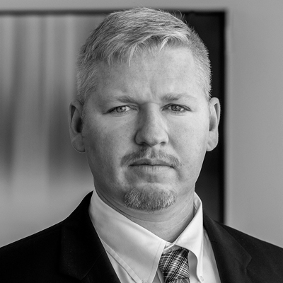
SENIOR RESEARCH FELLOW

Colin P. Clarke
Colin P. Clarke is a Senior Research Fellow at The Soufan Center. He is the Director of Policy and Research at The Soufan Group, where his research focuses on domestic and transnational terrorism, international security, and geopolitics. Prior to joining The Soufan Group, Clarke was a professor at Carnegie Mellon University, and a senior political scientist at the RAND Corporation, where he spent a decade researching terrorism, insurgency, and criminal networks. At RAND, Clarke led studies on ISIS financing, the future of terrorism and transnational crime, and lessons learned from all insurgencies since the end of the World War II.

Clarke is also an Associate Fellow at the International Centre for Counter-Terrorism (ICCT) – The Hague, a non-resident Senior Fellow in the Program on National Security at the Foreign Policy Research Institute (FPRI), an Associate Fellow at the Global Network on Extremism and Technology (GNET), and a member of the “Network of Experts” at the Global Initiative Against Transnational Organized Crime.

Clarke serves as part of the research advisory council at the RESOLVE Network and is a member of the advisory board at the International Counter-Terrorism Review (ICTR). He serves on the editorial board of three of the leading scholarly journals in the field of terrorism studies, Studies in Conflict and Terrorism, Terrorism and Political Violence, and Perspectives on Terrorism.

Clarke has testified before Congress on numerous occasions as an expert witness on a range of terrorism-related issues, appears frequently in the media to discuss national security-related matters, and has published several books on terrorism, including his most recent, After the Caliphate: The Islamic State and the Future Terrorist Diaspora.

Clarke has briefed his research at a range of national and international security forums, including the U.S. Army War College, US Air Force Special Operations School, Society for Terrorism Research International Conference, the Global Counterterrorism Forum (GCTF) and the Counter ISIS Financing Group (CIFG), which is part of the Global Coalition to Defeat ISIS. In 2011, he spent several months as an analyst with Combined Joint Interagency Task Force-Shafafiyat at ISAF headquarters in Kabul, Afghanistan, working for General H.R. McMaster, the former U.S. National Security Advisor, where he was responsible for analyzing criminal patronage networks in Afghanistan and how these networks fueled the insurgency.

Clarke has a Ph.D. in international security policy from the University of Pittsburgh’s Graduate School of Public and International Affairs (GSPIA).
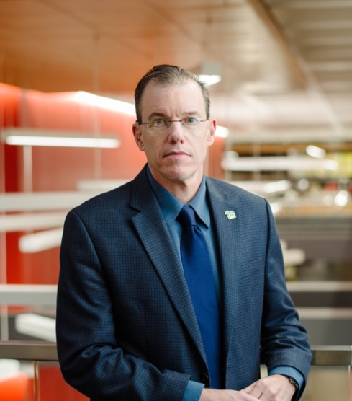
PROFESSOR, POSVAR CHAIR IN INTERNATIONAL SECURITY STUDIES, DIRECTOR OF THE RIDGWAY CENTER

Michael Kenney

Biography
Having published numerous academic journal articles on terrorism, Islamist militancy, and global crime, Kenney now serves on the Editorial Board of Terrorism and Political Violence, a leading journal in the field. Supported by the National Science Foundation, the Office of Naval Research, and the National Institute of Justice, he’s conducted field research around the world in places like Brazil, Colombia, Israel, Morocco, and Spain.

TEACHING AND RESEARCH AREAS
Kenney’s research is focused on these key areas:
- Terrorism and counter-terrorism
- Islamist militancy
- Social network analysis
- Drug control policy
- International relations
- Organization theory
- Qualitative research methods

SELECT PUBLICATIONS AND FUNDED RESEARCH
- The Islamic State in Britain: Radicalization and Resilience in an Activist Network. Cambridge University Press, 2018.
- “Cyber-Terrorism in a Post-Stuxnet World,” Orbis: A Journal of World Affairs 59, no. 1 (Winter 2015), pp. 111-128.
- Office of Naval Research, U.S. Department of the Navy, "Competitive Adaptation in Terrorist Networks," 2009-2012, $3.1 million.
- From Pablo to Osama: Trafficking and Terrorist Networks, Government Bureaucracies, and Competitive Adaptation. Pennsylvania State University Press, 2007.

AWARDS AND HONORS
- Nominee, U.S. Attorney General's Award for "Outstanding Contributions to Community Parternship for Public Safety," 2018.

OTHER ACADEMIC POSITIONS
- Wesley W. Posvar Chair in International Security Studies
- Director, Matthew B. Ridgway Center for International Security Studies
- Affiliate scholar, University of Pittsburgh Institute for Cyber Law, Policy, and Security

