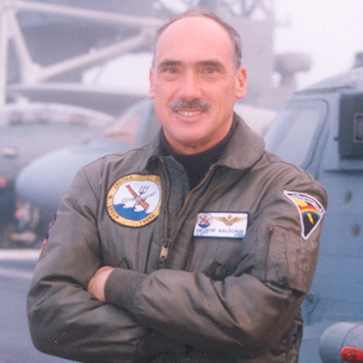
CAPT George Galdorisi, USN (Ret)

Naval Information Warfare Center Pacific
Director, Strategic Assessments & Technical Futures

George Galdorisi is Director of Strategic Assessments and Technical Futures for the Naval Information Warfare Center Pacific. Prior to joining NIWC Pacific, he completed a thirty-year career as a naval aviator, culminating in 14 years of consecutive experience as executive officer, commanding officer, commodore, and chief of staff.

During his career as a naval aviator he completed an array of operational assignments in all five Navy fleets. After completing a tour as Test Director in the LAMPS Mk III helicopter Program Office, he was one of a small cadre of officers who stood up the Navy’s first LAMPS Mk III squadron, HSL-41. His operational assignments culminated in commanding officer tours of HSL-43, the Navy’s first operational LAMPS Mk III squadron, HSL-41, the LAMPS Mk III Fleet Replacement Squadron, USS Cleveland (LPD-7), and Amphibious Squadron Seven. His last operational assignment spanned five years as Chief of Staff for Cruiser-Destroyer Group Three, during which he made combat deployments to the Western Pacific and Arabian Gulf embarked in the USS Carl Vinson and USS Abraham Lincoln. During this final tour he also led the U.S. Delegation for military-to-military consultations with the Chinese Navy.
He began his writing career in 1978 with an article in U.S. Naval Institute Proceedings. He has written fourteen books, including the New York Times best seller, Tom Clancy Presents: Act of Valor, the novelization of the Bandito Brothers/Relativity Media film and The Kissing Sailor, which proved the identity of the two principals in Alfred Eisenstaedt’s famous photograph. His reboot of the best-selling Tom Clancy’s Op-Center Series includes three consecutive the New York Times best sellers, Out of the Ashes, Into the Fire and Scorched Earth. His most recent fiction project is a new series of Rick Holden thrillers published by Braveship Books (The Coronado Conspiracy, For Duty and Honor and Fire and Ice). His most recent non-fiction project is the forthcoming AI at War How Big Data, Artificial Intelligence and Machine Learning Are Changing Naval Warfare (April 2021, U.S. Naval Institute Press). Additionally, he has published more than four hundred articles in professional journals and national newspapers.
He has received a number of national and international writing awards, including: the Navy League of the United States Alfred Thayer Mahan Award for Literary Achievement, the U.S. Naval Institute General Prize Essay Contest, the Surface Navy Association Literary Award, the Navy League of Australia's Annual Essay Competition, the Naval Helicopter Historical Association Literary Award, and the Military Writers Society of America Silver Medal Award, among others.
He is a 1970 graduate of the United States Naval Academy and holds a Masters Degree in Oceanography from the Naval Postgraduate School and a Masters Degree in International Relations from the University of San Diego. He graduated from both the Naval War College’s College of Command and Staff and the College of Naval Warfare, and in 1994 he received the Naval War College’s Admiral John Hayward Award for Academic Achievement. Additionally, he is a graduate of MIT Sloan School’s Program for Senior Executives.

Dr. Samuel J. Tangredi

U.S. Naval War College

Leidos Chair of Future Warfare Studies and Professor of National, Naval, and Maritime Strategy

Sam J. Tangredi is the Leidos Chair of Future Warfare Studies and professor of national, naval, and maritime strategy at the U.S. Naval War College. A U.S. Naval Academy and Naval Postgraduate School graduate, he earned a PhD in international relations from the University of Southern California. He served a thirty-year naval career as a surface warfare officer and as a strategic planner and leader of strategic planning. He is author of Anti-Access Warfare: Countering A2/AD Strategies.

