Ms. Sarah Cook (Freedom House)

Research Director for China, Hong Kong, and Taiwan
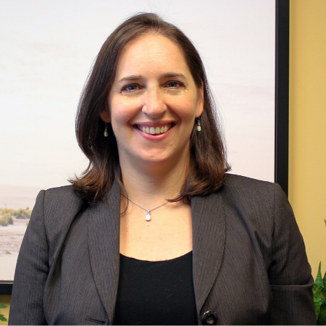
Sarah Cook is Research Director for China, Hong Kong, and Taiwan at Freedom House. She directs the China Media Bulletin, a monthly digest in English and Chinese providing news and analysis on media freedom developments related to China. Cook is also the author of several Asian country reports for Freedom House’s annual publications, as well as four special reports about China: Beijing's Global Megaphone (2020), The Battle for China’s Spirit (2017), The Politburo’s Predicament (2015), and The Long Shadow of Chinese Censorship (2013). Her comments and writings have appeared on CNN, The Wall Street Journal, Foreign Policy, and the U.S. Congressional-Executive Commission on China.
Before joining Freedom House, Ms. Cook co-edited the English translation of A China More Just, a memoir by prominent rights attorney Gao Zhisheng, and was twice a delegate to the United Nations Human Rights Commission meeting in Geneva for an NGO working on religious freedom in China. She received a B.A. in International Relations from Pomona College and as a Marshall Scholar, completed Master’s degrees in Politics and International Law at the School of Oriental and African Studies in London.

