Mr. Mathew Burrows (Atlantic Council)

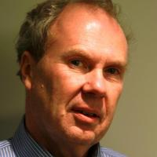
Mathew Burrows serves as director of the Atlantic Council's Strategic Foresight Initiative. His recent book is titled The Future Declassified: Megatrends that Will Undo the World Unless We Take Action (Palgrave/Macmillan, 2014).

In August 2013, Mr. Burrows retired from a 28-year career in the CIA and State Department, the last ten being spent at the National Intelligence Council (NIC). In 2007 he was appointed director of the analysis and production staff and was responsible for managing a staff of senior analysts and production technicians who guide and shepherd all NIC products from inception to dissemination. He was the principal drafter for the NIC publication “Global Trends 2030: Alternative Worlds,” which received widespread praise in the international media. He also drafted two earlier editions of the report.

Burrows joined the CIA in 1986, serving as analyst for the Directorate of Intelligence and covering Western Europe, including the development of European institutions such as the European Union. From 1998 to 1999 he was the first holder of the Intelligence Community Fellowship and served at the Council on Foreign Relations in New York. Other previous positions included assignments as special assistant to U.S. Ambassador to the United Nations Richard Holbrooke (1999-2001) and deputy national security advisor to U.S. Treasury Secretary Paul O'Neill (2001-2).

Burrows graduated from Wesleyan University in 1976 and received a Ph.D. in European history from Cambridge University, England in 1983.

Mr. Collin Meisel (University of Denver)
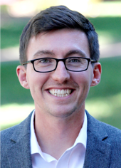
Education:
A.A.S. in Criminal Justice from the Community College of the Air Force, 2014
B.A. in Political Science from American Military University, 2015
M.P.P. in Public Policy from Georgetown University, 2018

Collin J. Meisel came to the Pardee Center’s Diplometrics Project in the fall of 2018 and transitioned to the role of Diplometrics Program Lead in spring of 2020. Prior to Pardee, Collin researched issues related to chemical, biological, radiological, and nuclear terrorism at the National Consortium for the Study of Terrorism and Responses to Terrorism's (START) Unconventional Weapons and Technology division. Before START, Collin served for 8 years as a Security Forces member in the U.S. Air Force, which included leading and advising security teams for Special Air Missions transporting the Vice President of the United States, First Lady, Secretaries of State and Defense, and other national and military leaders domestically and abroad.

Email: collin.meisel@du.edu

Dr. Jonathan D. Moyer (University of Denver)

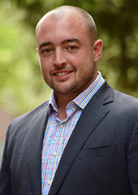
Position
Pardee Center Director
Assistant Professor

Education:
B.A. University of Bluffton, Bluffton Ohio, International Business, 2002
M.A. University of Denver, Josef Korbel School of International Studies, 2007
Ph.D. University of Denver, Josef Korbel School of International Studies, 2012

Jonathan D. Moyer is Assistant Professor at the Josef Korbel School of International Studies and Director of the Frederick S. Pardee Center for International Futures. He works across various research areas, extending and using the International Futures (IFs) integrated assessment platform. Jonathan studies patterns of human development through funded research for organizations like the African Union Development Agency and the United Nations. He leads the creation of new data and tools to better understand and analyze international relations contributing to reports such as the U.S. National Intelligence Council Global Trends 2030. Jonathan also researches patterns and drivers of state fragility and failure most notably as Lead Co-Principal Investigator on a five-year Minerva grant.

Email: Jonathan.Moyer@du.edu

