Dr. Erik Herron

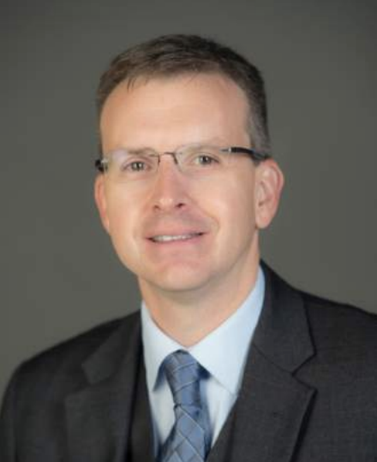
Dr. Erik Herron is the Eberly Family Distinguished Professor of Political Science at West Virginia University and serves as one of the leaders on the CESCI Project. He has conducted research across Eastern Europe and Eurasia, including a term as a Fulbright scholar in Ukraine and fifteen election observation missions. He has published research about political institutions, governance, and elections in many academic journals, and four books: Mixed Electoral Systems: Contamination and its Consequences (with Federico Ferrara and Misa Nishikawa), Elections and Democracy after Communism, The Oxford Handbook of Electoral Systems (with Robert Pekkanen and Matthew Shugart), and Normalizing Corruption: Failures of Accountability in Ukraine.

Dr. Cynthia J. Buckley

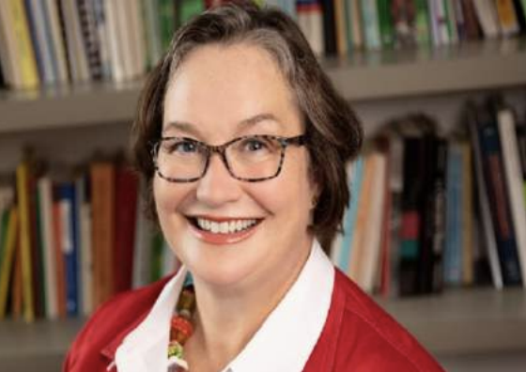
Cynthia J. Buckley (Ph.D., University of Michigan, 1991) is Professor of Sociology and Faculty Affiliate of the Center for Russian, East European and Eurasian Studies and the European Studies Center at the University of Illinois at Urbana-Champaign. A social demographer by training, her research focuses on the intersections of health, social inequality, population change, and social stability. Her work has appeared in a variety of academic journals including Demographic Research, The Gerontologist, International Migration Review, Comparative Economics, and Population Research and Policy Review as well as several media and policy outlets. She is the lead editor of Migration, Homeland and Belonging in Eurasia, (Johns Hopkins University Press). Dr. Buckley has held a number of policy Biographies 83 consultancies in Eurasia in the areas of reproductive health, health service provision, education, and data collection for the US Department of State, the Carnegie Foundation, the Central Intelligence Agency, and other regional governments, international agencies, and nonprofits.

