Air Marshal Ian Gale MBE MBA MA CMgr FCMI

Director General Joint Force Development, UK StratCom

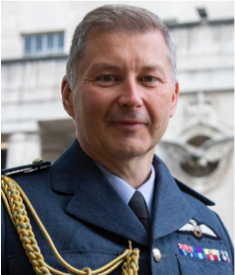
Ian was appointed Director General Joint Force Development in April 2021, responsible for the conceptual element of UK fighting power: concepts & doctrine, training & education, exercise & experimentation, lessons learned & innovation. Before that he was Assistant Chief of the Air Staff from April 2019, responsible for the coherence and coordination of the Royal Air Force, international relations, strategic engagement and parliamentary business on behalf of the Chief. Ian has commanded at flight, wing and station level amassing over 3000 flying hours and 350 operational missions as a Tornado Weapons Instructor and in Operational Test & Evaluation of Tornado and Typhoon. He was appointed MBE for his leadership in ops and trials and the Sir Arthur Barratt prize for developing new tactics / techniques for the 2003 Scud-hunting campaign. He was at the forefront of the deployment of Tornado to Afghanistan in 2009 and fought the 2011 Libya campaign as the Deputy Air Contingent Commander. As CO RAF Lossiemouth, he commanded a unit of 2500 personnel, three Tornado Squadrons, a Search and Rescue Flight, an RAF Regiment Wing and various smaller units across Scotland, during a time of unprecedented operational activity in two theatres, for which he received the 1 Group Leadership Prize and an Institute of Directors award. Ian has served twice in MOD capability directorates. He led the rapid procurement of the HERMES 450 Remotely Piloted Air System to Iraq and Afghanistan during his time in the Intelligence, Surveillance & Reconnaissance (ISR) area and serving in Deep Target Attack, was responsible for the Complex Weapons portfolio. In 2013/14, he worked in Joint Forces Command as the Deputy Head of Collection in C4ISR, where he led strategic development across all three services, as well as programme directing a record-breaking urgent procurement case for a new Maritime Patrol Aircraft. As Assistant Chief of Staff for C2ISR Capability Delivery, he was the Senior Responsible Owner for current and nascent airborne ISR capabilities including Reaper and Protector, Sentinel, Shadow, Airseeker, E-7 Wedgetail and the P-8A Maritime Patrol Aircraft. His programmes secured the Minister for Defence Procurement’s acquisition award in each of the 4 calendar years he served in that post. Ian has completed the Civil Service Senior Leadership Programme and Higher Command and Staff Course. He holds an MA in Defence Studies and an MBA. He is a Chartered Manager and a graduate of the Major Projects Leadership Academy at Oxford University’s Business School and is a mentor on the RAF's 'Rise Together' scheme, where he enjoys helping others to achieve their best.

Vice Admiral Stuart Munsch

Director for Operational Plans and Joint Force Development, J7, Joint Staff

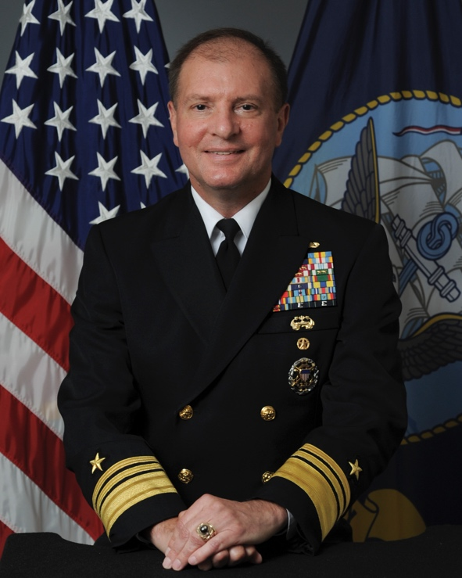
Vice Adm. Stuart Munsch, a native of North Dakota, graduated from the Naval Academy in 1985 with a Bachelor of Science in Electrical Engineering. At Annapolis, he was brigade commander of his class and an All-American and national champion pistol shooter. Selected for a Rhodes Scholarship, he attended Oxford University and earned a Bachelor of Arts and a Master of Arts in Philosophy, Politics and Economics.

He then was assigned to four consecutive sea duty assignments, serving on USS Will Rogers (SSBN 659), USS Jefferson City (SSN 759), USS Kitty Hawk (CV 63) on the staff of Commander, Cruiser Destroyer Group 5, and USS Tucson (SSN 770). In 1999, Munsch reported ashore to U.S. Pacific Command, where he served in the Plans and Policy Directorate (J5) prior to becoming deputy executive assistant to the commander. He then was selected for a White House Fellowship and served as special assistant to the Secretary of Agriculture.

Munsch commanded USS Albuquerque (SSN 706) from 2002 to 2005, followed by duty in the Pentagon as the military assistant to the Deputy Secretary of Defense and then as executive assistant to the Director, Submarine Warfare, Office of the Chief of Naval Operations (OPNAV N87).
Munsch commanded Submarine Development Squadron (DEVRON) 5 from 2008 to 2010 and then returned to the Pentagon to head the Navy Strategy branch (OPNAV N513). Selected for flag rank, he was reassigned as deputy director, Undersea Warfare (OPNAV N97).

Sent overseas to Japan and Bahrain, Munsch commanded Submarine Group 7 and Task Forces 74 and 54 from 2013 to 2015, followed by duty in the Pentagon as the senior military assistant to the Deputy Secretary of Defense. In 2017 Munsch reported to OPNAV N3/N5 as the assistant and in 2018 became the deputy chief of naval operations for Operations, Plans and Strategy. In 2019 he established and served as the initial deputy chief of naval operations for Warfighting Development, N7. He assumed his role as director for Joint Force Development (J7) in 2020.

Munsch is a member of the Council on Foreign Relations, a Massachusetts Institute of Technology Seminar XXI fellow and recipient of the U.S. Navy League's Decatur Award for operational excellence. His awards include the Defense Distinguished Service Medal, Navy Distinguished Service

Medal, Defense Superior Service Medal, Legion of Merit (five awards), and several unit awards shared with shipmates

