Dr. Paul Krugman Biography

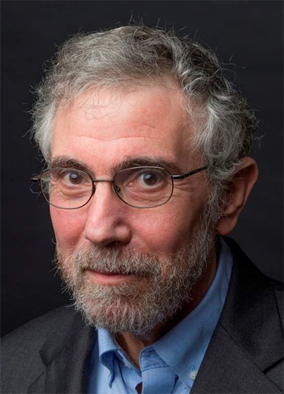
Dr. Paul Krugman is an American economist who is the Distinguished Professor of Economics at the Graduate Center of the City University of New York and a columnist for The New York Times. Dr. Krugman is also the recipient of the 2008 Nobel Prize in Economics.

