Mark Cooter and Alec Bierbauer Biographies

Col. Mark Cooter, USAF (Retired)

Mark Cooter is a retired United States Air Force Colonel and served as an intelligence officer for 28 years. He has experience in DESERT STORM, the Balkans, Iraq, Afghanistan, and Libya operations. As a Fighter Weapons School Graduate, he commanded the 497th of Intelligence, Surveillance, and Reconnaissance Group and the 547th Intelligence Squadron. He also had staff tours at the Air Staff, Air Combat Command, United States Central Command, and United States U.S. Air Forces Central Command.

Mark Cooter served as the Operations Officer for the Air Combat Command’s Expeditionary Air Intelligence Squadron, the United States Air Force component of this Joint CIA/USAF venture operating the RQ-1 and MQ-1 Predator Remotely Piloted Aircraft System. He also served as the Air Force’s lead action officer for this endeavor. His team’s efforts are chronicled in the book, “Never Mind, We'll Do lt Ourselves. The Inside Story of How a Team of Renegades Broke Rules, Shattered Barriers, and Launched a Drone Warfare Revolution, which he coauthored.

His decorations include the National Intelligence Distinguished Service Medal, Defense Superior Service Medal, two Legions of Merit, ten Meritorious Service Medals, the Aerial Achievement Medal two, Air Force Commendation Medals, and the Air Force Achievement Medal. He was twice recognized as the Air Combat Command Intelligence Officer of the Year. He holds a bachelor’s degree in Mathematics from East Tennessee State University, a master’s Degree in Computer Resources and Information Management from Webster University, and a master’s Degree in Joint Campaign Planning and Strategy from the National Defense University.

Since retiring from active duty in 2013, he’s served as the Director of Intelligence, Surveillance, and Reconnaissance Operations for PatchPlus Consulting, Inc. As such, he provides subject matter expertise to operations, acquisition, and industry partners including support to warfighting and research efforts, instruction for various training courses, and staff support.

Mr. Alec Bierbauer, CEO of Blackrock Strategy, LLC

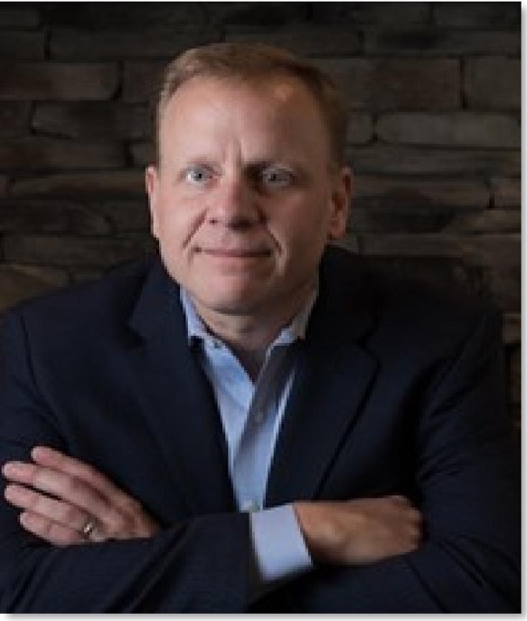
Alec has over 30 years of risk mitigation experience, including more than a decade working with international Fortune 500 companies to protect their people, brands, and market share. He also has over 20 years of experience in counterintelligence and counterterrorism conducting and managing unique special military and other government operations.

Alec's career began as an Army Counterintelligence Special Agent working espionage investigations and Special Access Program support in Korea, Ft. Meade USA, Kuwait, and Panama. Following his active duty Army obligations.

Alec's intelligence career continued with an assignment as a principal US Department of Defense intelligence officer for briefing the Joint Staff, Office of the Secretary of Defense, and Defense Intelligence Agency leadership on special programs.

His government service culminated with his work in the CIA's Clandestine Service as a Case Officer. Alec was assigned to the CIA's Counter Terrorism Center, where he was the founder, Program Manager, and Director for a National Security Council requirement that Has grown to be one of CIA's most successful collection and operational engagement programs. His duties included regular interaction with his managed assets in the field as well as key leaders across the spectrum of the US Government stakeholders. Alec also served as a Chief of Base and an Operations Officer in multiple war and conflict zones.

Alec’s post-government career continued support to US interests through government contracting as well as support to large businesses needing to mitigate risks across the globe to their people and interests.

In 2021, he became published as the co-author of "Never Mind, We'll Do lt Ourselves: The inside Story of How a Team of Renegades Broke Rules, Shattered Barriers, and Launched a Drone Warfare Revolution."

Alec holds a Bachelor of Science degree from The Pennsylvania State University, USA.

