SMA STRATCOM Panel Discussion: Challenges to 21st Century Deterrence (Part II)

Speaker Biographies
Dr. Allison Astorino-Courtois is Executive Vice President at NSI, Inc. She has also served as co-chair of a National Academy of Sciences study on Strategic Deterrence Military Capabilities in the 21st Century, and as a primary author on a study of the Defense and Protection of US Space Assets. Dr. Astorino-Courtois has served as technical lead on a variety of rapid turn-around, Joint Staff-directed Strategic Multilayer Assessment (SMA) projects in support of US forces and Combatant Commands. These include assessments of key drivers of political, economic and social instability and areas of resilience in South Asia; development of an analytic approach used to identify USINDOPACOM requirements for humanitarian support in a Megacity (case study: Dhaka, Bangladesh); development of a methodology for conducting provincial assessments for the ISAF Joint Command; production of a "rich contextual understanding" (RCU) to supplement intelligence reporting for the ISAF J2 and Commander; projects for USSTRATCOM on deterrence assessment methods; and, work for USSOCOM on operationalizing its “gray zone” concept.
Previously, Dr. Astorino-Courtois was a Senior Analyst at SAIC (2004-2007) where she served as a USSTRATCOM liaison to US and international academic and business communities. Prior to that Dr. Astorino-Courtois was a tenured Associate Professor of International Relations at Texas A&M University in College Station, TX (1994-2003) where her research focused on the cognitive aspects of political decision making and how to “market” peaceful conflict resolution to adversarial actors. She has received a number of academic grants and awards and has published articles in multiple peer-reviewed journals. She has also taught at Creighton University and as a visiting instructor at the US Military Academy at West Point. Dr. Astorino-Courtois earned her Ph.D. in International Relations and MA in and Research Methods from New York University. Her BA is in political science from Boston College. Finally, Dr. Astorino-Courtois also has the distinction of having been awarded both a US Navy Meritorious Service Award and a US Army Commander's Award.

Dr. Belinda Bragg (NSI, Inc.)
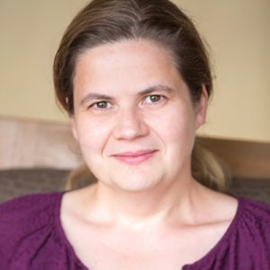
Dr. Belinda Bragg is a Principal Research Scientist for NSI. She has provided core support for DoD Joint Staff and USSTRATCOM, USEUCOM, USPACOM, USCENTCOM, USAFRICOM Strategic Multi-layer Analysis (SMA) projects for the past ten years. Dr. Bragg has extensive experience reviewing and building social science models and frameworks. Her research has focused on decision making, causes of conflict, interest analysis, and state instability. She is one of the two designers of a stability model, (the StaM) that has been used by ISAF to determine the success of stability efforts in Afghanistan, by the Joint Staff to evaluate state stability in Pakistan, and at the city-level to explore the drivers and buffers of instability in megacities, with a case study of Dhaka. She developed NSI’s Pathways model, which examines future trajectories of fragile states, and has been applied to Pakistan and Afghanistan. Prior to joining NSI, Dr. Bragg was a visiting lecturer in International Relations at Texas A&M University in College Station, where she continues to teach on a regular basis. Dr. Bragg earned her Ph.D. in political science from Texas A&M University, and her BA from the University of Melbourne, Australia.

