COL (Ret) Sleevi Brief Bio:
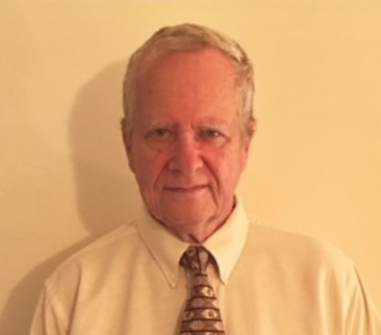
Neil Sleevi, Colonel, USA, Retired, holds a Master of Science Degree from the University of Colorado and a Master of Strategic Studies from the US Army War College. Neil Sleevi served from 2014 to 2021 as a Research and Simulation Analyst in contract support to the TRADOC G-2 M&S Office at Ft. Leavenworth, Kansas. There he provided expertise to visualize the Operational Environment (OE) and improve understanding of Political, Military, Economic, Social, Infrastructure, Information, Physical Environment, and Time (PMESII-PT) variables in military operations. He provided simulation support to studies and experimentation primarily using Athena and other human, social, culture models and simulation. He has provided support to Athena simulation-based studies, reports and analyses supporting TRADOC and other military organizations. He has authored papers published in Signal Magazine (1975), Roundtable Magazine (1976), The Interservice / Industry Training, Simulation and Education Conference (I/ITSEC) (2015, 2016, 2018, 2020 and 2021) OPNET Contributed Papers, and for the Military Operation Research Society (MORS). Neil has served as a military officer in Vietnam, Iraq, Afghanistan. He is currently a Military Analyst with the Irregular Warfare Proponent, Mission Command Center of Excellence, TRADOC.

